Fundamentals Of Data Science-DSA0410
Lab Experiments

A.Surendra krishna
192472202

Experiment-16
Program:
reviews = [
"This product is very good",
"This product is not good",
"I like this product"
]
from collections import Counter
text = " ".join(reviews).lower()
words = text.split()
word_freq = Counter(words)
print(word_freq)

Output:

Experiment-17
Program:
import pandas as pd
import string
from collections import Counter
import matplotlib.pyplot as plt
feedback_data = pd.DataFrame({
"feedback": [
"This product is very good",
"I love this product",
"This product is not good",
"The quality of the product is excellent",
"I am not happy with this product"
]
})
stop_words = {"the", "is", "and", "this", "to", "a", "of", "with", "am"}
text = " ".join(feedback_data["feedback"]).lower()
text = text.translate(str.maketrans("", "", string.punctuation))
words = [word for word in text.split() if word not in stop_words]
word_freq = Counter(words)
N = int(input("Enter number of top words: "))
top_words = word_freq.most_common(N)
print("Top frequent words:")
for word, freq in top_words:
print(word, ":", freq)
words, counts = zip(*top_words)
plt.bar(words, counts)
plt.xlabel("Words")
plt.ylabel("Frequency")
plt.title("Top Frequent Words in Customer Feedback")
plt.show()

Output:
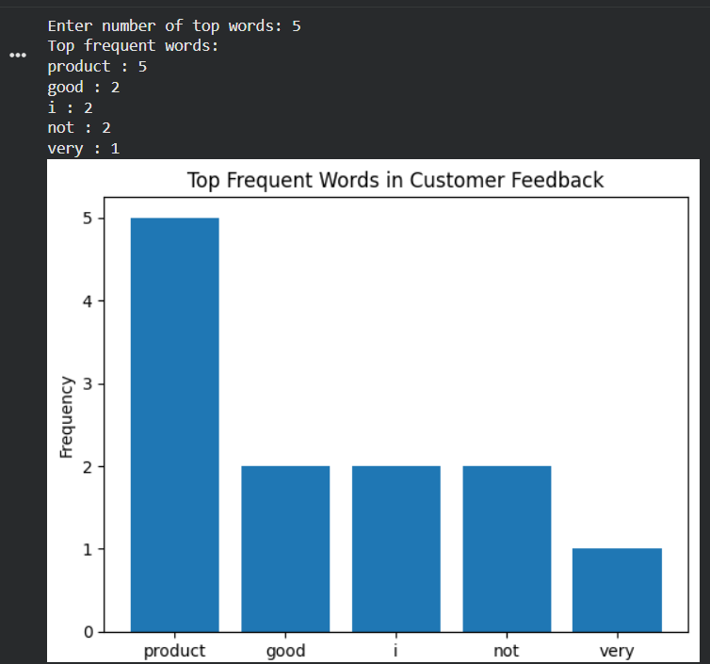

Experiment-18:
Program:
import pandas as pd
import matplotlib.pyplot as plt
import scipy.stats as stats
data = pd.DataFrame({
"Age": [23,25,30,35,40,45,50,28,33,38,42,47,52,29,34,39,44,48],
"Fat": [18,20,22,25,27,30,32,21,24,26,29,31,33,23,25,28,30,34]
})
data.boxplot()
plt.scatter(data["Age"], data["Fat"])
plt.xlabel("Age")
plt.ylabel("Body Fat %")
plt.show()
stats.probplot(data["Fat"], plot=plt)
plt.show()

Output:
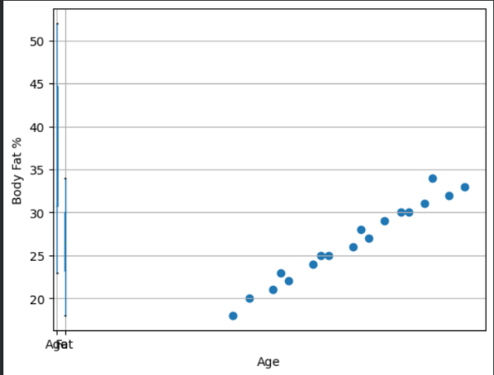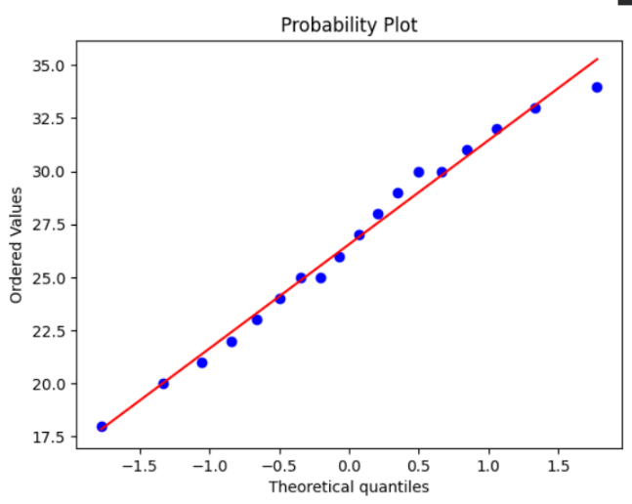

Experiment-19:
Program:
import numpy as np
drug = np.random.normal(10, 2, 50)
placebo = np.random.normal(4, 2, 50)
import scipy.stats as stats
import numpy as np
def confidence_interval(data):
mean = np.mean(data)
sem = stats.sem(data)
ci = stats.t.interval(0.95, len(data)-1, mean, sem)
return ci
print("Drug CI:", confidence_interval(drug))
print("Placebo CI:", confidence_interval(placebo))

Output:

Experiment-20:
Program:
import numpy as np
design_A = np.random.normal(0.05, 0.01, 100)
design_B = np.random.normal(0.06, 0.01, 100)
from scipy.stats import ttest_ind
t_stat, p_value = ttest_ind(design_A, design_B)
print("P-value:", p_value)
if p_value < 0.05:
print("Statistically significant difference")
else:
print("No statistically significant difference")

Output:


