Student Name : Anisetti Surendra Krishna
Registration Number : 192472202
Course Code & Name : MLA0302 - Reinforcement Learning
Date of Submission : 21-11-2024

Question 1: Grid World Navigation using OpenAI Gym
Aim
To develop a Reinforcement Learning model using the OpenAI Gym Grid World environment where an agent reaches the goal while avoiding obstacles.
Procedure
- Import the required Python libraries.
- Create the Grid World (FrozenLake) environment.
- Initialize the agent at the starting position.
- Select actions to move in the grid.
- Receive rewards after every action.
- Stop when the goal is reached or the episode ends.
- Display the total reward obtained.

Code:
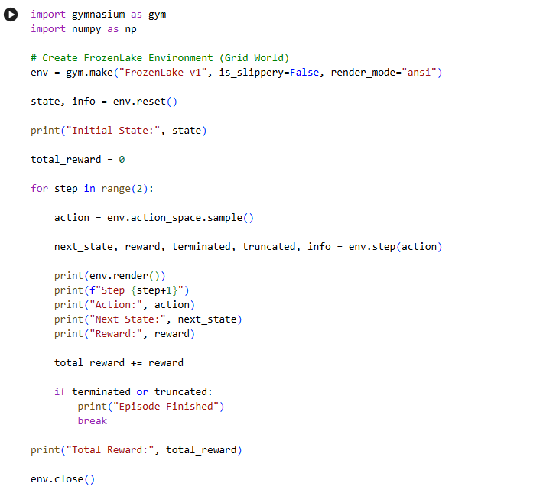
Output:
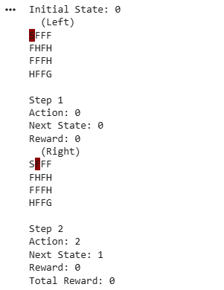

Result
The Grid World environment was successfully simulated. The agent navigated the grid and attempted to reach the goal while avoiding obstacles. The rewards obtained indicate the effectiveness of the selected actions.

Question 2: ε-Greedy Multi-Armed Bandit
Aim
To implement the ε-Greedy Multi-Armed Bandit algorithm and compare the performance for ε = 0.1, 0.3, and 0.5 over 500 trials.
Procedure
- Define five slot machine arms with different reward values.
- Initialize estimated rewards and action counts.
- Execute the ε-Greedy algorithm for 500 trials.
- Choose exploration or exploitation based on ε.
- Update the estimated reward after every action.
- Plot cumulative rewards for each ε value.
- Compare the performance.

Code:
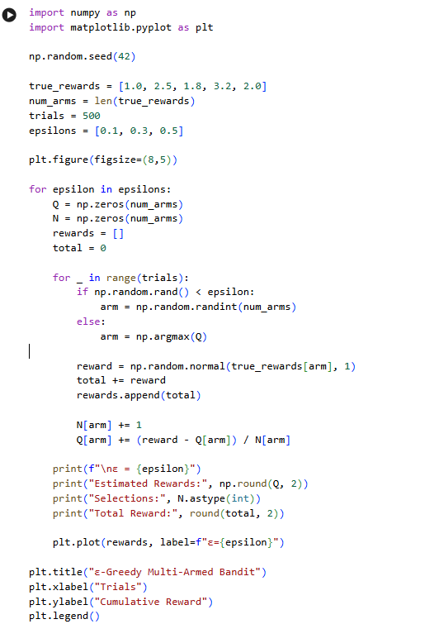
Output:
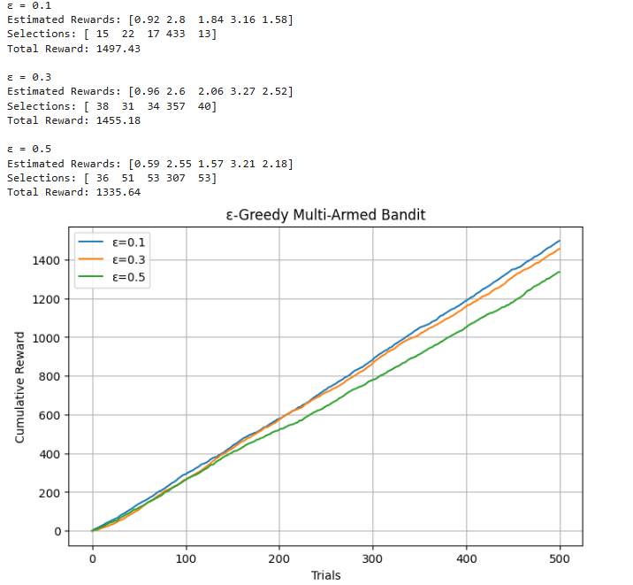

Result
The ε-Greedy algorithm successfully balanced exploration and exploitation. Among the tested values, ε = 0.1 achieved the highest cumulative reward because it exploited the best action more frequently while still performing limited exploration.

Question 3: Autonomous Robot MDP
Aim
To design a Markov Decision Process (MDP) for an autonomous robot that reaches the destination while minimizing energy consumption.
Procedure
- Define the robot states.
- Define the possible actions.
- Assign transition probabilities.
- Specify rewards for reaching the destination.
- Decrease energy after every movement.
- Continue until the destination is reached or energy is exhausted.
- Display the remaining energy and total reward.

Code:
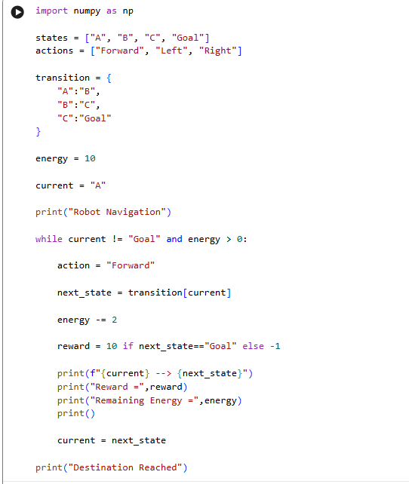
Output:
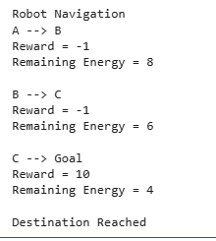
Result
The robot successfully reached the destination while minimizing energy usage. The MDP model effectively demonstrated optimal decision-making under energy constraints.

Question 5: Warehouse Robot Battery Constraint
Aim
To design a Reinforcement Learning framework that enables a warehouse robot to complete the maximum number of deliveries without exceeding the battery limit.
Procedure
- Initialize the battery capacity.
- Assign battery usage for each delivery.
- Perform deliveries while battery remains available.
- Reduce battery after every delivery.
- Increase the reward for successful deliveries.
- Stop when the battery becomes insufficient.
- Display the total deliveries and reward.

Code:
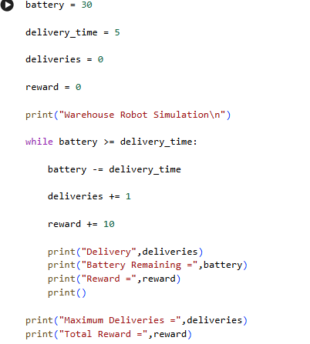
Output:
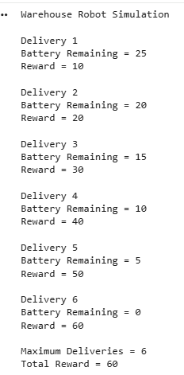
Result
The warehouse robot successfully completed the maximum possible deliveries within the battery limit. The battery constraint was satisfied, and the reward increased with each successful delivery.

Question 8: Random vs ε-Greedy Action Selection
Aim
To compare Random Action Selection and ε-Greedy Action Selection in a Multi-Armed Bandit problem using cumulative rewards.
Procedure
- Define multiple bandit arms.
- Execute the Random Action Selection strategy.
- Execute the ε-Greedy strategy.
- Record cumulative rewards for both methods.
- Plot the reward curves.
- Compare the final cumulative rewards.
- Analyze which strategy performs better.
Code & Output:

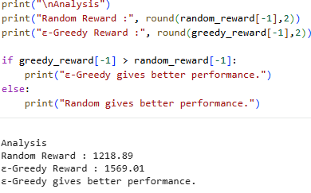
Result
The ε-Greedy strategy achieved higher cumulative rewards than Random Action Selection. The experiment showed that balancing exploration and exploitation leads to better long-term performance than selecting actions randomly.

