Final Report
Project Overview
I worked on analysing customer churn in a telecommunications dataset. The goal of this project was to predict customer churn and identify the customer characteristics most related to churn. The dataset had about 7,000 customer records, and the task was a binary classification problem where each customer was labelled as churned or not churned.
Data Preparation
The dataset included customer information like demographics, account details, service subscriptions, and billing data. Before training the model, I removed customer_id because it does not help in prediction. While checking missing values, I noticed blank entries in the TotalCharges column. At first they did not appear as nulls because the column was stored as text, but after converting it to numeric, 11 null values appeared and I removed those rows. I also encoded categorical variables and scaled the main numerical columns before training the network.
What I Found in the Data
While exploring the data, I noticed a few important patterns. First, customers with month-to-month contracts were more likely to churn compared to those with longer contracts. Second, newer customers (with less tenure) were more likely to leave than longer-term customers. These patterns were useful because they showed which customer groups were more likely to leave and helped me interpret the model results later.

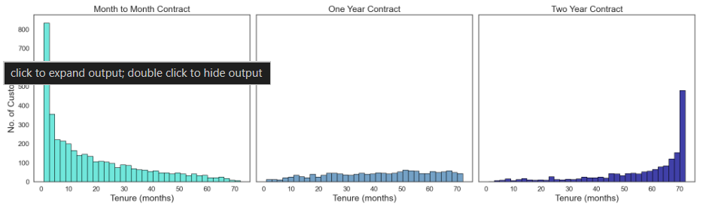

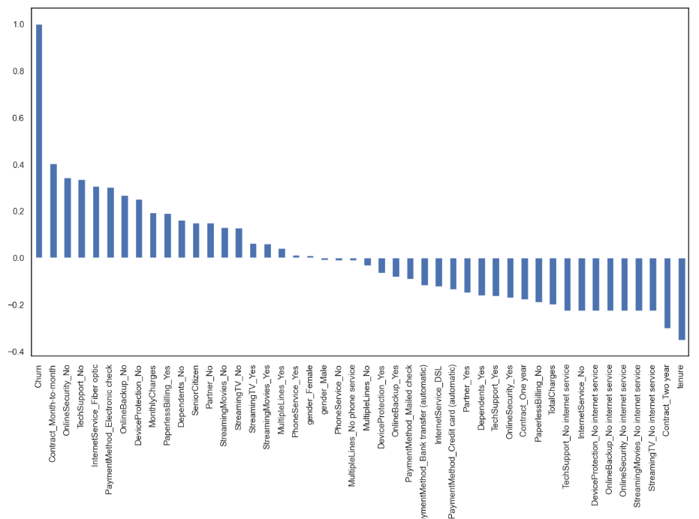
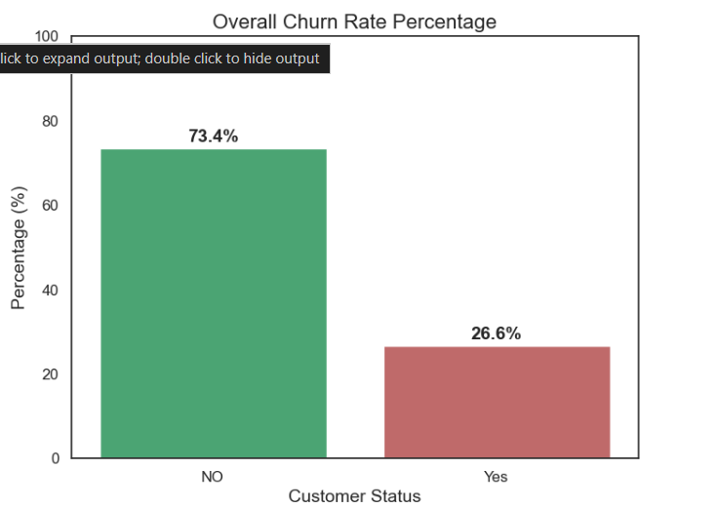

Building the Neural Network
I built a simple feed forward neural network with two hidden layers containing 16 and 8 neurons. I used ReLU in the hidden layers and Adam as the optimizer. I also enabled early stopping so that training would stop once the validation score stopped improving.. Adam was used as the optimizer, and I enabled early stopping to avoid over fitting. The model was allowed to train for up to 300 iterations, but in practice it stopped much earlier, around 20 iterations, because early stopping was triggered.
Model Results
The training loss decreased sharply in the beginning and then became more stable, which suggests that the model was learning during training without continuing unnecessarily for too long.
On the test set, the model achieved 80% accuracy overall. However, looking at the detailed metrics, the model was much better at identifying customers who don't churn (precision 0.83, recall 0.91, F1-score 0.87) compared to customers who do churn (precision 0.66, recall 0.49, F1-score 0.57). This shows that the model performed better on non-churn customers than on churn customers, and missing many real churn cases is an important limitation.
The confusion matrix showed that out of 374 actual churn customers, the model correctly identified 185 but missed 189. This matters from a business perspective because customers who are likely to leave may not be identified in time for retention efforts.
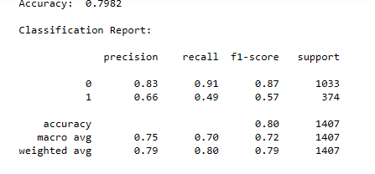

What This Means for Business
Based on the analysis, I would suggest focusing retention efforts on high-risk customers.
Customers with month-to-month contracts, shorter tenure, and higher monthly charges appear to be at higher risk of churn. Offering targeted plans, discounts, or early support to these customers may help reduce customer loss.

