
RUNGTA COLLEGE OF ENGINEERING & TECHNOLOGY
Bhilai, Chhattisgarh

MINOR PROJECT REPORT
ON
CUSTOMER SEGMENTATION USING K-MEANS CLUSTERING

Submitted in partial fulfilment of the academic requirements
for the Minor Project in Artificial Intelligence / Machine Learning

Submitted by
Surendra Kumar Rana
ERP / Student ID: 6605507

Department of Computer Science and Engineering
Academic Session: 2026–2027

DECLARATION
I, Surendra Kumar Rana (ERP: 6605507), declare that this minor project report titled “Customer Segmentation Using K-Means Clustering” has been prepared for academic purposes. The report describes analysis using the Mall Customer Segmentation dataset, Python-based data analysis, and the K-Means clustering method. Sources used for the dataset and project reference are acknowledged in the references section.
Student Signature: __________________________
Date: __________________ Place: Bhilai, Chhattisgarh

ACKNOWLEDGEMENT
I would like to express my sincere gratitude to Rungta College of Engineering & Technology and the Department of Computer Science and Engineering for providing the academic environment to undertake this minor project. I am also thankful to the creators of the publicly available Mall Customer Segmentation dataset and learning resources that helped me understand the workflow. This project gave me practical exposure to data exploration, visualization, feature scaling, and unsupervised machine learning.

ABSTRACT
Customer segmentation is a practical way to understand that different customers may have different spending patterns. This project applies K-Means clustering to the Mall Customer Segmentation dataset, containing 200 customer records. Annual income and spending score are selected as the main clustering features. The workflow includes data inspection, exploratory data analysis, feature standardization, the Elbow Method, silhouette evaluation, clustering, and interpretation. With five clusters and a fixed random seed, the reproduced analysis obtains a silhouette score of 0.555. The resulting groups can support exploratory marketing ideas, although they should not be treated as definitive customer labels without additional business data.

TABLE OF CONTENTS
- Introduction
- Problem Statement and Objectives
- Dataset Description
- Tools and Technologies
- Methodology
- Exploratory Data Analysis
- K-Means Clustering and Cluster Selection
- Results and Discussion
- Limitations and Future Scope
- Conclusion
- References

1. INTRODUCTION
Businesses often serve customers with different needs, budgets, and shopping habits. Treating every customer in exactly the same way can make marketing less relevant. Customer segmentation groups customers with similar characteristics so an organisation can better understand its audience and plan suitable communication or offers.
In this project, K-Means, an unsupervised machine learning algorithm, is used to group mall customers based on annual income and spending score. The aim is not to predict a predefined answer, but to discover patterns in the data and interpret them in a useful way.

2. PROBLEM STATEMENT AND OBJECTIVES
Problem statement: How can a mall use basic customer information to identify groups with similar income and spending behaviour, and use those groups to explore more focused marketing strategies?
- Understand the structure and quality of the customer dataset.
- Explore age, gender, annual income, and spending-score distributions.
- Apply K-Means to annual income and spending score.
- Use the Elbow Method and silhouette score to assess candidate cluster counts.
- Visualize the clusters and centroids, and summarize their characteristics.
- Discuss possible business uses and the limitations of the analysis.

3. DATASET DESCRIPTION
The project uses the Mall Customer Segmentation dataset. It contains 200 rows and five columns and is intended for learning customer segmentation. It does not contain preassigned target labels.
Column | Meaning | Use in this project
CustomerID | Unique customer identifier | Not used for clustering
Gender | Recorded gender category | Exploratory analysis
Age | Customer age in years | Exploratory analysis
Annual Income (k$) | Annual income in thousands of dollars | Main clustering feature
Spending Score (1-100) | Mall-assigned score representing spending behaviour | Main clustering feature
The dataset contains 200 records. Mean age is 38.85 years, mean annual income is 60.56 thousand dollars, and mean spending score is 50.20. The dataset has 0 missing values.

4. TOOLS AND TECHNOLOGIES
- Python: primary programming language.
- Pandas and NumPy: data loading, cleaning, and numerical operations.
- Matplotlib and Seaborn: charts and exploratory visualizations.
- Scikit-learn: StandardScaler, KMeans, and silhouette_score.
- Google Colab / Jupyter Notebook: interactive execution environment.
- GitHub: project source-code repository.

5. METHODOLOGY
- Data loading: Load Mall_Customers.csv into a Pandas DataFrame.
- Data inspection: Review rows, columns, data types, summary statistics, missing values, and duplicates.
- Exploratory analysis: Plot gender counts and distributions of age, income, and spending score.
- Feature selection: Use annual income and spending score; exclude CustomerID because it is only an identifier.
- Feature scaling: Apply StandardScaler so features contribute on a comparable scale to distance calculations.
- Cluster selection: Plot inertia for K=1–10 and review silhouette scores for K=2–10.
- Model fitting: Fit K-Means with K=5, random_state=42, and n_init=10.
- Interpretation: Plot assigned clusters and centroids, summarize profiles, and export segmented data.

5.1 How K-Means works
K-Means starts with K centroid locations, assigns each observation to its nearest centroid, and recalculates each centroid as the mean of the assigned observations. These steps repeat until assignments or centroid positions stabilize. The algorithm seeks to reduce within-cluster sum of squares (inertia).

5.2 Why standardization is used
Income and spending score use different numeric ranges. StandardScaler transforms each feature to approximately zero mean and unit variance. This prevents a feature's raw scale from dominating distance calculations simply because of its units.

6. EXPLORATORY DATA ANALYSIS
Exploratory data analysis builds a basic understanding of the dataset before applying the model. The following figures were generated from the public 200-row Mall Customer dataset.
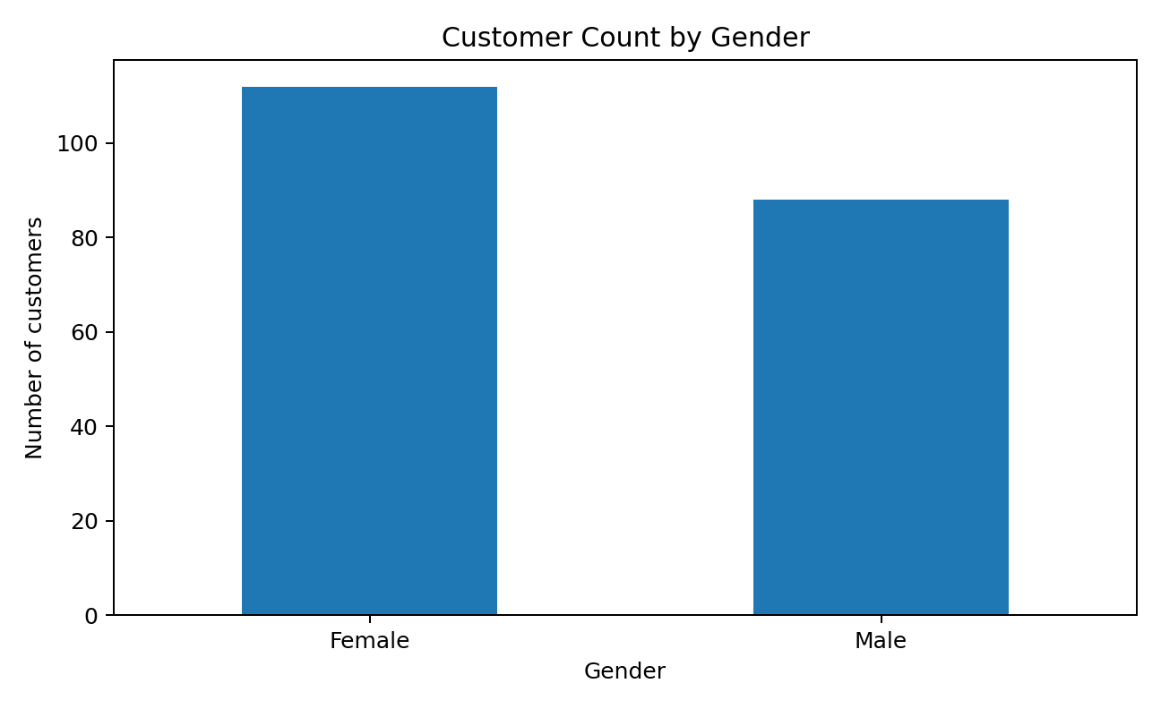
Figure 1. Distribution of customers by gender.
The dataset includes 112 female and 88 male records. Gender is used for exploratory analysis, not as a clustering feature.
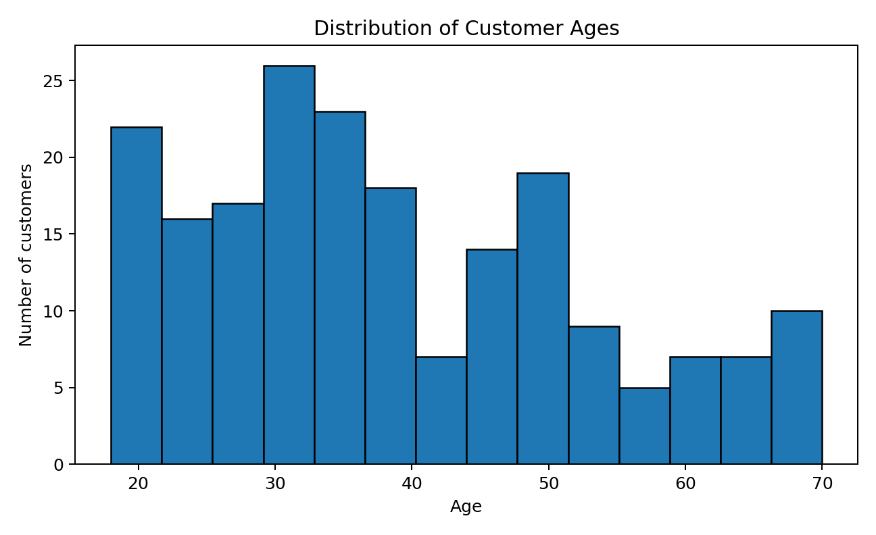
Figure 2. Age distribution across the customer sample.
The histogram shows the range and concentration of ages. Age is retained for descriptive analysis, while the primary clustering model uses income and spending score.
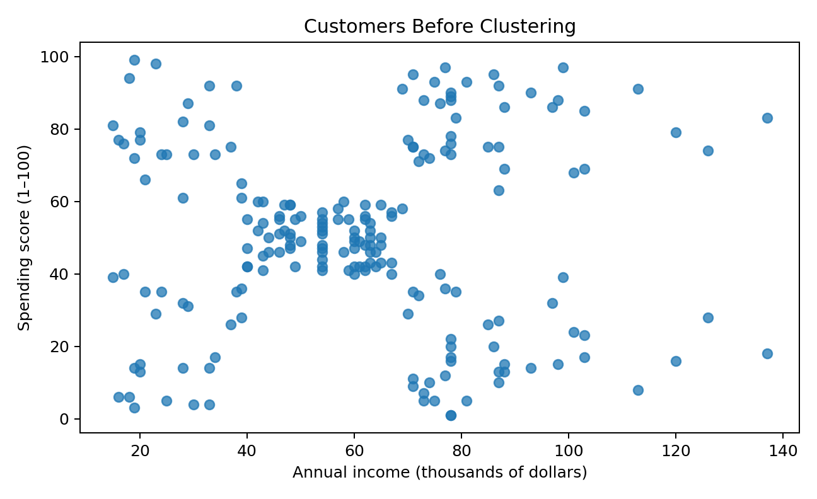
Figure 3. Annual income versus spending score before clustering.
The unclustered scatter plot shows that customers with similar income can have different spending scores, making the two-dimensional view useful for exploring customer groups.

7. K-MEANS CLUSTERING AND CLUSTER SELECTION

7.1 Elbow Method
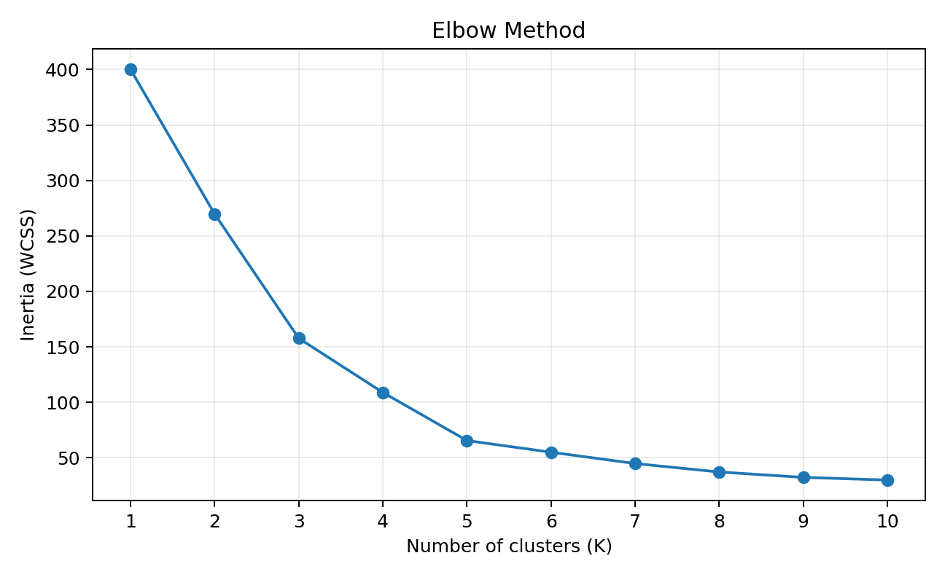
Figure 4. Elbow plot showing inertia for K=1 to K=10.
Inertia measures the total squared distance between observations and their assigned centroids. It decreases as K increases, so the goal is to identify a practical bend in the curve. K=5 is used here as a common, interpretable choice for this dataset.

7.2 Silhouette evaluation
For the five-cluster model, the silhouette score in this run is 0.555. Scores closer to 1 generally indicate better separation, scores near 0 indicate overlapping groups, and negative values may indicate questionable assignments. This is a clustering diagnostic, not classification accuracy.

7.3 Final clustering visualization
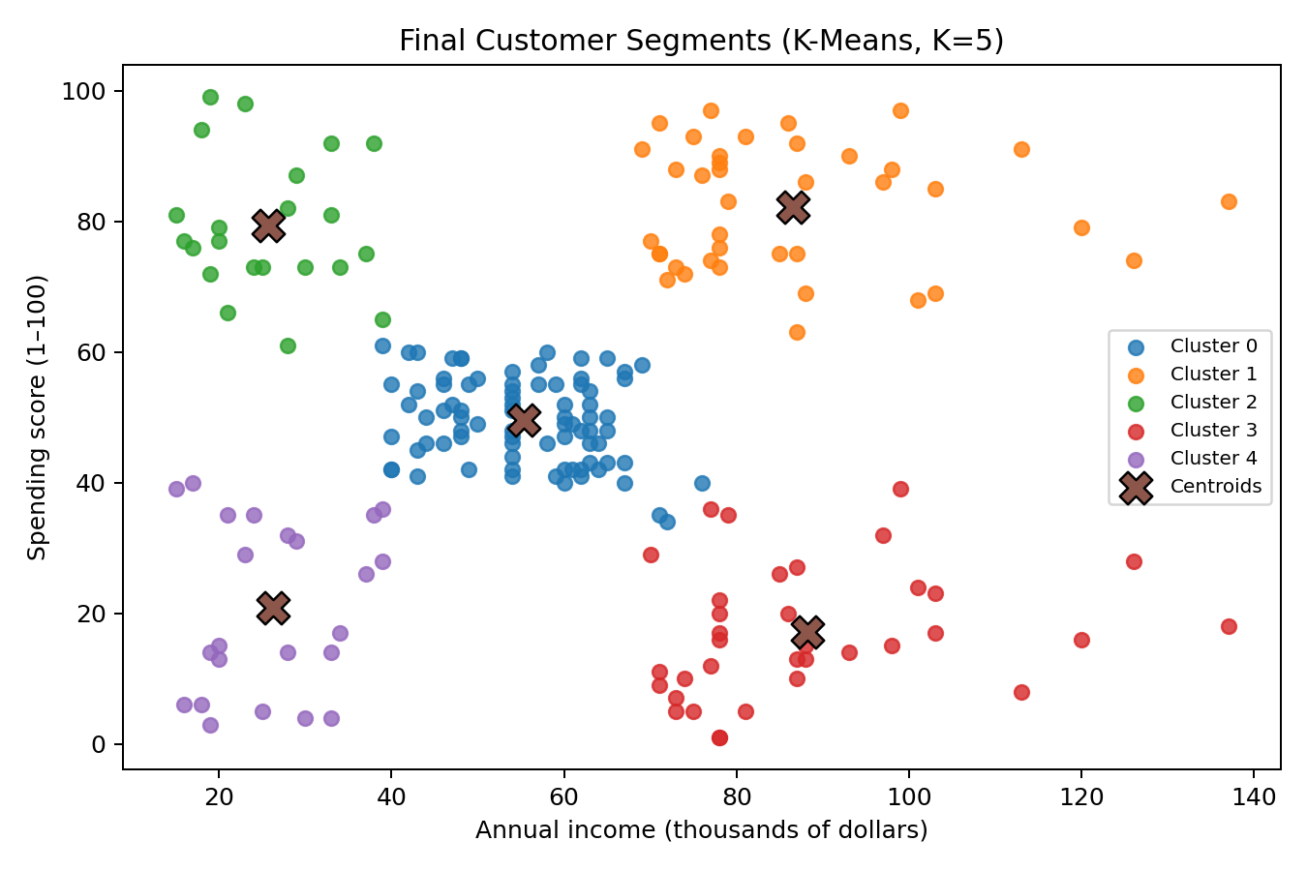
Figure 5. Customer groups and centroids using K-Means with K=5.
Each point represents a customer. Colours indicate the assigned cluster, while X markers indicate centroids mapped back to the original units. Cluster numbers are arbitrary labels, not rankings.

8. RESULTS AND DISCUSSION
The model assigned all 200 customers to five clusters. The final silhouette score was 0.555. The cluster sizes and average feature values are summarized below.
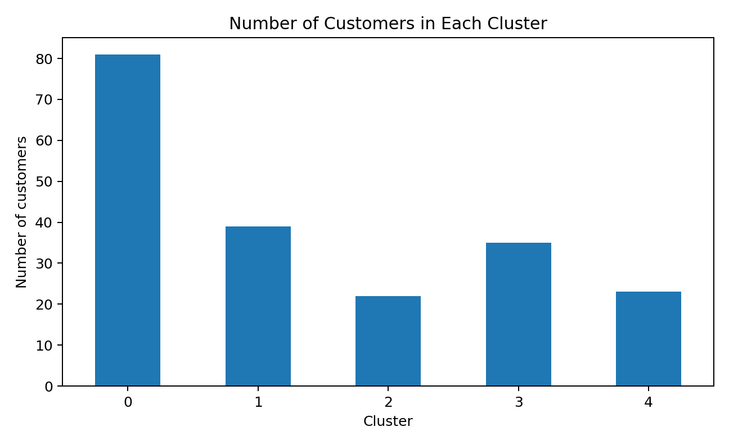
Figure 6. Number of customers assigned to each cluster.
Cluster | Customers | Share (%) | Avg. age | Avg. income (k$) | Avg. spending
0 | 81 | 40.50 | 42.72 | 55.30 | 49.52
1 | 39 | 19.50 | 32.69 | 86.54 | 82.13
2 | 22 | 11.00 | 25.27 | 25.73 | 79.36
3 | 35 | 17.50 | 41.11 | 88.20 | 17.11
4 | 23 | 11.50 | 45.22 | 26.30 | 20.91
Profiles should be interpreted by comparing average income and spending score, not by assuming a cluster number has a fixed meaning. A group with relatively high income and spending may be a candidate for loyalty benefits, while a high-income group with lower spending may respond to tailored engagement. These are hypotheses that need validation with real campaign outcomes.

8.1 Practical implications
- Explore loyalty offers for customers with relatively high income and spending scores.
- Test personalized campaigns for customers with high income but lower spending scores.
- Consider value-focused offers for groups with lower average income.
- Review segment sizes before allocating marketing effort and refresh the analysis when new data becomes available.

9. LIMITATIONS AND FUTURE SCOPE
- The dataset has only 200 records and is primarily intended for educational use.
- The detailed business calculation behind the Spending Score is not provided.
- K-Means is sensitive to feature selection, scaling, initial centroids, and the chosen K.
- The analysis does not include transaction history, product preferences, customer lifetime value, or campaign outcomes.
- Future work could compare age-plus-spending and three-feature models, test alternative clustering algorithms, build an interactive dashboard, and validate marketing recommendations with real outcomes.

10. CONCLUSION
This minor project demonstrates an introductory workflow for customer segmentation using K-Means. The dataset was inspected and visualized, income and spending score were standardized, and five clusters were fitted and examined. The resulting plots and cluster profiles provide a practical way to discuss customer patterns and possible marketing approaches. The silhouette score of 0.555 is one measure of separation and should be considered alongside the plots and business context. Overall, the project provides hands-on experience with exploratory data analysis, preprocessing, unsupervised learning, evaluation, visualization, and interpretation.

REFERENCES
- Dataset reference notebook (Kaggle): https://www.kaggle.com/code/kushal1996/customer-segmentation-k-means-analysis
- Project source repository (provided by the student): https://github.com/SurendraRana77/Customer-Segmentation.git
- Public copy of Mall Customers CSV: https://github.com/harshjuly12/Customer-Segmentation-Using-K-Means-Clustering/blob/main/Mall_Customers.csv
- Scikit-learn KMeans documentation: https://scikit-learn.org/stable/modules/generated/sklearn.cluster.KMeans.html
- Scikit-learn silhouette score documentation: https://scikit-learn.org/stable/modules/generated/sklearn.metrics.silhouette_score.html
Before submission, review the report and add your project guide's name, signature, and any college-specific certificate required by your department.

