**Goal:** scrape all member data from 6 directories listed below:

1. [**https://search.itaa.be/nl-nl**](https://search.itaa.be/nl-nl) (about 16k members) (search for different letter combinations and extract all the results, then deduplicate them?) $200  
     
   Use the ‘beiden’ option to search for both people and companies:  
   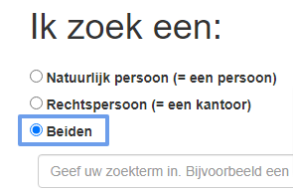  
   1. Data points for people  
      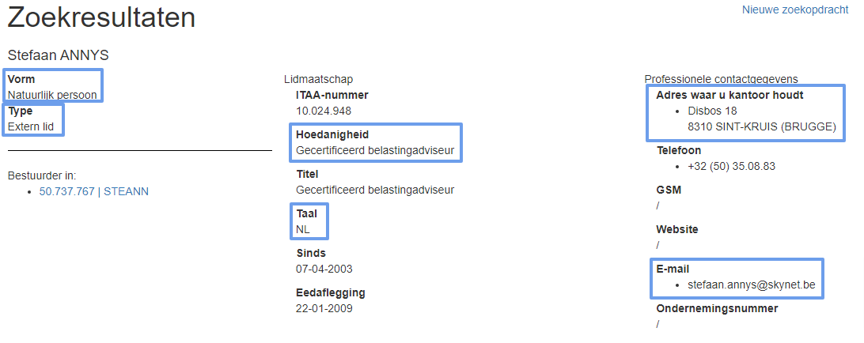
   2. Data points for companies  
      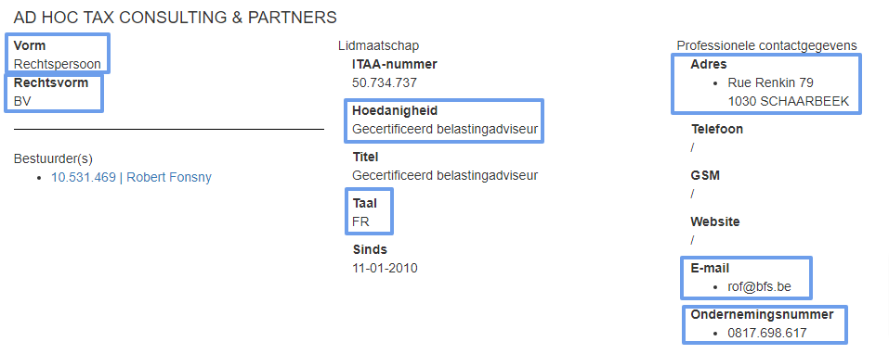
2. [**https://advocaat.be/zoek-een-advocaat/zoekresultaten?advancedsearch=1**](https://advocaat.be/zoek-een-advocaat/zoekresultaten?advancedsearch=1) (about 10k members) (search results are limited to 100 results, so probably need to search for different letter combinations too?) – 150$

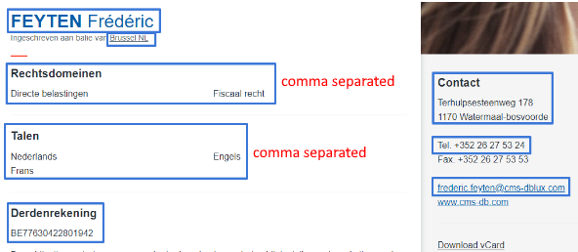

1. [**https://avocats.be/node/30**](https://avocats.be/node/30) (about 8k members) - just hit ‘Rechercher to view all records: $60  
   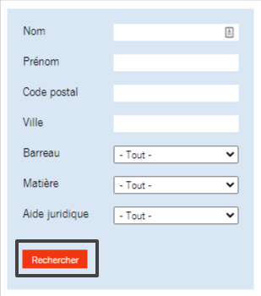

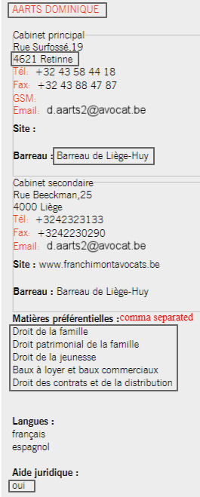

1. [**https://www.fbc-cfm.be/nl/zoeken-naar-een-bemiddelaar**](https://www.fbc-cfm.be/nl/zoeken-naar-een-bemiddelaar) (about 1k members) - simple, just hit enter in the ‘Naam’ field to view all records $40  
   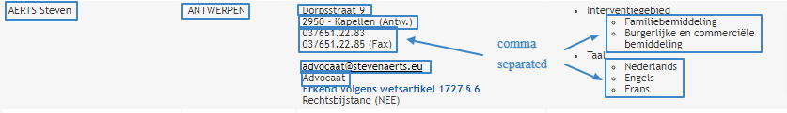
2. [**https://www.notaris.be**/](https://www.notaris.be/) (about 8k members) - click on ‘Adresboek’ in the top right corner, enter a zipcode from [this list](https://docs.google.com/spreadsheets/d/1oZCrHTy26UVRVs8DeJXx3_El0X_oyoFODKF7p6a-IcY/edit?usp=sharing) and search $100  
   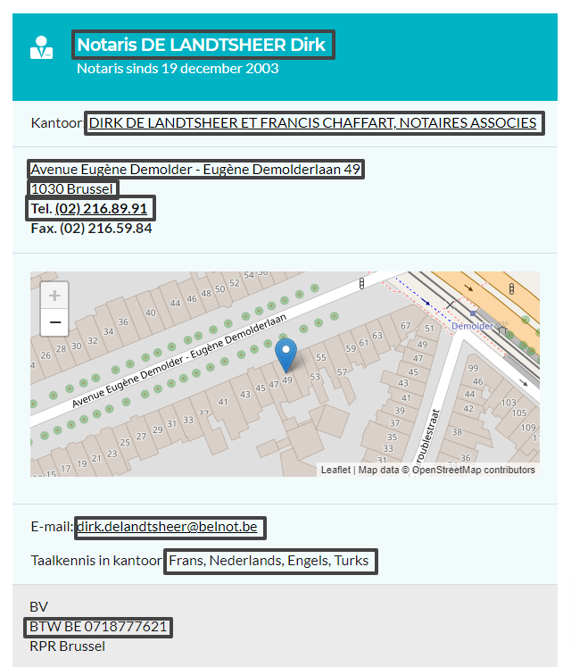
3. **<https://www.biv.be/de-vastgoedmakelaar/alle-vastgoedmakelaars-vind-je-hier>** - use this field to search by zipcode (use the zipcode list from the previous point) $130  
   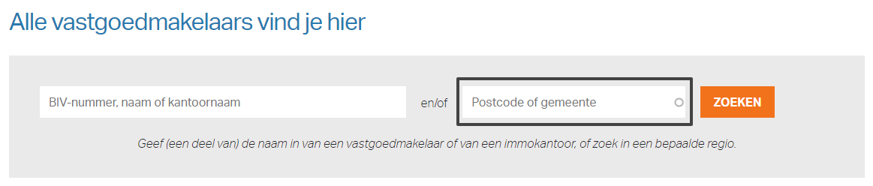  
   Data points needed:  
   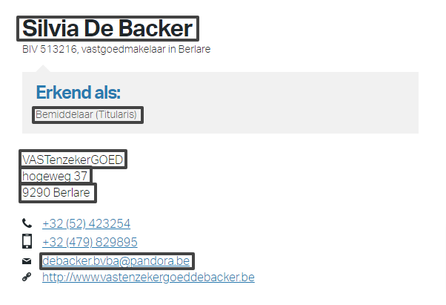

**Output format:** CSV

Need a quote for each of the 6 websites separately.