Power Factor improvement by simulation and implementation of FC-TCR

Surendra Tamang Vijaya Sharma Dhan Bahadur Khadka

*Department of Electrical Engineering Department of Electrical Engineering Department of Electrical Engineering*

# Pashchimanchal Campus Pashchimanchal Campus Pashchimanchal Campus

Lamachaur, Pokhara Lamachaur, Pokhara Lamachaur, Pokhara 72bel240@gmail.com vijayasharma21@gmail.com sagar.me@gmail.com

|  |  |
| --- | --- |
| Yogesh Karki  *Department of Electrical Engineering*  *Pashchimanchal Campus*  Lamachaur, Pokhara iamyogen@gmail.com | Rajendra Dhakal  *Department of Electrical Engineering*  *Lecturer*  *Pashchimanchal Campus*  Lamachaur, Pokhara |

*Abstract*—The Electricity generation has been changing with the development of new techniques. Reactive Power compensation is required to change the natural electrical characteristics of the transmission line to make it more compatible with the prevailing load demand. The purpose of this paper presents the modeling and simulation of Static Var Compensator (SVC) in power system studies by MATLAB. SVC is basically a shunt connected static var generator whose output is adjusted to exchange capacitive or inductive current so as to maintain or control specific power variable. For this a Single Machine Infinite Bus (SMIB) system is modeled. In this paper, simple circuit model of Fixed Capacitor Thyristor Controlled Reactor is modeled and simulated. The simulation results are presented. The current drawn by the FCTCR varies with the variation in the firing angle.

*Index Terms*—FACTS, FC-TCR, SVC, SIMULINK, TCR

1. INTRODUCTION

The power system is an interconnection of generating units to load centers through high voltage electric transmission lines and in general is mechanically controlled. With the ongoing expansion and growth of electric utility industry, including deregulation in many areas, numerous changes are continuously developed. Also, expansion of transmission system is always not possible. Due to these restrictions the whole power system is working to their maximum capacity which can lead to instability and blackouts under any severe fault conditions. To provide stable, secure, controlled, high quality electric power on today’s environment and to do better utilization of available power system capacities Flexible AC transmission systems (FACTS) controllers are employed to enhance power system stability in addition to their main function of power flow control. The dynamic behavior of industrial loads requires the use of compensator that can be adapted to load changes. Unfortunately, the techniques frequently used for compensation are based on circuit controllers that alter the waveform of the signal subjected to control. Such is the case of the static compensator [1], [2], which must perform harmonic cancellation, reactive power compensation, power factor correction, and energy saving. Although the static compensator is commonly used and studied under sinusoidal voltage conditions, waveforms corresponding to the controlled current present high harmonic content [9]. This paper focuses on microprocessor-based approach to control the firing angle in thyristor-controlled reactor [3]. The voltage control and dynamic performance of power transmission system using SVC has been analyzed [4] and comparison of FACTS devices for power system stability enhancement Power System stability enhancement using FACTS controllers [5]-[[8]. A SIMULINK based approach of interactive Object-Oriented Simulation of Interconnected Power Systems [11] has been also done.

1. DESIGN & MODELLING OF FC-TCR

In steady state, the SVC will provide some steady-state control of the voltage to maintain it the highest voltage bus at the pre-defined level. If the voltage bus begins fall below its set point range, the SVC will inject reactive power (Q net) into the system (within its control limits), thereby increasing the bus voltage back to its desired voltage level. If bus voltage increases, the SVC will inject less (or TCR will absorb more) reactive power (within its control limits), and the result will be to achieve the desired bus voltage. The Fixed Capacitor Thyristor-Controlled Reactor (FC-TCR) is a var generator arrangement using a fixed (permanently connected) capacitance with a thyristor controlled reactors shown in Fig :a. The current in the reactor is varied by the previously discussed method of firing delay angle control. A filter network that has the necessary capacitive impedance at the fundamental frequency to generate the reactive power required usually substitutes the fixed capacitor in practice, fully or partially, but it provides low impedance at selected frequencies to shunt the dominant harmonics produced by the TCR. The fixed capacitor thyristor-controlled reactor type VAR generator may be considered essentially to consist of a variable reactor (controlled by a delay angle *α*) and a fixed capacitor. With

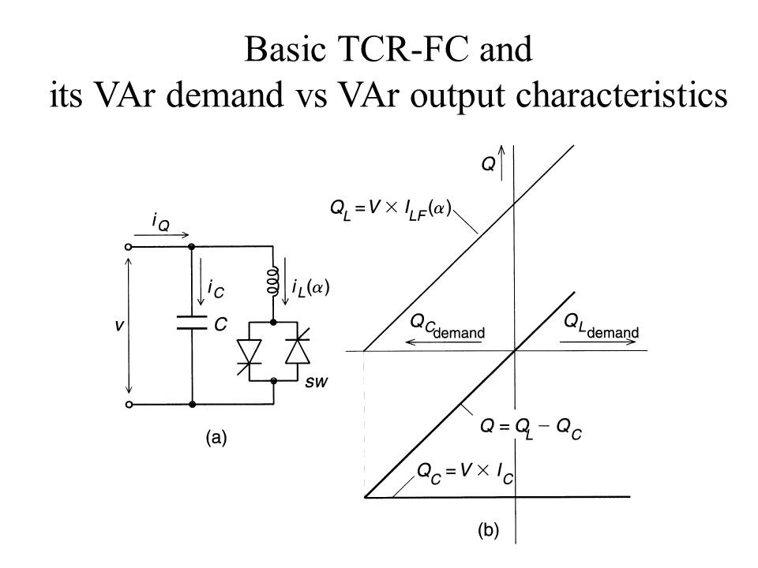

Fig. 1. : Structure of Basic FC-TCR

an overall VAR demand versus VAR output characteristic as shown in Fig.b in constant capacitive VARgenerator (Qc) of the fixed capacitor is opposed by the variable VAR absorption (QL) of the thyristor-controlled reactor, to yield the total VAR output (Q) required. At the maximum capacitive VAR output, the thyristor-controlled reactor is off *α*= 90 degree). To decrease the capacitive output, decreasing delay angle *α*. At zero VAR output increases the current in the reactor, the capacitive and inductive current becomes equal and thus the capacitive and inductive VARs cancel out. With a further decrease of angle *α*, the inductive current becomes larger than the capacitive current, resulting in a net inductive VAR output. At zero delay angles, the thyristor-controlled reactor conducts current over the full 180 degree interval, resulting in maximum inductive VAR output that is equal to the difference between the VARs generated by the capacitor and those absorbed by the fully conducting reactor.

In Fig.3 the voltage defines the V-I operating area of the FCTCR VAR generator and current rating of the major power components. To decrease the capacitive output, the current in the reactor is increased by decreasing delay angle *α*. At zero var output, the capacitive and inductive currents become equal and thus both the vars cancels out. With further decrease of angle *α*, the inductive current becomes larger than the capacitive current, resulting in a net inductive output.

# A. OPERATING PRINCIPLES AND MODELING OFFC-TCR

The control of thyristor –controlled reactor in the FC-TCR type var generator needs to provide four basic functions as shown in figure 4. One function is Synchronizing timing. This function is usually provided by a phase locked loop circuit

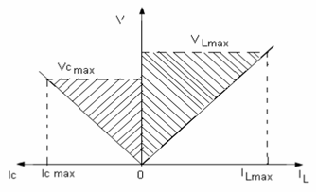

Fig. 2. : V-I characteristics of the FC-TCR type VAR Generator

that runs in synchronism with ac system voltage and generates appropriate timing pulses with respect to peak voltage.The second function is the reactive (or admittance ) to firing angle conversion. This can be provided by a real time implementation of the mathematical relationship between the amplitude of TCR current iLF (*α*) and the delay *α*. The third function is the computation of the required fundamental reactor current iLF , from the requested total output current Iq (sum total of the fixed capacitor and the TCR currents)defined by the amplitude reference input IQRef to the var generator control.The fourth function is the thyristor firing pulse generation. This is accomplished by the firing pulse generator (gate drive) circuit which produces thenecessary gate current pulse for thyristors to turn on in response to the output signal provided by the reactive current to firing angle converter. The current in the reactor can be controlled from maximum (SCR closed) to zero (SCR open) by themethod of firing delay angle control. That is, the SCR conduction delayed with respect to the peak of the applied voltage in each half-cycle, and thus the duration of the current conduction interval is controlled. When *α* = 0, the SCR closes at the crest of the applied voltage and evidently the resulting current in the reactor will be the same as that obtained in steady state with a permanently closed switch.

When the gating of the SCR is by an angle) with respect to the crest of the voltage, the current in the reactor can be expressed as follows

*V*(*t*) = *Vcosωt* (1)

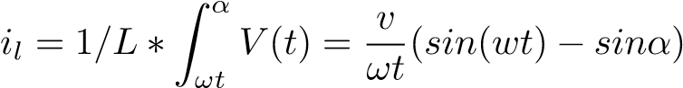 (2)

Since the SCR, by definition, opens as the current reaches zero, is valid for the interval *α* ≤ *ω*t ≤ *π* -*α*. For subsequent negative half-cycle intervals, the sign of the terms in equation (1) becomes opposite. In the above equation (1) the term (V/*ω*L) sin *α* = 0 is offset which is shifted down for positive and up for negative current half-cycles obtained at *α* = 0, as illustrated in Fig.3. Since the SCRs automatically turns off at the instant of current zero crossing of SCR this process actually controls the conduction intervals (or angle) of the

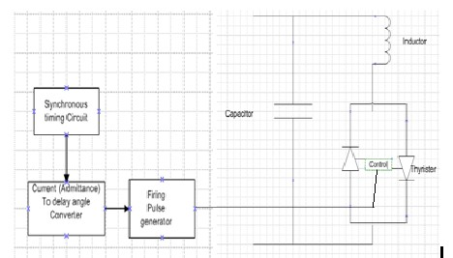

Fig. 3. : Figure 4: Basic Firing angle control of FC-TCR

SCR. That is, the delay angle *α* defines defines the prevailing conduction angle *α* (*α* = *π* - 2*α.* Thus, as the delay angle *α* increases, the corresponding increasing offset results in the reduction of the conduction angle *α* of the SCR, and the consequent reduction of the reactor current. At the maximum delay of *α* /2, the offset also reaches its maximum of V/*ω* L, at which both the conduction angle and the reactor current becomes zero. The two parameters, delay angle (*α)* and conduction angle (*σ)* are equivalent and therefore TCR can be characterized by either of them. For this reason, expression related to the TCR can be found both in terms of *α* and *σ.* It is evident that the magnitude of the current in the reactor varied continuously by delay angle control from maximum (*α* =0) to zero (*α* = *π*/2) shown in Fig.5, where the reactor current (*α)* together with its fundamental component (*α)* are shown at various delay angles *α* . Fig 5. Operating Wave The

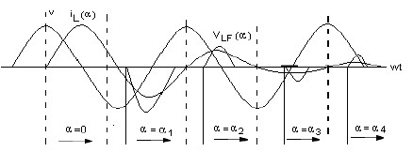

Fig. 4. : Figure 4: Basic Firing angle control of FC-TCR

amplitude ILF (*α*) of the fundamental reactor current iLF (*α*) can be expressed as a function of angle *α*.

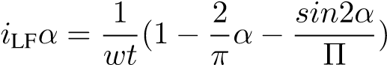 (3)

TCR can control the fundamental current continuously from zero (SCR open) to a maximum (SCR closed) as if it was a variable reactive admittance. Thus, an effective reactance admittance, BL *α*, for the TCR can be defined. This admittance, as a function of angle *α* is obtained as:

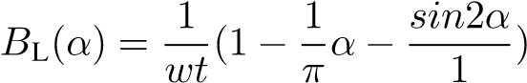 (4)

III. PROPOSED SYSTEM FRAMEWORK

Basically, in our project we are using SVC mainly for unifying power factor from no load to full load for any combination of inductive loads like motors. Thus, main focus is to make a variable capacitor generating reactive power to compensate the reactive power absorbed by inductive load like motor load. The variable capacitor can be made by using the thyristor-controlled reactor (TCR) and fixed capacitor (FC) commonly known as FC-TCR type SVC. For convenient and easy proposed we are mainly focusing of 10KW motor load and controlling it power factor for no load to full load. A FCTCR is used for controlling reactive power to the motor load from no load to full load and its power factor is nearly unified.

# A. general algorithm

* Step 1. Measurement of initial reactive power consumed by load
* Step 2. Calculation of required triac gate pulse using Arduino controller by coding.
* Step 3. Generation of reactive power using FC-TCR by suitable firing angle.
* Step 4. Displaying the VAR generated by FC-TCR for compensation of reactive power in LCD module.

IV. SIMULATION & RESULT

For simulation, three phase AC voltage source is taken of

100V ,50Hz. The parameters for load which is connected 100V, 50Hz of 10KW and 10 KVAR RL type fixed load. The source is connected by transmission line with fixed capacitor in parallel with thyristor-controlled reactor (TCR) branch with parallel load. Now for any load capacitor will continuously provide fix 10KVAR reactive power, so we have to compensate this by switching on the TCR, otherwise over compensation will occur. Here the reactive power of the load measured by 3 *v*Isin(fie) . So logic is that Q of load is subtracted from the Q of capacitor, so remaining Q will be required from the TCR. To get this Q from TCR we have to adjust *α*. After that total reactive power of star connected TCR =3*V*I To match this both value we rotate one loop in which *α* is continuously vary from 90°-180°. The measured active and reactive power is used to determine the power factor with the help MATLAB program. At starting where the system is not connected to compensator at power factor of 0.7071. When power factor improvement needed the FC-TCR circuit is connected to the system. It tries to acquire the approximate unity power factor.

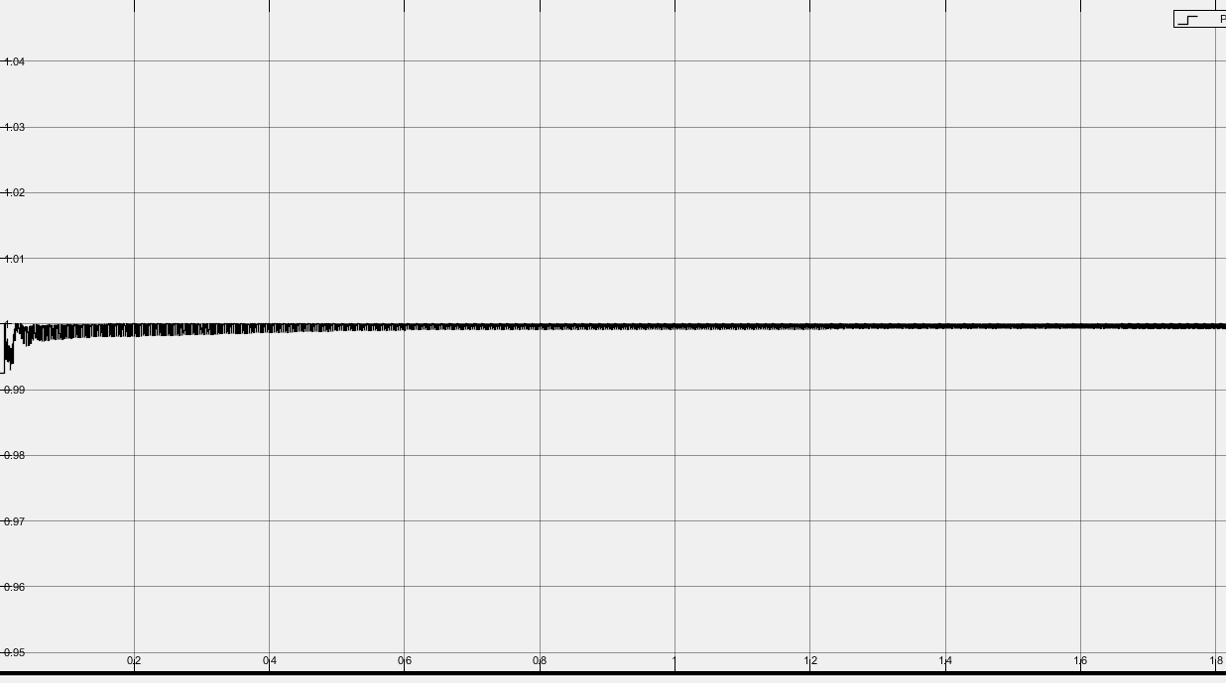

Fig. 5. : MATLAB SIMULATION RESULT IN WAVE

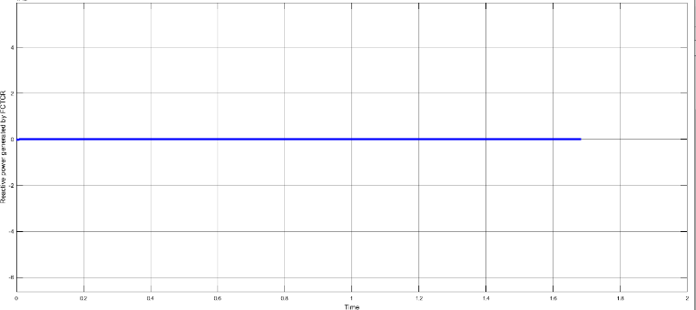

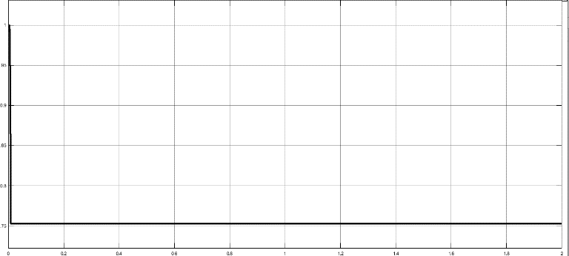

ma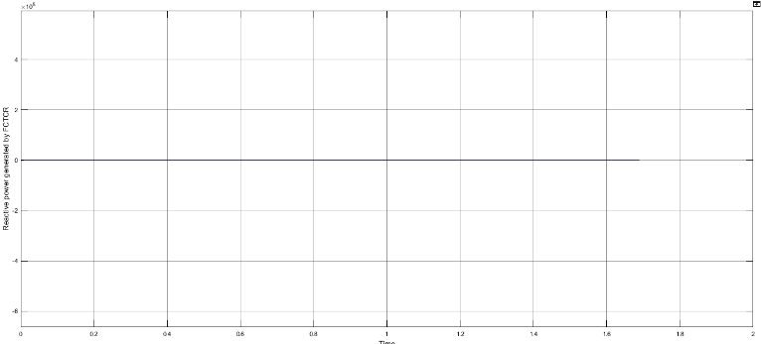

# A. RESULTS AND DISCUSSION

Matlab simution is done for various inductive loads at sending end voltage 100 volt. From this simulation,the power factor has improved from 0.7075 to unity.

Fig. 7. :PROTEUS SIMULATION WITH RESULT

V. CONCLUSION

From the simulation studies it is observed that the reactive power variation is smoother by using FC TCR system. Reactive power drawn by the load increases with FC-TCR, since the bus voltage increases. The control of reactive power in system using FC-TCR is analyzed. The variation of reactive power with the variation in the firing angle is studied. The range of reactive power control can be increased by using the combination of thyristor-controlled reactor and fixed Capacitor system. The circuit model for FC-TCR is obtained and the same is used for simulation using MATLAB Simulink. From the simulation studies it is observed that the reactive power variation is smoother by using FC TCR system with the power factor correction to approximately unity.

REFERENCES

1. S. Y. Lee, S. Bhattacharya, T. Lejonberg, A. Hammad, and S. Lefebvre, ”Detailed modeling of static VAR compensators using the electromagnetic transients program (EMTP),” IEEE Trans. on Power Delivery, vol. 7, no. 2, pp. 836-847, Apr. 1992.
2. G. G. Karady, ”Continuous regulation of capacitive reactive power

,”IEEE Trans. on power Delivery, vol. 7, no. 3, pp. 1466-73, Jul. 1992

1. A. Gomez, F. Gonzalez, C. Lzquierdo, T. Gonzalez, and F. Pozo,”Microprocessor based control of an SVC for optimal load Compensation,” IEEE Trans. on power Delivery, vol. 7, no. 2, pp. 706-712, Apr. 1992.
2. Narain G. Hingorani, Laszlo Gyugi “ Understanding FACTS” IEEE press.
3. Nang Sabai, and Thida Win “Voltage control and dynamic performance of power transmission system using SVC” World Academy of Science, Engineering and Technology,2008, Pp. 425-429.
4. M.A Abibo, “Power System stability enhancement using FACTS controllers” TheArabian Journal for Science and Engineering Volume 34, Pp. 153-161.
5. Eric Allen, NielsLaWhite, Yong Yoon, Jeffrey Chapman, and MarijaIlic ”Interactive Object-Oriented Simulation of Interconnected Power Systems Using SIMULINK,IEEE Transactionson Education,vol. 44, no.1, Feb.2001 .
6. “Power electronics” by P.S. Bhimbra.