**Home Page:**  Create New Entry option and View All the Entries of InventoryList

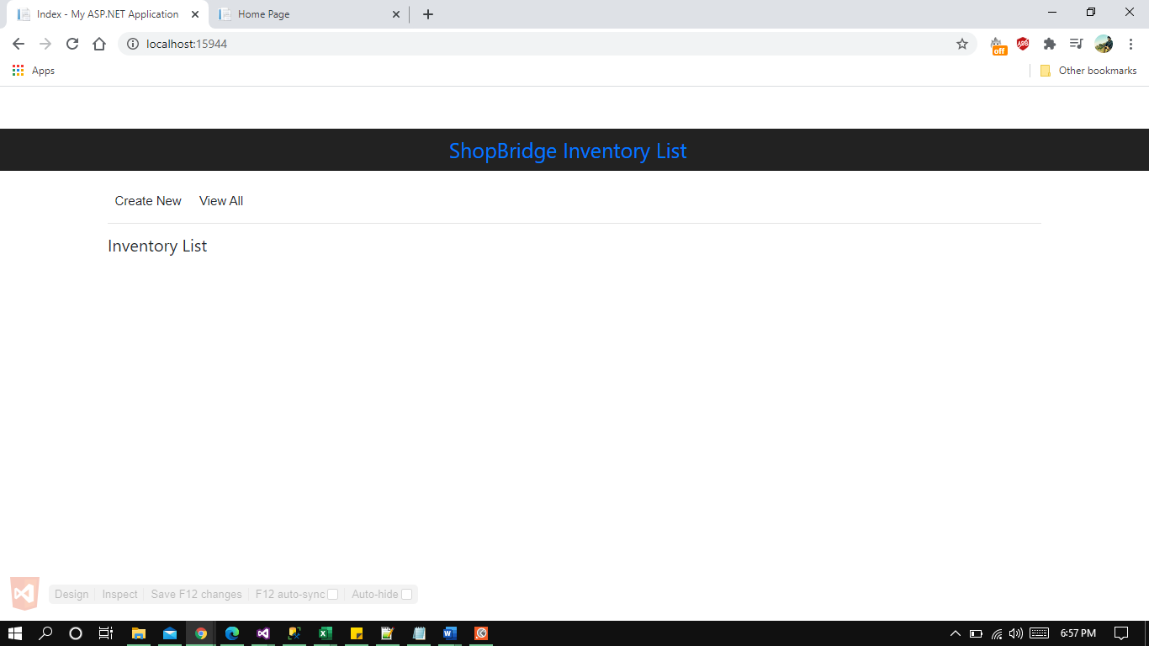

**Viewing All Entry In The Inventory:** Once clicked on View All

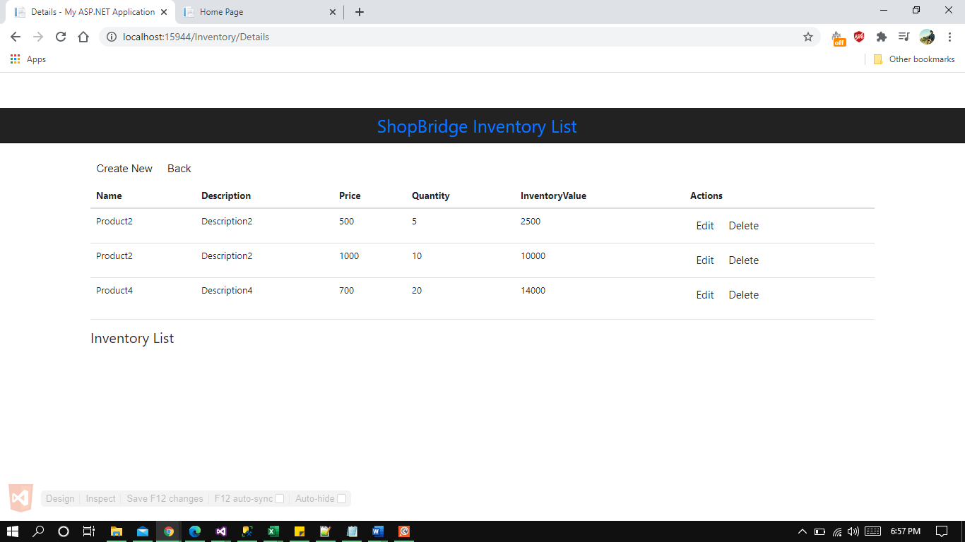

**Creating New Entry:** Clicked on Create New

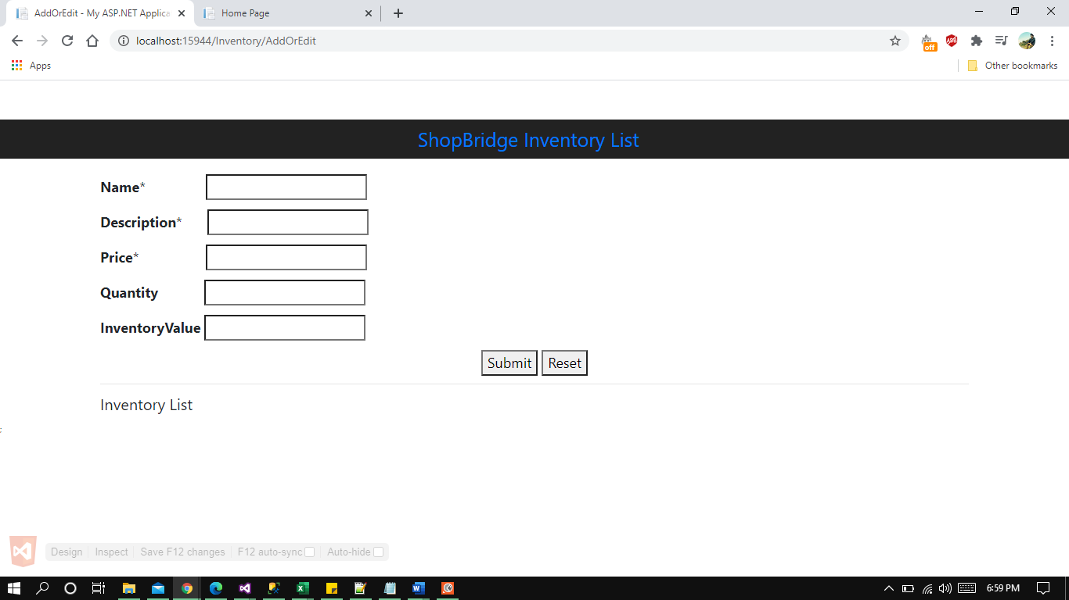

**Data Validation For Mandatory Fields:** Clicked on submit without values

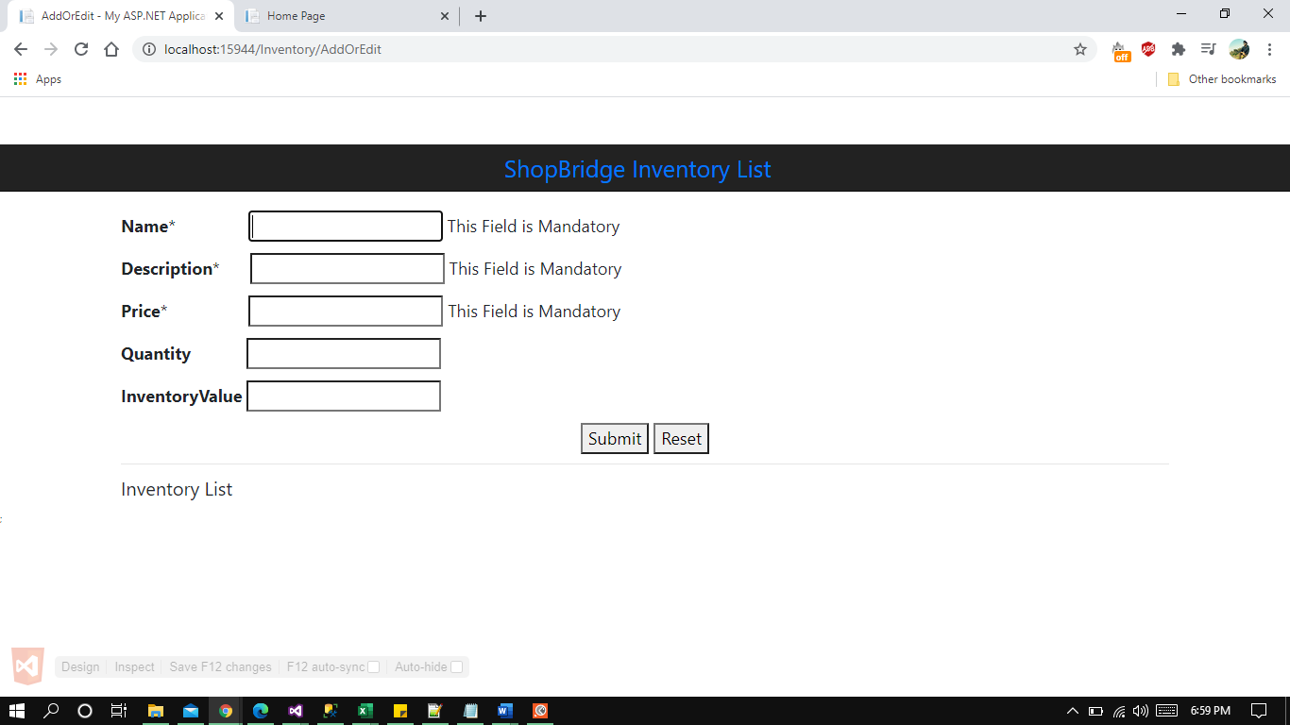

**Data Validation For Valid Integer Number:**

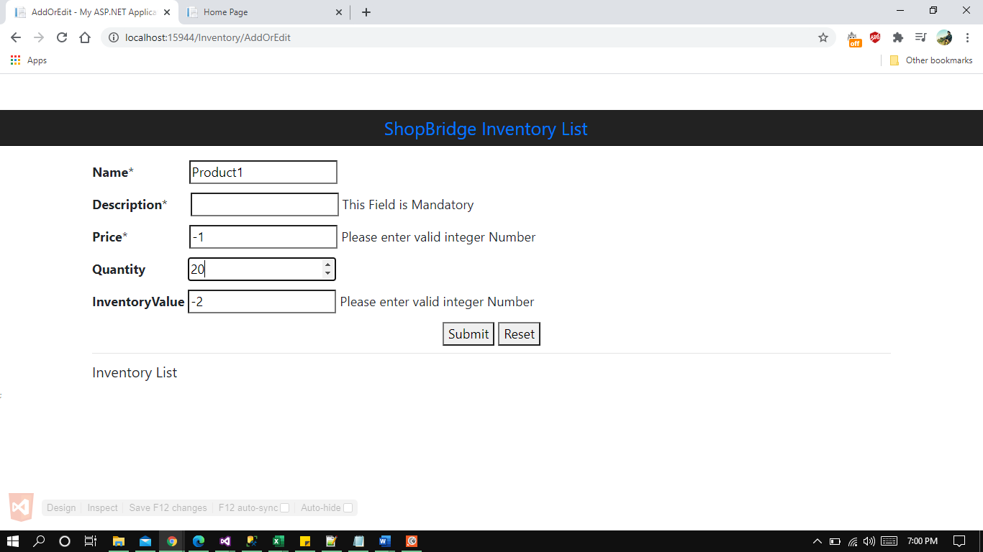

**New Entry Created:** After adding values and click on submit

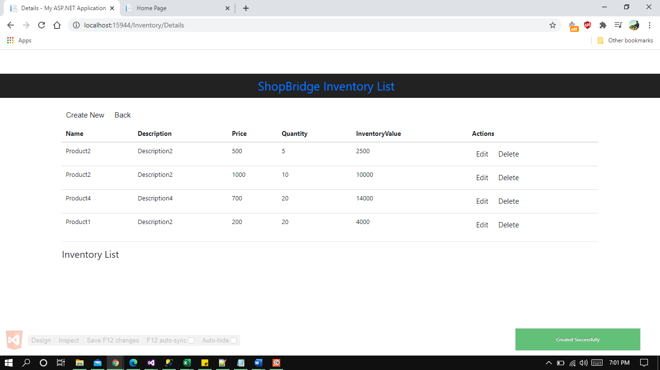

**Editing The Existing Entry From The List:** Clicking on Edit option on an entry

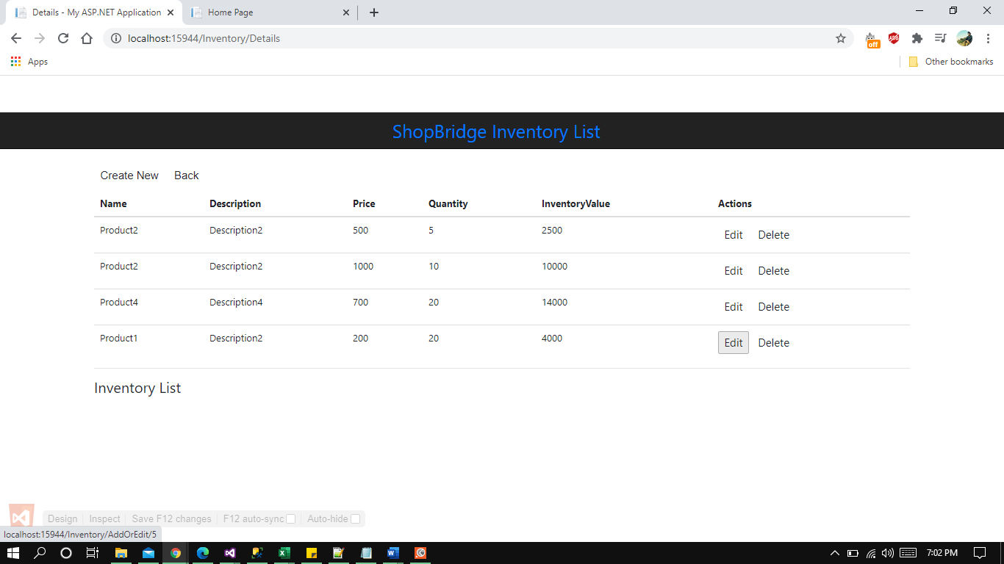

Changing Values of Existing Entry

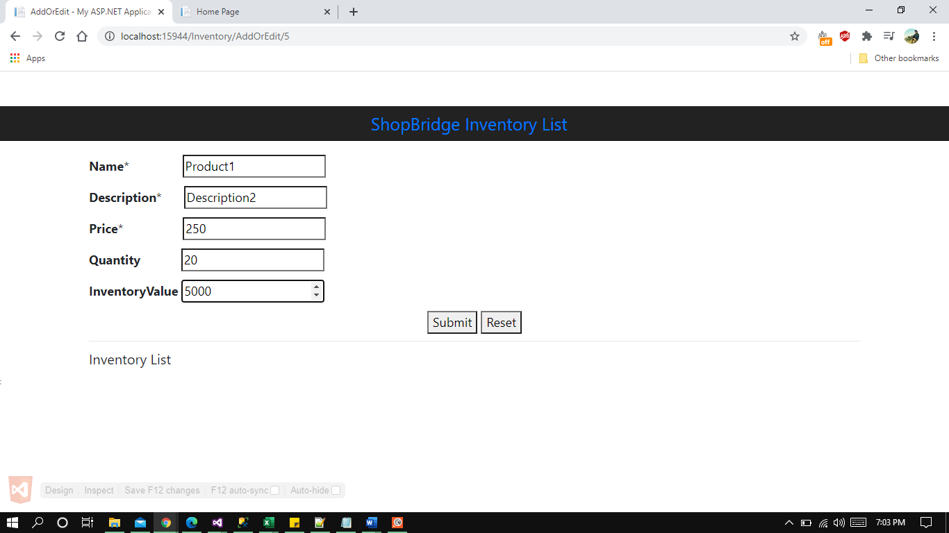

Updated Existing Entry

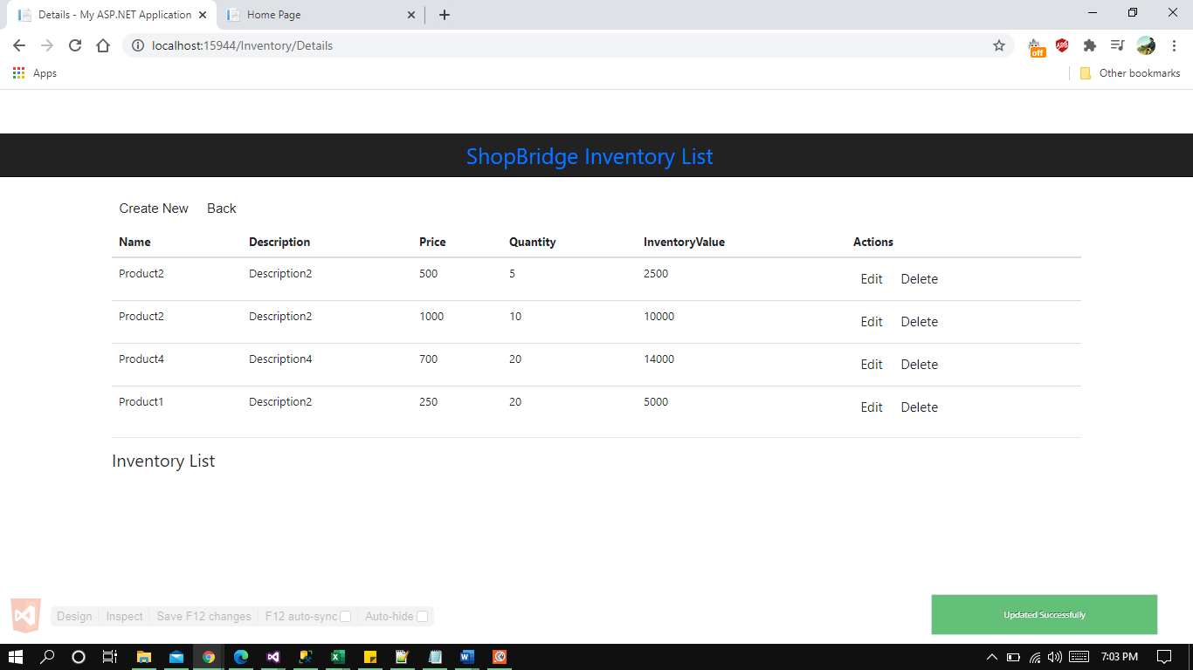

**Deletion of An Entry:**

