WEEKLY STATUS REPORT

From | ERUDITE IT PROFESSIONALS PVT. LTD.
Period | 22-Dec-2014 to 27-Dec-2014
Project | AUPL Services Support

- Weekly Calls Resolution Status (22-Dec-2014 to 27-Dec-2014)

  - Current Status (Including Backlog)

Group | Total Opened Including Backlog | Total Resolved | Pending
Priority 1 | 0 | 0 | 0
Priority 2 | 0 | 0 | 0
Priority 3 | 30 | 25 | 5
Total | 30 | 25 | 5

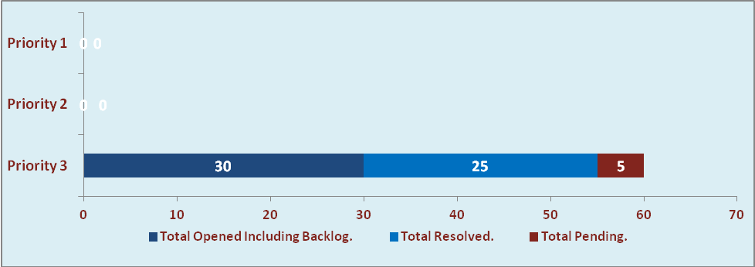

  - Current Tickets Status Distribution for the Week (22-Dec-2014 to 27-Dec-2014)

Distribution | Tickets
Finance | 12
Purchasing | 5
HRMS | 1
Custom | 9

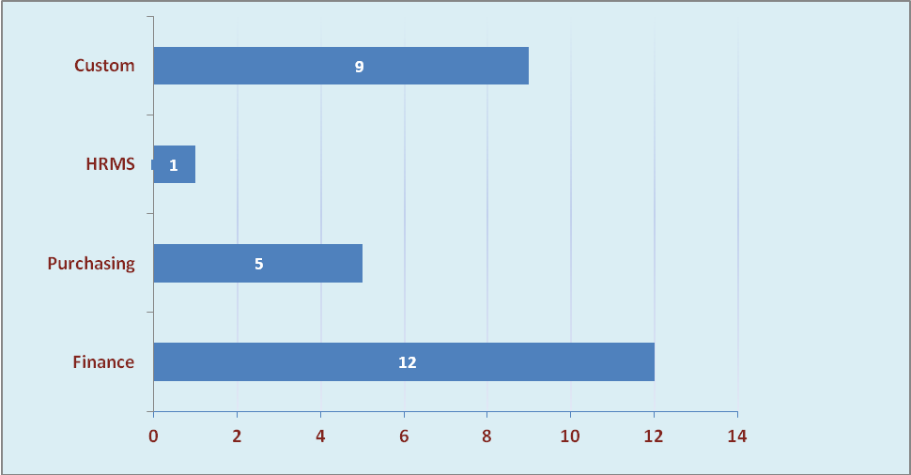

1.3 SLA Summary

Group | Total Tickets Resolved | Resolved within SLA | % SLA Achieved
Priority 1 | 0 | 0 | 0%
Priority 2 | 0 | 0 | 0%
Priority 3 | 25 | 23 | 92%
Total | 25 | 23 | 92%

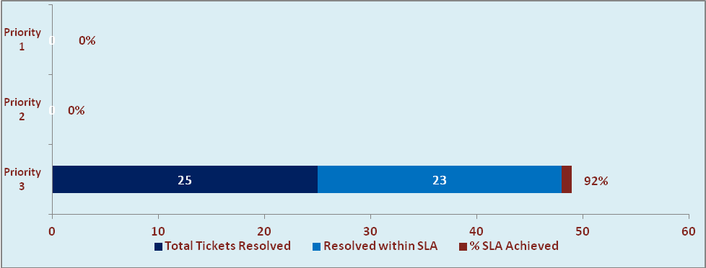

- Developments & Other Efforts

Hours | Effort (Hrs.) | Status | Delivered
Amar Ujala Consumption (General Stores) Report With Value | 12 | Test Instance | 26-12-2014
OM Setup (Mode of Selling of Books) | 10 | Test Instance
OM Reports | 32 | Work in Progress (Modification)
Total Efforts | 54

- Potential Bottlenecks

- The current Oracle version needs upgrade. The current version has bugs and in case of critical issues, Oracle does not respond properly due to old version.
- Lack of DR site can lead to major downtime in case of any breakdown.

