WEEKLY STATUS REPORT

From | ERUDITE IT PROFESSIONALS PVT. LTD.
Period | 29th -Dec-2014 to 3rd -Jan-2015
Project | AUPL Services Support

- Weekly Calls Resolution Status (29th -Dec-2014 to 3rd -Jan-2015)

  - Current Status (Including Backlog)

Group | Total Opened Including Backlog | Total Resolved | Pending
Priority 1 | 0 | 0 | 0
Priority 2 | 1 | 1 | 0
Priority 3 | 41 | 37 | 4
Total | 42 | 38 | 4

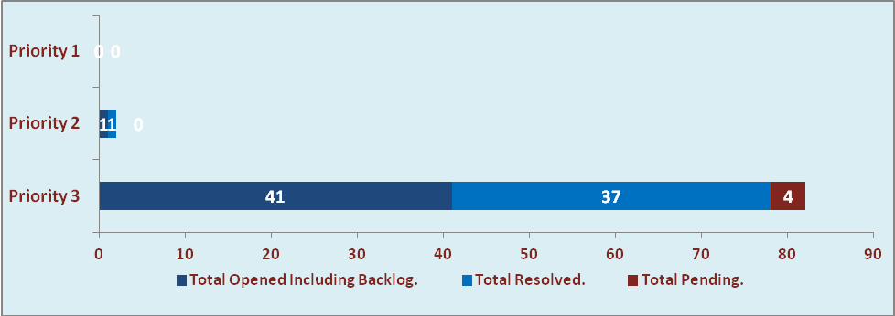

  - Current Tickets Status Distribution for the Week (29th -Dec-2014 to 3rd -Jan-2015)

Distribution | Tickets
Finance | 10
Purchasing | 4
DBA | 1
Adpro | 1
HRMS | 4
Custom | 20

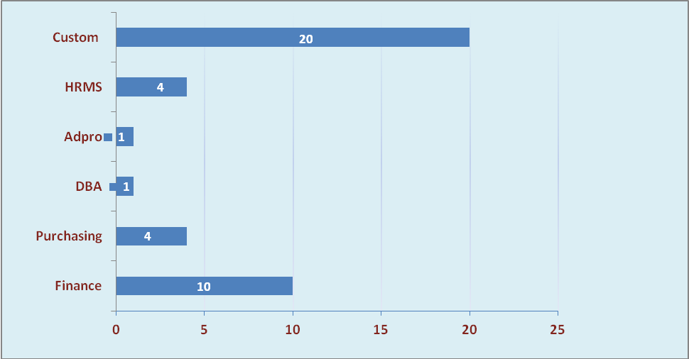

1.3 SLA Summary

Group | Total Tickets Resolved | Resolved within SLA | % SLA Achieved
Priority 1 | 0 | 0 | 0%
Priority 2 | 1 | 1 | 100%
Priority 3 | 37 | 35 | 95%
Total | 38 | 36 | 95%

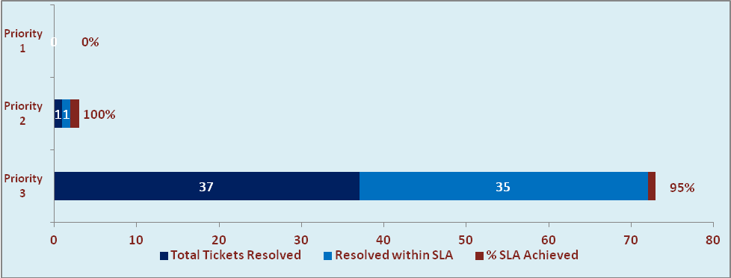

- Developments & Other Efforts

Hours | Effort (Hrs.) | Status | Delivered
Vehicle Rent module Payment details | 32 | Production | 5th Jan 2014
Amar Ujala Payroll General MIS Report - HRMS  (Add new Column) | 10 | Test Instance | 5th Jan 2014
Bill Format Report | 24 | Test Instance | 1st Jan 2014
OM Reports | 12 | Test Instance
Total Efforts | 78

- Potential Bottlenecks

- The current Oracle version needs upgrade. The current version has bugs and in case of critical issues, Oracle does not respond properly due to old version.
- Lack of DR site can lead to major downtime in case of any breakdown.

