WEEKLY STATUS REPORT

From | ERUDITE IT PROFESSIONALS PVT. LTD.
Period | 05th-Jan-2015 to 10th -Jan-2015
Project | AUPL Services Support

- Weekly Calls Resolution Status (05th Jan-2015 to 10th -Jan-2015)

  - Current Status (Including Backlog)

Group | Total Opened Including Backlog | Total Resolved | Pending
Priority 1 | 2 | 2 | 0
Priority 2 | 3 | 3 | 0
Priority 3 | 35 | 28 | 7
Total | 40 | 33 | 7

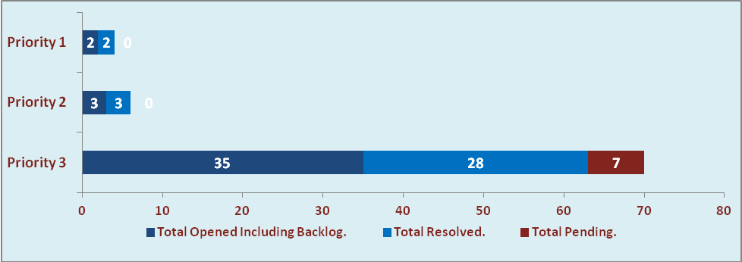

  - Current Tickets Status Distribution for the Week (05th -Jan-2015 to 10th -Jan-2015)

Distribution | Tickets
Finance | 17
Purchasing | 7
DBA | 2
Waste Mgt | 1
HRMS | 1
Custom | 10

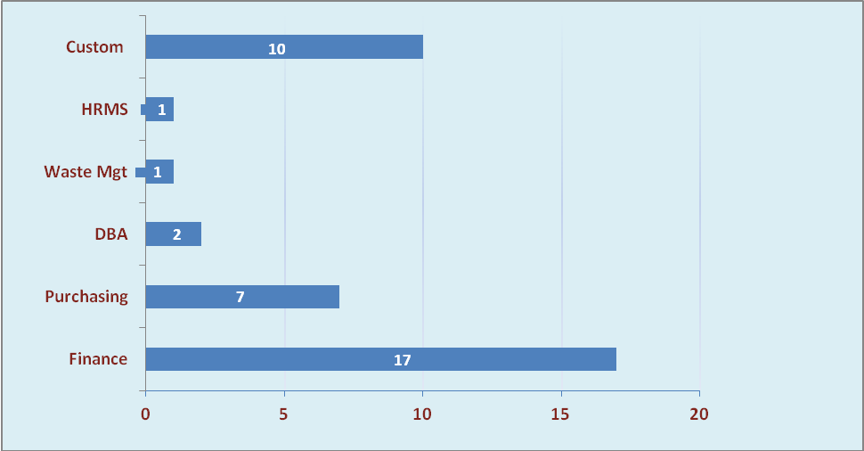

1.3 SLA Summary

Group | Total Tickets Resolved | Resolved within SLA | % SLA Achieved
Priority 1 | 2 | 2 | 100%
Priority 2 | 3 | 3 | 100%
Priority 3 | 28 | 25 | 89%
Total | 33 | 30 | 91%

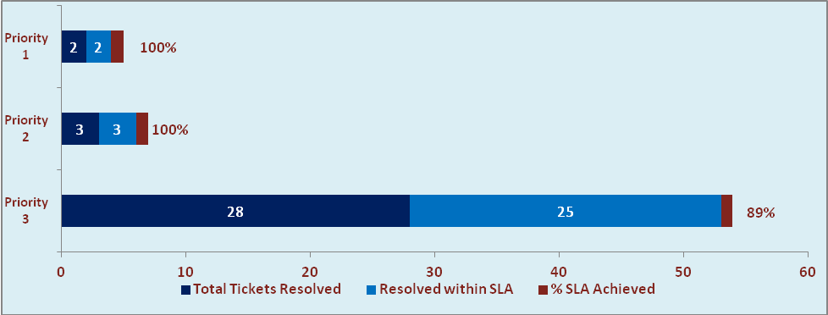

- Developments & Other Efforts

Hours | Effort (Hrs.) | Status | Delivered
Bill Format Report | 10 | Production | 6th Jan 2015
Car Lease Report | 24 | Production | 09th Jan 2015
Customer Balance Report | 08 | Production | 10th Jan 2015
New Event Summary Report | 16 | Test Instance | 12th Jan 2015
Total Efforts | 58

- Potential Bottlenecks

- The current Oracle version needs upgrade. The current version has bugs and in case of critical issues, Oracle does not respond properly due to old version.
- Lack of DR site can lead to major downtime in case of any breakdown.

