WEEKLY STATUS REPORT

From | ERUDITE IT PROFESSIONALS PVT. LTD.
Period | 12th-Jan-2015 to 17th -Jan-2015
Project | AUPL Services Support

- Weekly Calls Resolution Status (12th Jan-2015 to 17th -Jan-2015)

  - Current Status (Including Backlog)

Group | Total Opened Including Backlog | Total Resolved | Pending
Priority 1 | 0 | 0 | 0
Priority 2 | 1 | 1 | 0
Priority 3 | 43 | 38 | 5
Total | 44 | 39 | 5

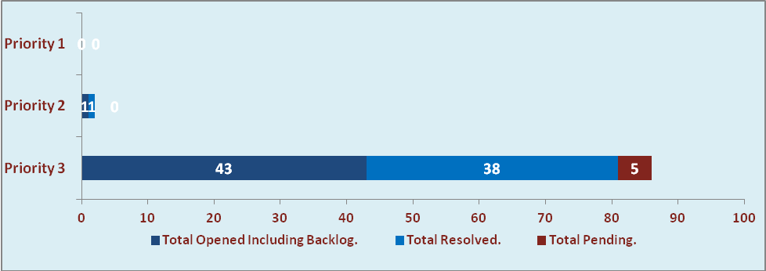

  - Current Tickets Status Distribution for the Week (12th -Jan-2015 to 17th -Jan-2015)

Distribution | Tickets
Finance | 16
Purchasing | 5
HRMS | 4
Custom | 17

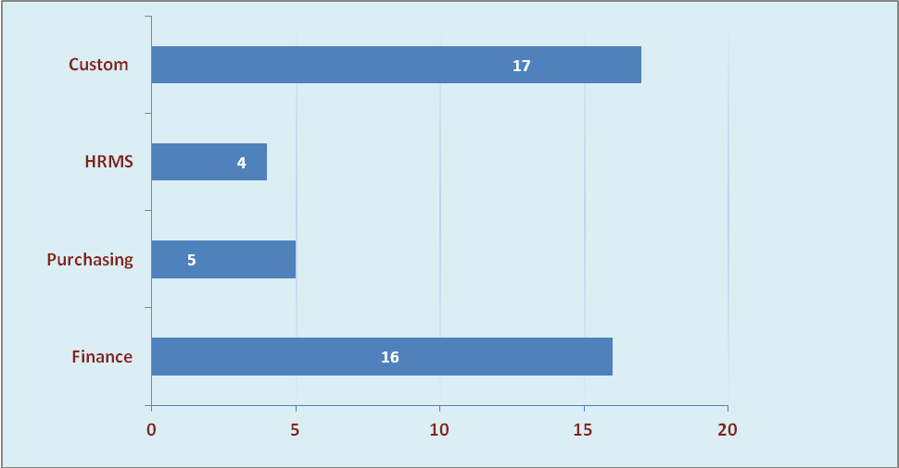

1.3 SLA Summary

Group | Total Tickets Resolved | Resolved within SLA | % SLA Achieved
Priority 1 | 0 | 0 | 0%
Priority 2 | 1 | 1 | 100%
Priority 3 | 38 | 34 | 89%
Total | 39 | 35 | 90%

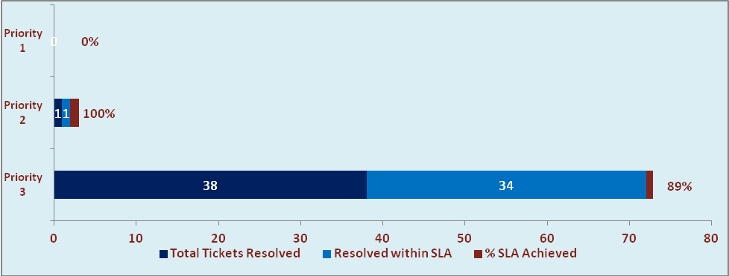

- Developments & Other Efforts

Hours | Effort (Hrs.) | Status | Delivered
New Event Summary Report | 05 | Production | 12th Jan 2015
Order Management | 50 | Production
Total Efforts | 55

- Potential Bottlenecks

- The current Oracle version needs upgrade. The current version has bugs and in case of critical issues, Oracle does not respond properly due to old version.
- Lack of DR site can lead to major downtime in case of any breakdown.

