WEEKLY STATUS REPORT

From | ERUDITE IT PROFESSIONALS PVT. LTD.
Period | 19th-Jan-2015 to 24th -Jan-2015
Project | AUPL Services Support

- Weekly Calls Resolution Status (19th Jan-2015 to 24th -Jan-2015)

  - Current Status (Including Backlog)

Group | Total Opened Including Backlog | Total Resolved | Pending
Priority 1 | 0 | 0 | 0
Priority 2 | 5 | 5 | 0
Priority 3 | 35 | 32 | 3
Total | 40 | 37 | 3

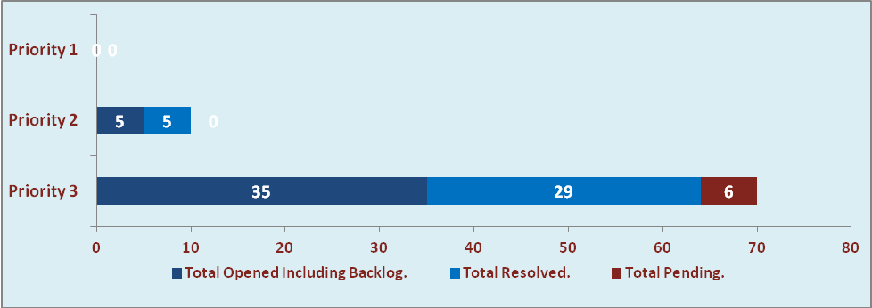

  - Current Tickets Status Distribution for the Week (19th -Jan-2015 to 24th -Jan-2015)

Distribution | Tickets
Finance | 14
Adpro | 1
Purchasing | 6
DBA | 2
Waste Mgt | 3
HRMS | 2
Custom | 9

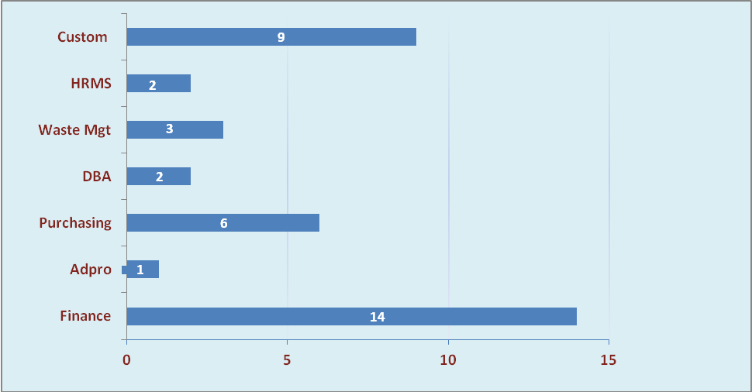

1.3 SLA Summary

Group | Total Tickets Resolved | Resolved within SLA | % SLA Achieved
Priority 1 | 0 | 0 | 0%
Priority 2 | 5 | 5 | 100%
Priority 3 | 32 | 29 | 91%
Total | 37 | 34 | 92%

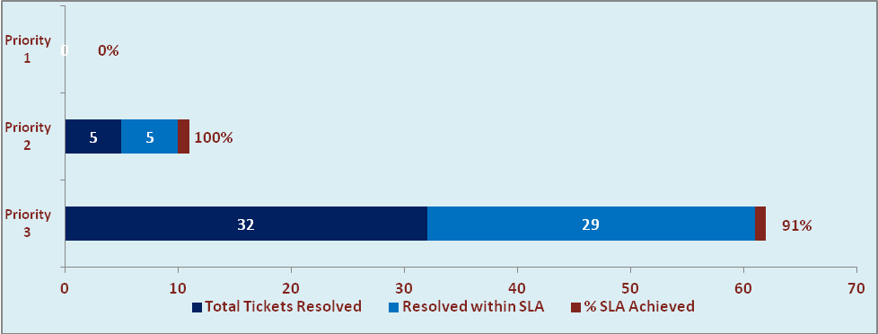

- Developments & Other Efforts

Hours | Effort (Hrs.) | Status | Delivered
WM - Purchase Report | 32 | Production | 24 Jan 2015
WM - Sales Report | 32 | Production | 24 Jan 2015
Total Efforts | 64

- Potential Bottlenecks

- The current Oracle version needs upgrade. The current version has bugs and in case of critical issues, Oracle does not respond properly due to old version.
- Lack of DR site can lead to major downtime in case of any breakdown.

