WEEKLY STATUS REPORT

From | ERUDITE IT PROFESSIONALS PVT. LTD.
Period | 26th-Jan-2015 to 31th -Jan-2015
Project | AUPL Services Support

- Weekly Calls Resolution Status (26th Jan-2015 to 31th -Jan-2015)

  - Current Status (Including Backlog)

Group | Total Opened Including Backlog | Total Resolved | Pending
Priority 1 | 0 | 0 | 0
Priority 2 | 2 | 2 | 0
Priority 3 | 42 | 35 | 7
Total | 44 | 37 | 7

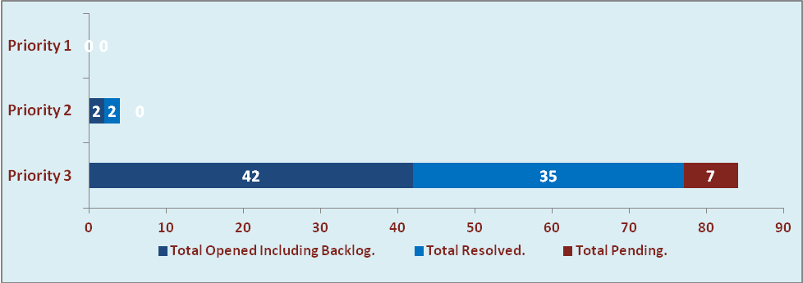

  - Current Tickets Status Distribution for the Week (26th -Jan-2015 to 31th -Jan-2015)

Distribution | Tickets
Finance | 16
Purchasing | 4
DBA | 3
HRMS | 3
Custom | 15

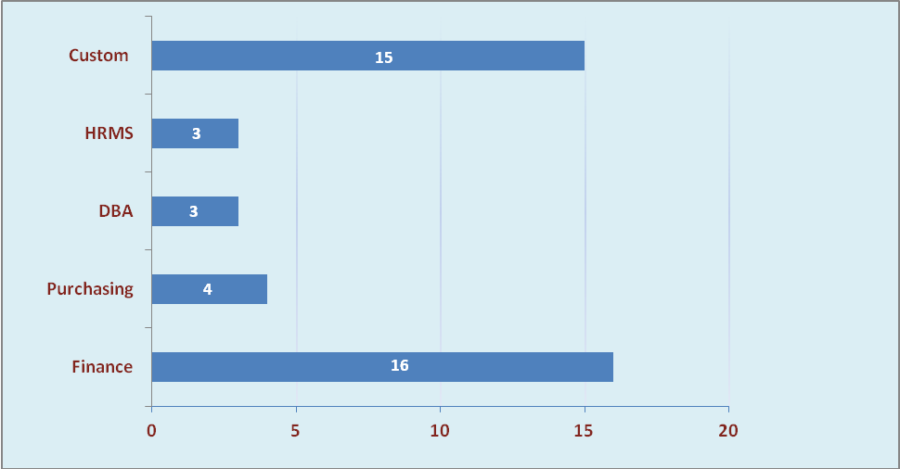

1.3 SLA Summary

Group | Total Tickets Resolved | Resolved within SLA | % SLA Achieved
Priority 1 | 0 | 0 | 0%
Priority 2 | 2 | 2 | 100%
Priority 3 | 35 | 32 | 91%
Total | 37 | 34 | 92%

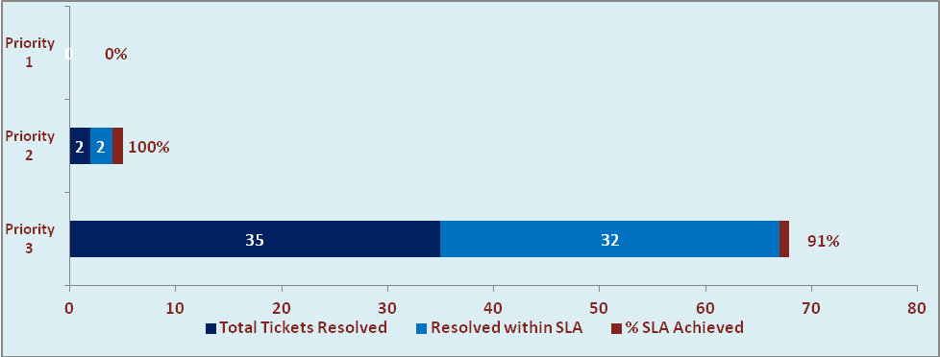

- Developments & Other Efforts

Hours | Effort (Hrs.) | Status | Delivered
Invoice output report | 16 | Production | 30-jan-2015
Bill Format Report | 10 | Work in progress
Employee Detail Report | 04 | Work in progress
Total Efforts | 30

- Potential Bottlenecks

- The current Oracle version needs upgrade. The current version has bugs and in case of critical issues, Oracle does not respond properly due to old version.
- Lack of DR site can lead to major downtime in case of any breakdown.

