WEEKLY STATUS REPORT

From | ERUDITE IT PROFESSIONALS PVT. LTD.
Period | 02nd Feb-2015 to 07th Feb-2015
Project | AUPL Services Support

- Weekly Calls Resolution Status (2nd Feb-2015 to 7th Feb-2015)

  - Current Status (Including Backlog)

Group | Total Opened Including Backlog | Total Resolved | Pending
Priority 1 | 0 | 0 | 0
Priority 2 | 1 | 1 | 0
Priority 3 | 43 | 35 | 8
Total | 44 | 36 | 8

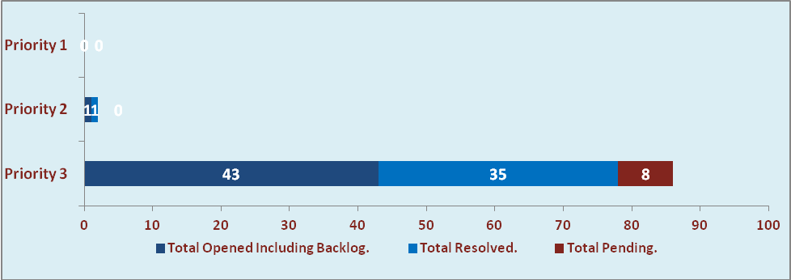

  - Current Tickets Status Distribution for the Week (02nd Feb-2015 to 07th Feb-2015)

Distribution | Tickets
Finance | 12
Purchasing | 07
DBA | 03
HRMS | 04
Custom | 11

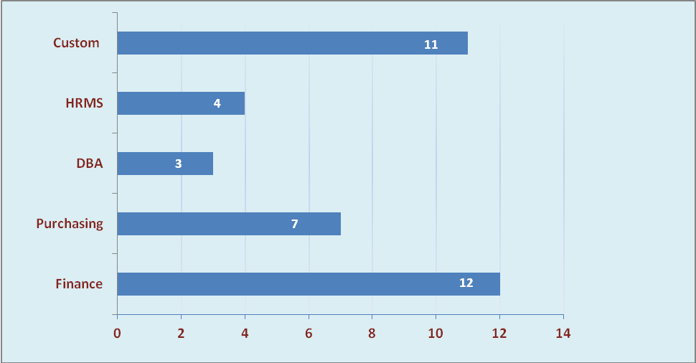

1.3 SLA Summary

Group | Total Tickets Resolved | Resolved within SLA | % SLA Achieved
Priority 1 | 0 | 0 | 0%
Priority 2 | 1 | 1 | 100%
Priority 3 | 35 | 31 | 89%
Total | 36 | 32 | 89%

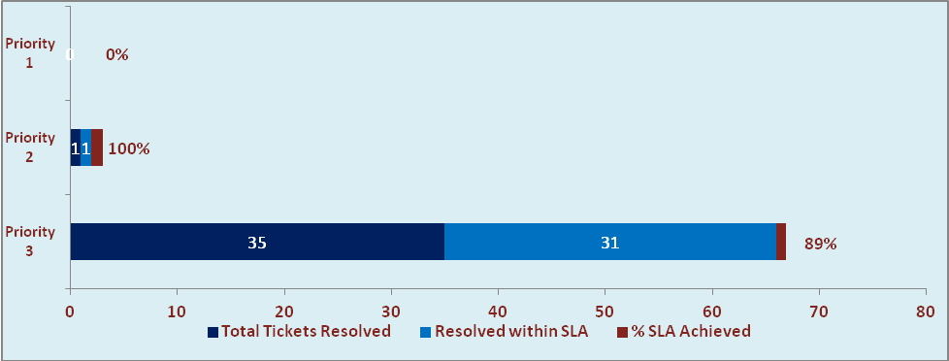

- Potential Bottlenecks

- The current Oracle version needs upgrade. The current version has bugs and in case of critical issues, Oracle does not respond properly due to old version.
- Lack of DR site can lead to major downtime in case of any breakdown.

