WEEKLY STATUS REPORT

From | ERUDITE IT PROFESSIONALS PVT. LTD.
Period | 09th Feb-2015 to 14th Feb-2015
Project | AUPL Services Support

- Weekly Calls Resolution Status (09th Feb-2015 to 14th Feb-2015)

  - Current Status (Including Backlog)

Group | Total Opened Including Backlog | Total Resolved | Pending
Priority 1 | 0 | 0 | 0
Priority 2 | 0 | 0 | 0
Priority 3 | 45 | 40 | 5
Total | 45 | 40 | 5

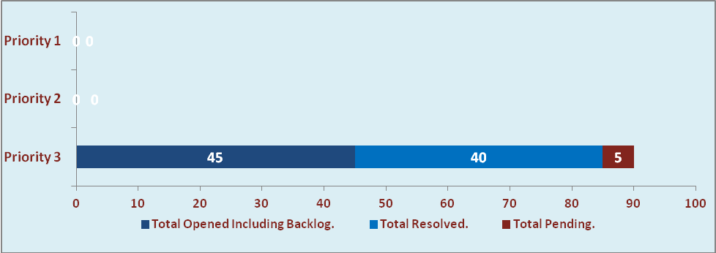

  - Current Tickets Status Distribution for the Week (09th Feb-2015 to 14th Feb-2015)

Distribution | Tickets
Finance | 12
Purchasing | 3
DBA | 4
HRMS | 3
Custom | 17

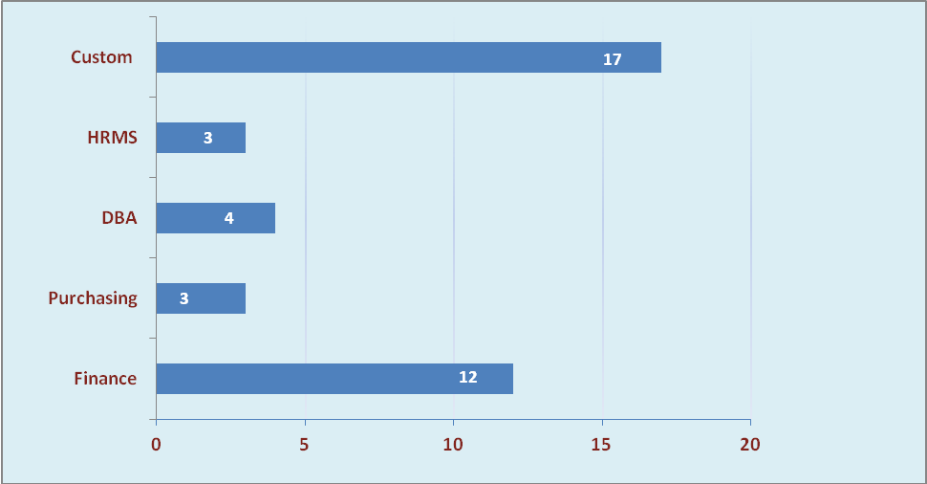

1.3 SLA Summary

Group | Total Tickets Resolved | Resolved within SLA | % SLA Achieved
Priority 1 | 0 | 0 | 0%
Priority 2 | 0 | 0 | 0%
Priority 3 | 40 | 36 | 90%
Total | 40 | 36 | 90%

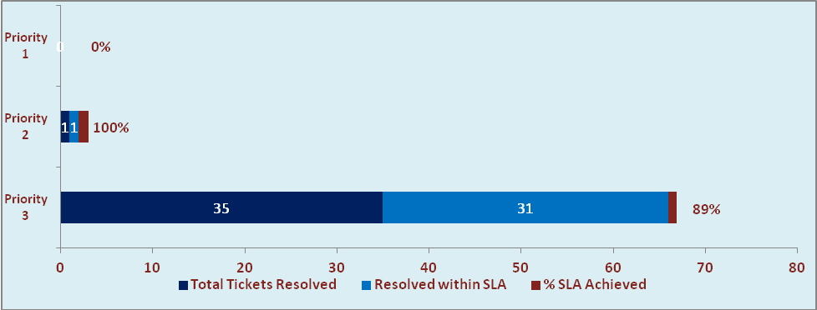

- Potential Bottlenecks

- The current Oracle version needs upgrade. The current version has bugs and in case of critical issues, Oracle does not respond properly due to old version.
- Lack of DR site can lead to major downtime in case of any breakdown.

