WEEKLY STATUS REPORT

From | ERUDITE IT PROFESSIONALS PVT. LTD.
Period | 16th Feb-2015 to 21st Feb-2015
Project | AUPL Services Support

- Weekly Calls Resolution Status (16th Feb-2015 to 21st Feb-2015)

  - Current Status (Including Backlog)

Group | Total Opened Including Backlog | Total Resolved | Pending
Priority 1 | 0 | 0 | 0
Priority 2 | 1 | 1 | 0
Priority 3 | 30 | 24 | 6
Total | 31 | 25 | 6

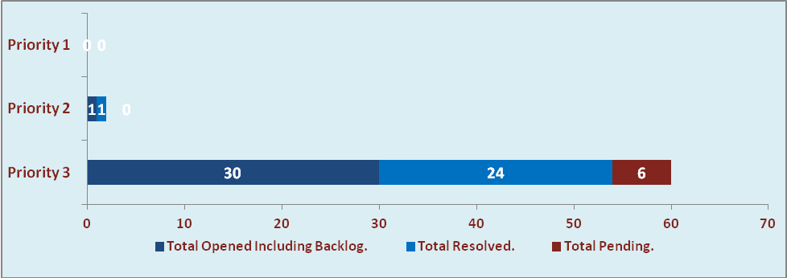

  - Current Tickets Status Distribution for the Week (16th Feb-2015 to 21st Feb-2015)

Distribution | Tickets
Finance | 2
Purchasing | 4
Waste Mgt | 1
DBA | 4
HRMS | 3
Custom | 12

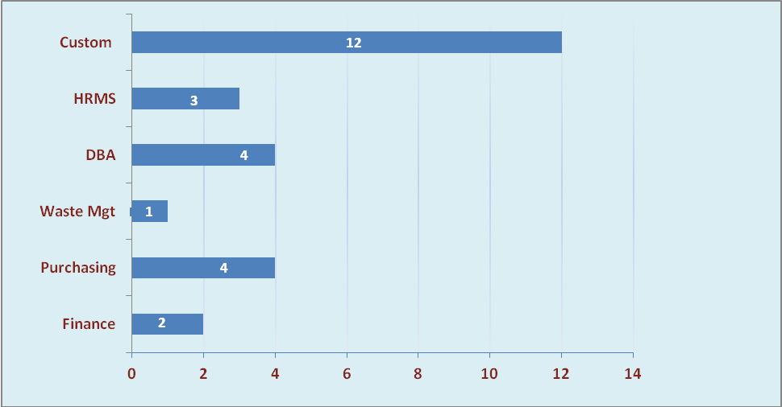

1.3 SLA Summary

Group | Total Tickets Resolved | Resolved within SLA | % SLA Achieved
Priority 1 | 0 | 0 | 0%
Priority 2 | 1 | 1 | 100%
Priority 3 | 24 | 21 | 88%
Total | 25 | 22 | 88%

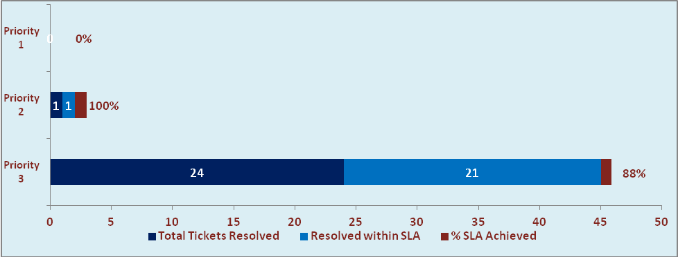

- Developments & Other Efforts

Hours | Effort (Hrs.) | Status | Delivered
Form 12 Report | 32 | Testing Phase
Retro Process in Payroll | 40 | Work in Process
ABC Outstanding (New Process & Reports ) | 02 | Work in Process
Total Efforts | 74

- Potential Bottlenecks

- The current Oracle version needs upgrade. The current version has bugs and in case of critical issues, Oracle does not respond properly due to old version.
- Lack of DR site can lead to major downtime in case of any breakdown.

