WEEKLY STATUS REPORT

From | ERUDITE IT PROFESSIONALS PVT. LTD.
Period | 23rd Feb-2015 to 28th Feb-2015
Project | AUPL Services Support

- Weekly Calls Resolution Status (23rd Feb-2015 to 28th Feb-2015)

  - Current Status (Including Backlog)

Group | Total Opened Including Backlog | Total Resolved | Pending
Priority 1 | 0 | 0 | 0
Priority 2 | 0 | 0 | 0
Priority 3 | 30 | 23 | 7
Total | 30 | 23 | 7

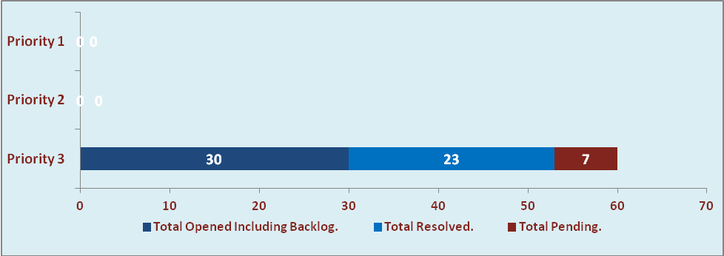

  - Current Tickets Status Distribution for the Week (23rd Feb-2015 to 28th Feb-2015)

Distribution | Tickets
Finance | 6
Purchasing | 2
DBA | 1
HRMS | 1
Custom | 15

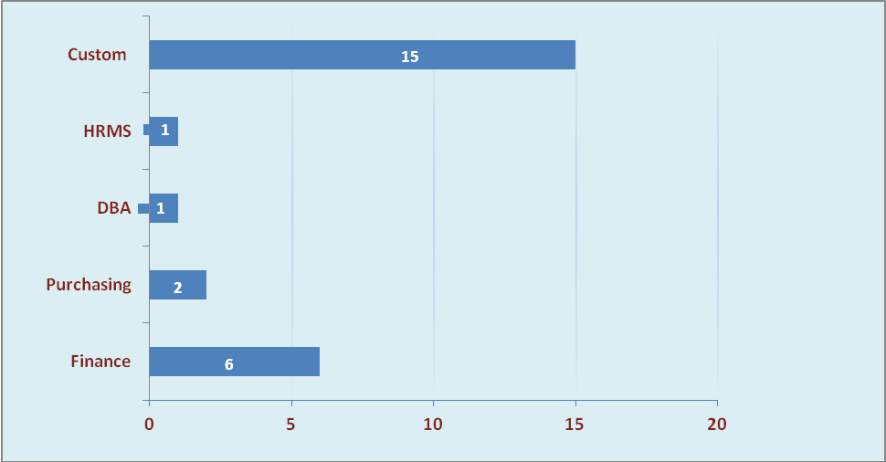

1.3 SLA Summary

Group | Total Tickets Resolved | Resolved within SLA | % SLA Achieved
Priority 1 | 0 | 0 | 0%
Priority 2 | 0 | 0 | 0%
Priority 3 | 23 | 20 | 87%
Total | 23 | 20 | 87%

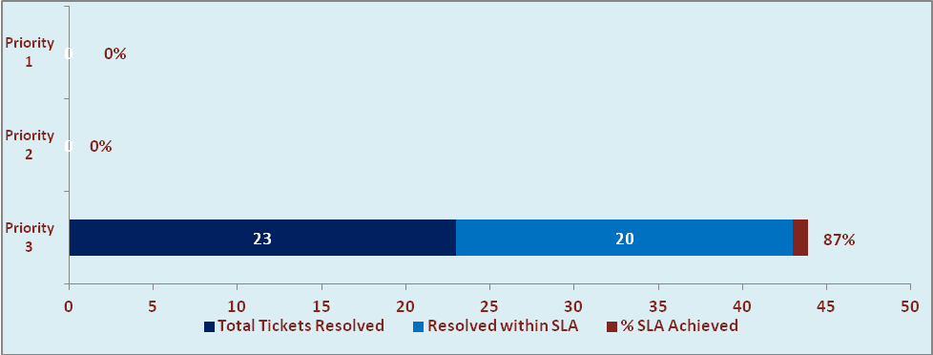

- Developments & Other Efforts

Hours | Effort (Hrs.) | Status | Delivered
Retro Process in Payroll | 30 | Work in Process
ABC Outstanding (New Process & Reports ) | 10 | Work in Process
Total Efforts | 40

- Potential Bottlenecks

- The current Oracle version needs upgrade. The current version has bugs and in case of critical issues, Oracle does not respond properly due to old version.
- Lack of DR site can lead to major downtime in case of any breakdown.

