WEEKLY STATUS REPORT

From | ERUDITE IT PROFESSIONALS PVT. LTD.
Period | 09th March-2015 to 14th March -2015
Project | AUPL Services Support

- Weekly Calls Resolution Status (09th March -2015 to 14th March-2015)

  - Current Status (Including Backlog)

Group | Total Opened Including Backlog | Total Resolved | Pending
Priority 1 | 0 | 0 | 0
Priority 2 | 2 | 2 | 0
Priority 3 | 29 | 23 | 6
Total | 31 | 25 | 6

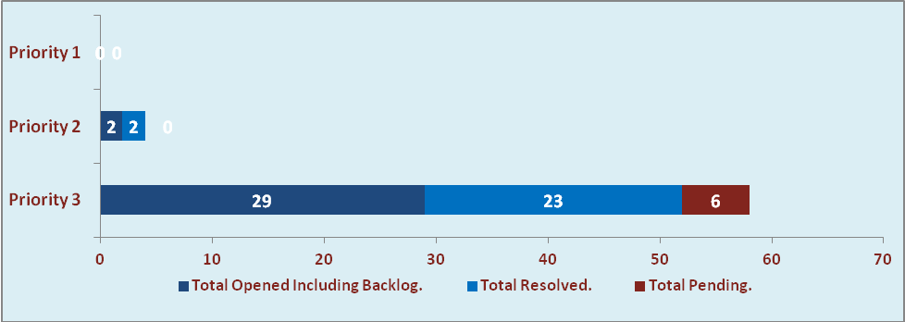

  - Current Tickets Status Distribution for the Week (09th March-2015 to 14th March-2015)

Distribution | Tickets
Finance | 13
Purchasing | 2
DBA | 3
HRMS | 2
Custom | 6

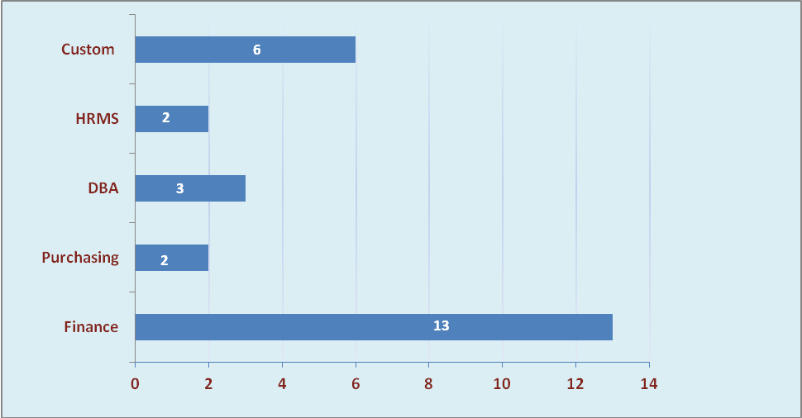

1.3 SLA Summary

Group | Total Tickets Resolved | Resolved within SLA | % SLA Achieved
Priority 1 | 0 | 0 | 0%
Priority 2 | 2 | 2 | 100%
Priority 3 | 23 | 20 | 87%
Total | 25 | 22 | 88%

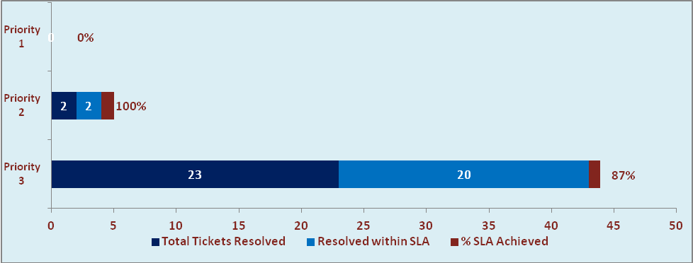

- Developments & Other Efforts

Hours | Effort (Hrs.) | Status | Delivered
Tax Computation | 10 | Production | 12th March 2015
Bill Format Report | 05 | Production | 13th March 2015
ABC Outstanding Report | 15 | Work in progress
Total Efforts | 30

- Potential Bottlenecks

- The current Oracle version needs upgrade. The current version has bugs and in case of critical issues, Oracle does not respond properly due to old version.
- Lack of DR site can lead to major downtime in case of any breakdown.

