WEEKLY STATUS REPORT

From | ERUDITE IT PROFESSIONALS PVT. LTD.
Period | 16th March-2015 to 21st March -2015
Project | AUPL Services Support

- Weekly Calls Resolution Status (16th March -2015 to 21st March-2015)

  - Current Status (Including Backlog)

Group | Total Opened Including Backlog | Total Resolved | Pending
Priority 1 | 2 | 2 | 0
Priority 2 | 3 | 3 | 0
Priority 3 | 33 | 28 | 5
Total | 38 | 33 | 5

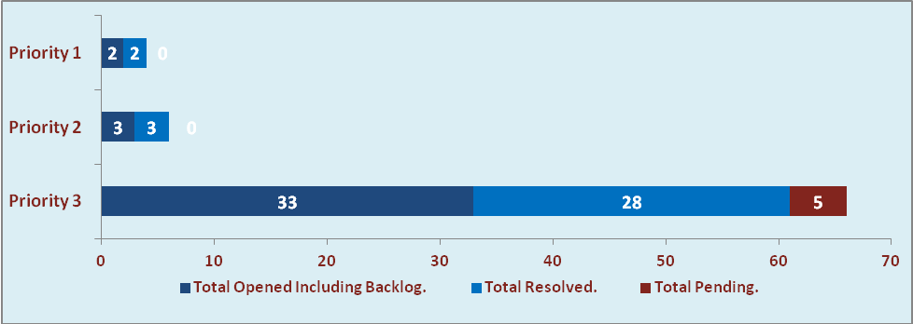

  - Current Tickets Status Distribution for the Week (16th March-2015 to 21st March-2015)

Distribution | Tickets
Finance | 15
Purchasing | 1
System/DBA | 4
SMS | 1
HRMS | 1
Custom | 6

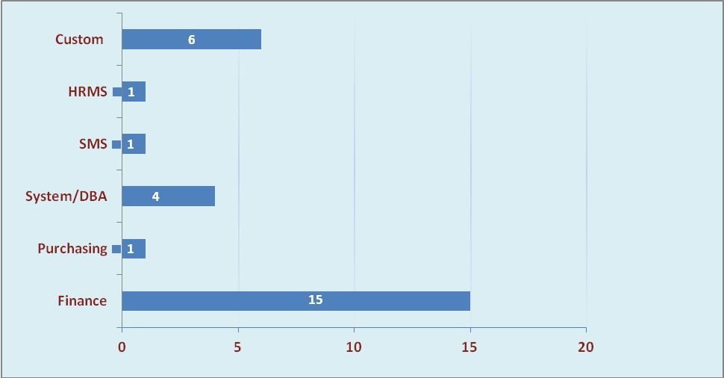

1.3 SLA Summary

Group | Total Tickets Resolved | Resolved within SLA | % SLA Achieved
Priority 1 | 2 | 2 | 100%
Priority 2 | 3 | 3 | 100%
Priority 3 | 28 | 25 | 89%
Total | 33 | 30 | 91%

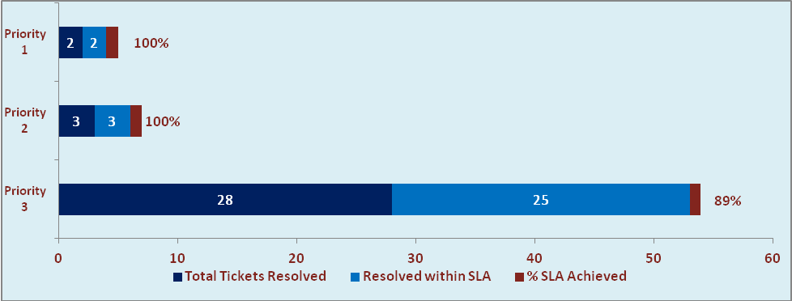

- Developments & Other Efforts

Hours | Effort (Hrs.) | Status | Delivered
ABC Outstanding Report | 20 | Testing (Phase 1& 2)
Updation In Gate Cash receipt Module | 05 | Work in progress
AU Effort Estimation for Salary Change | 10 | Work in progress
Total Efforts | 35

- Potential Bottlenecks

- The current Oracle version needs upgrade. The current version has bugs and in case of critical issues, Oracle does not respond properly due to old version.
- Lack of DR site can lead to major downtime in case of any breakdown.

