WEEKLY STATUS REPORT

From | ERUDITE IT PROFESSIONALS PVT. LTD.
Period | 23rd March-2015 to 28th March -2015
Project | AUPL Services Support

- Weekly Calls Resolution Status (23rd March -2015 to 28th March-2015)

  - Current Status (Including Backlog)

Group | Total Opened Including Backlog | Total Resolved | Pending
Priority 1 | 1 | 1 | 0
Priority 2 | 0 | 0 | 0
Priority 3 | 36 | 33 | 3
Total | 37 | 34 | 3

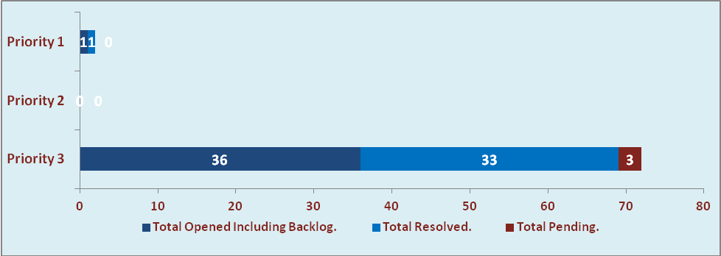

  - Current Tickets Status Distribution for the Week (23rd March-2015 to 28th March-2015)

Distribution | Tickets
Finance | 14
Purchasing | 6
System/DBA | 2
SMS | 0
HRMS | 0
Custom | 10

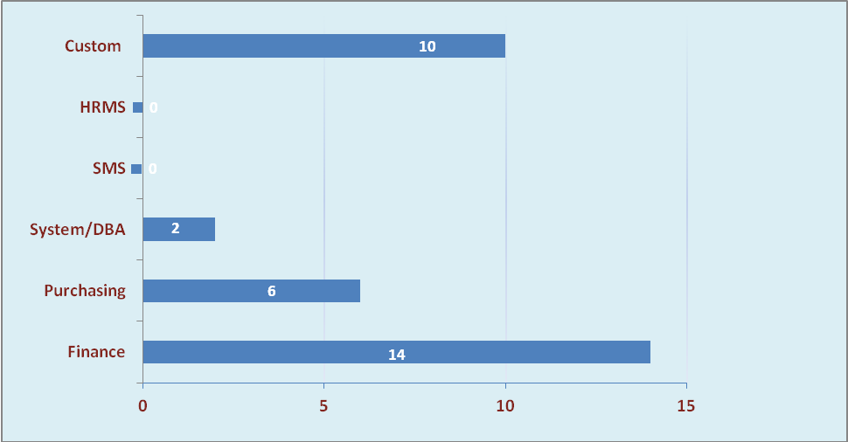

1.3 SLA Summary

Group | Total Tickets Resolved | Resolved within SLA | % SLA Achieved
Priority 1 | 1 | 1 | 100%
Priority 2 | 0 | 0 | 0%
Priority 3 | 33 | 30 | 91%
Total | 34 | 31 | 91%

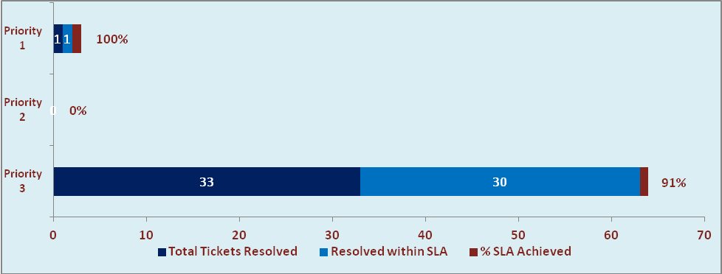

- Developments & Other Efforts

Hours | Effort (Hrs.) | Status | Delivered
ABC Outstanding Report | 08 | Testing Phase
Updation In Gate Cash receipt Module | 08 | Work in progress
AU Effort Estimation for Salary Change | 20 | Work in progress
Total Efforts | 36

- Potential Bottlenecks

- The current Oracle version needs upgrade. The current version has bugs and in case of critical issues, Oracle does not respond properly due to old version.
- Lack of DR site can lead to major downtime in case of any breakdown.

