WEEKLY STATUS REPORT

From | ERUDITE IT PROFESSIONALS PVT. LTD.
Period | 30th March-2015 to 04th April -2015
Project | AUPL Services Support

- Weekly Calls Resolution Status (30th March -2015 to 4th April-2015)

  - Current Status (Including Backlog)

Group | Total Opened Including Backlog | Total Resolved | Pending
Priority 1 | 0 | 0 | 0
Priority 2 | 3 | 3 | 0
Priority 3 | 65 | 60 | 5
Total | 68 | 63 | 5

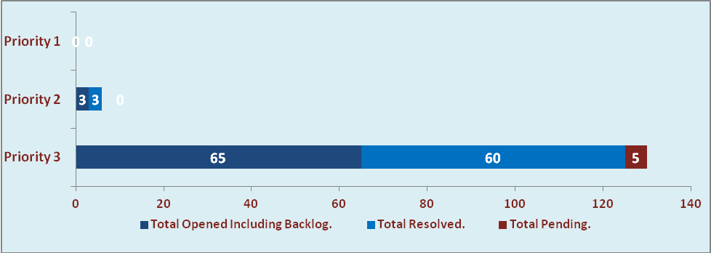

  - Current Tickets Status Distribution for the Week (30th March-2015 to 4th April-2015)

Distribution | Tickets
Finance | 28
Purchasing | 8
System/DBA | 2
SMS | 0
HRMS | 11
Custom | 14

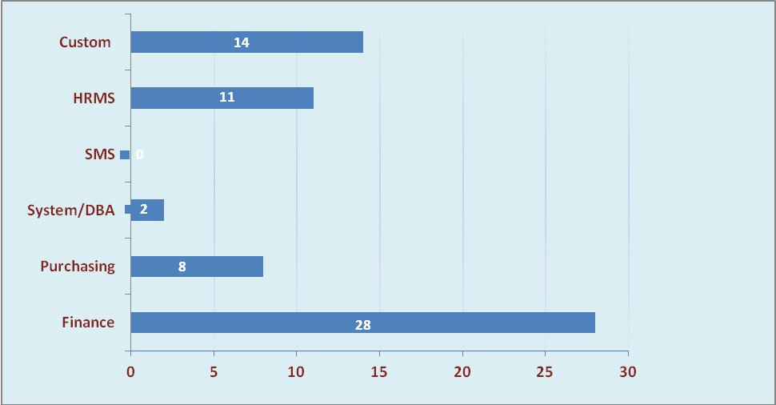

1.3 SLA Summary

Group | Total Tickets Resolved | Resolved within SLA | % SLA Achieved
Priority 1 | 0 | 0 | 0%
Priority 2 | 3 | 3 | 100%
Priority 3 | 60 | 56 | 93%
Total | 63 | 59 | 94%

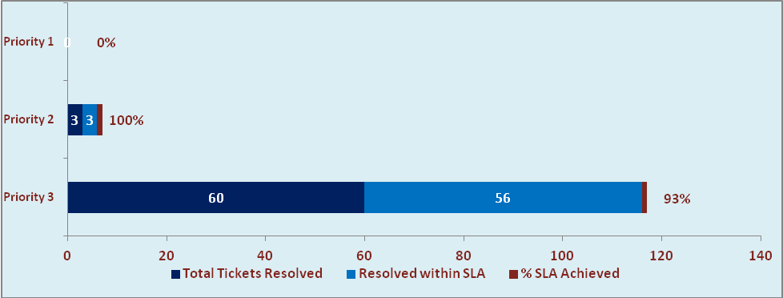

- Developments & Other Efforts

Hours | Effort (Hrs.) | Status | Delivered
List of confirmatory Purchase order | 3 | Moved to Production
PO Closure | 10 | Testing Phase
Amar Ujala Newsprint Consumption report (Item wise) | 5 | Testing Phase
Total Efforts | 18

- Potential Bottlenecks

- The current Oracle version needs upgrade. The current version has bugs and in case of critical issues, Oracle does not respond properly due to old version.
- Lack of DR site can lead to major downtime in case of any breakdown.

