WEEKLY STATUS REPORT

From | ERUDITE IT PROFESSIONALS PVT. LTD.
Period | 06th April -2015 to 11th April -2015
Project | AUPL Services Support

- Weekly Calls Resolution Status (06th April -2015 to 11th April-2015)

  - Current Status (Including Backlog)

Group | Total Opened Including Backlog | Total Resolved | Pending
Priority 1 | 0 | 0 | 0
Priority 2 | 3 | 3 | 0
Priority 3 | 42 | 38 | 4
Total | 45 | 41 | 4

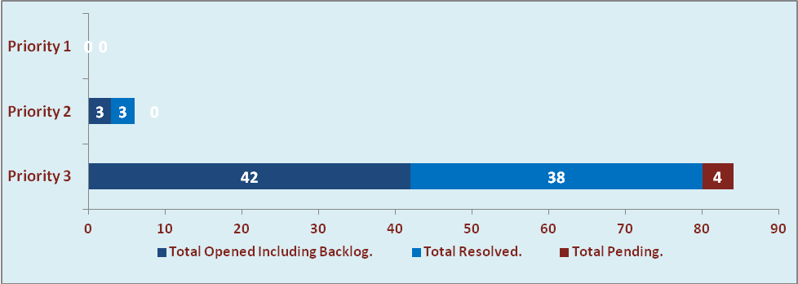

  - Current Tickets Status Distribution for the Week (06th April-2015 to 11th April-2015)

Distribution | Tickets
Finance | 25
Purchasing | 6
System/DBA | 4
SMS | 0
HRMS | 1
Custom | 4

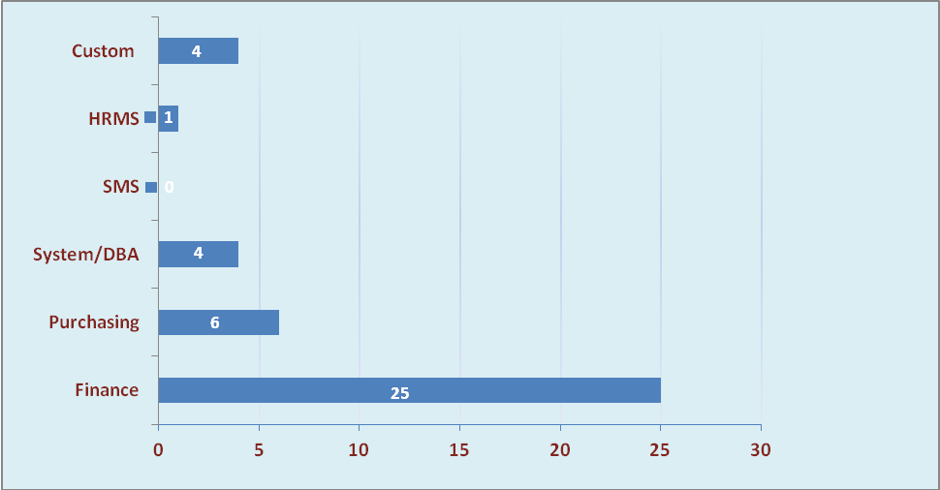

1.3 SLA Summary

Group | Total Tickets Resolved | Resolved within SLA | % SLA Achieved
Priority 1 | 0 | 0 | 0%
Priority 2 | 3 | 3 | 100%
Priority 3 | 38 | 35 | 92%
Total | 41 | 38 | 93%

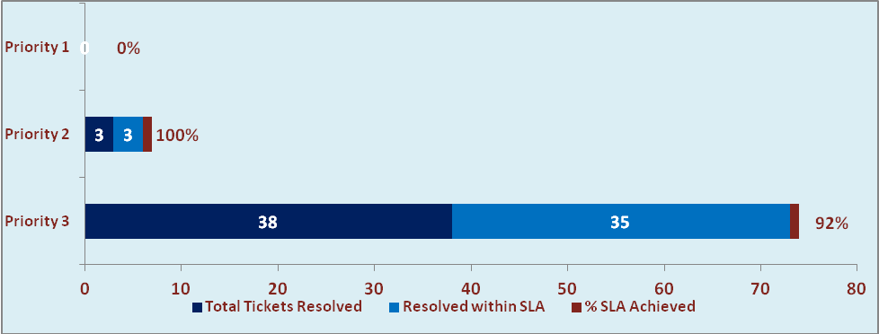

- Potential Bottlenecks

- The current Oracle version needs upgrade. The current version has bugs and in case of critical issues, Oracle does not respond properly due to old version.
- Lack of DR site can lead to major downtime in case of any breakdown.

