WEEKLY STATUS REPORT

From | ERUDITE IT PROFESSIONALS PVT. LTD.
Period | 13th April -2015 to 18th April -2015
Project | AUPL Services Support

- Weekly Calls Resolution Status (13th April -2015 to 18th April-2015)

  - Current Status (Including Backlog)

Group | Total Opened Including Backlog | Total Resolved | Pending
Priority 1 | 0 | 0 | 0
Priority 2 | 1 | 1 | 0
Priority 3 | 34 | 29 | 5
Total | 35 | 30 | 5

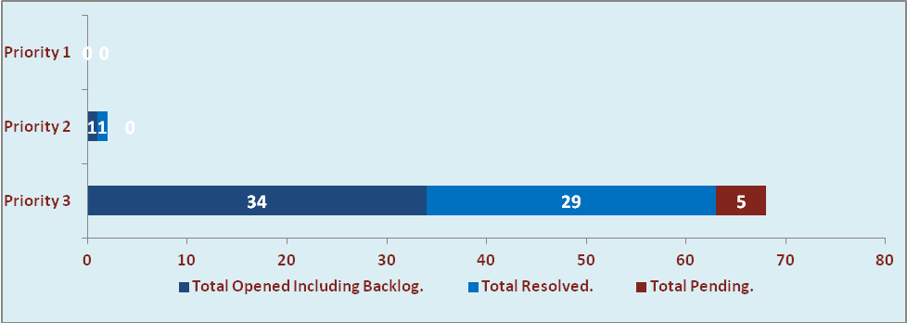

  - Current Tickets Status Distribution for the Week (13th April-2015 to 18th April-2015)

Distribution | Tickets
Finance | 11
Purchasing | 5
System/DBA | 2
SMS | 0
HRMS | 0
Custom | 11

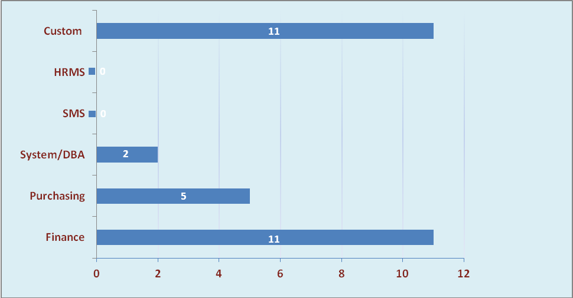

1.3 SLA Summary

Group | Total Tickets Resolved | Resolved within SLA | % SLA Achieved
Priority 1 | 0 | 0 | 0%
Priority 2 | 1 | 1 | 100%
Priority 3 | 29 | 26 | 90%
Total | 30 | 27 | 90%

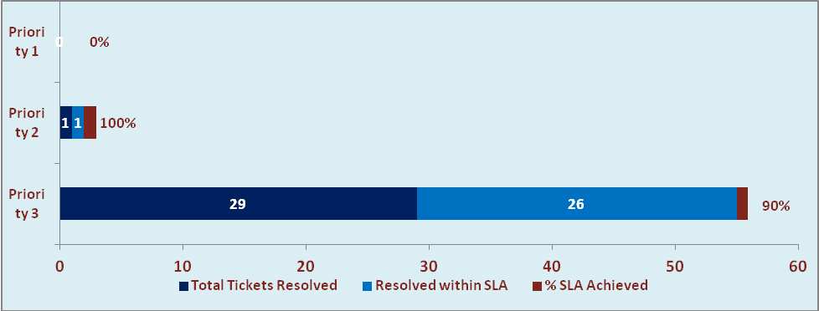

- Developments & Other Efforts

Hours | Effort (Hrs.) | Status
Open the Fin. Year 2015-16 in 10g Forms. | 15 | Delivered
Bill Format of Book Division | 10 | Work in Process
Total Efforts | 25

- Potential Bottlenecks

- The current Oracle version needs upgrade. The current version has bugs and in case of critical issues, Oracle does not respond properly due to old version.
- Lack of DR site can lead to major downtime in case of any breakdown.

