WEEKLY STATUS REPORT

From | ERUDITE IT PROFESSIONALS PVT. LTD
Period | 04th May -2015 to 09th May -2015
Project | AUPL Services Support

- Weekly Calls Resolution Status (04th May -2015 to 09th May -2015)

  - Current Status (Including Backlog)

Group | Total Opened Including Backlog | Total Resolved | Pending
Priority 1 | 0 | 0 | 0
Priority 2 | 2 | 2 | 0
Priority 3 | 31 | 28 | 3
Total | 33 | 30 | 3

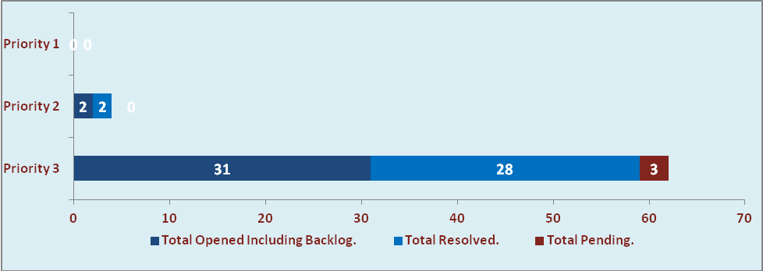

  - Current Tickets Status Distribution for the Week (04th May -2015 to 09th May -2015)

Distribution | Tickets
Finance | 8
Purchasing | 1
System/DBA | 2
SMS | 0
HRMS | 0
Custom | 17

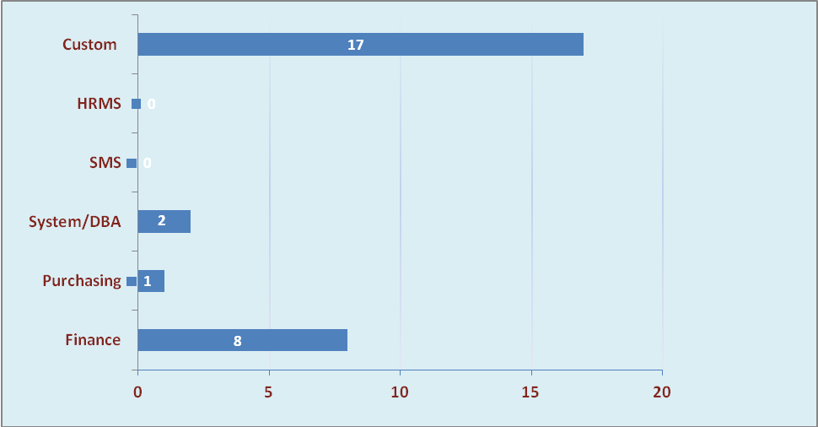

1.3 SLA Summary

Group | Total Tickets Resolved | Resolved within SLA | % SLA Achieved
Priority 1 | 0 | 0 | 0%
Priority 2 | 2 | 2 | 100%
Priority 3 | 28 | 26 | 93%
Total | 30 | 28 | 93%

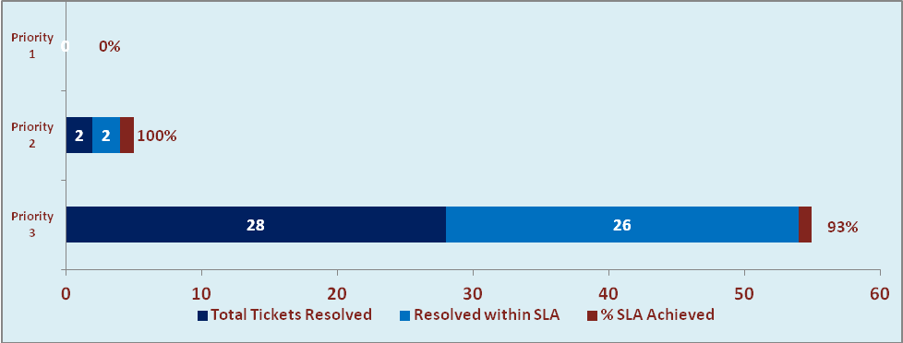

- Developments & Other Efforts

Hours | Effort (Hrs.) | Status
Tax Computation for Financial year 2015-16 | 05 | Work in Progress
CN Rate of Variant | 10 | Work in Progress
Total Efforts | 15

- Potential Bottlenecks

- The current Oracle version needs upgrade. The current version has bugs and in case of critical issues, Oracle does not respond properly due to old version.
- Lack of DR site can lead to major downtime in case of any breakdown.

