WEEKLY STATUS REPORT

From | ERUDITE IT PROFESSIONALS PVT. LTD
Period | 01st June -2015 to 06th June -2015
Project | AUPL Services Support

- Weekly Calls Resolution Status (01st June -2015 to 06th June -2015)

  - Current Status (Including Backlog)

Group | Total Opened Including Backlog | Total Resolved | Pending
Priority 1 | 0 | 0 | 0
Priority 2 | 1 | 1 | 0
Priority 3 | 49 | 43 | 6
Total | 50 | 44 | 6

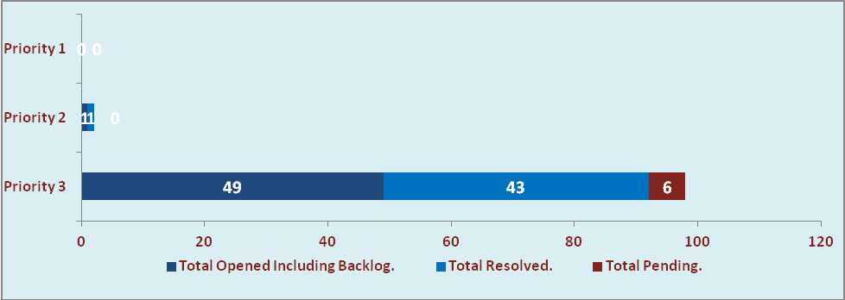

  - Current Tickets Status Distribution for the Week (01st June -2015 to 06th June -2015)

Distribution | Tickets
Finance | 15
Purchasing | 0
System/DBA | 2
SMS | 0
HRMS | 1
Custom | 27

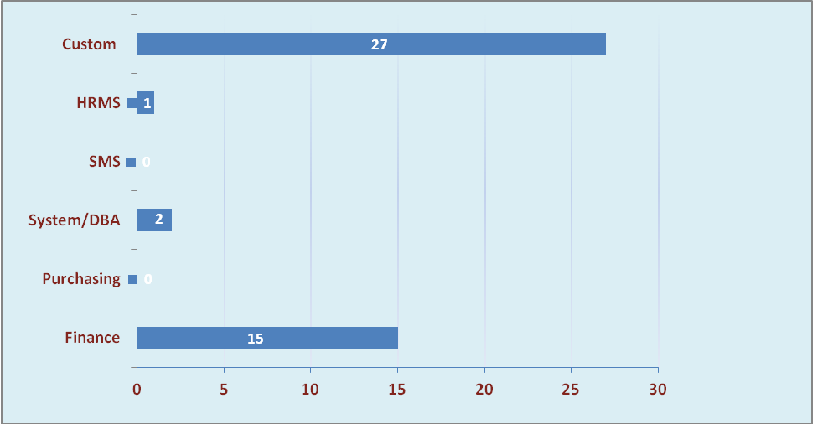

1.3 SLA Summary

Group | Total Tickets Resolved | Resolved within SLA | % SLA Achieved
Priority 1 | 0 | 0 | 0%
Priority 2 | 1 | 1 | 100%
Priority 3 | 43 | 40 | 93%
Total | 44 | 41 | 93%

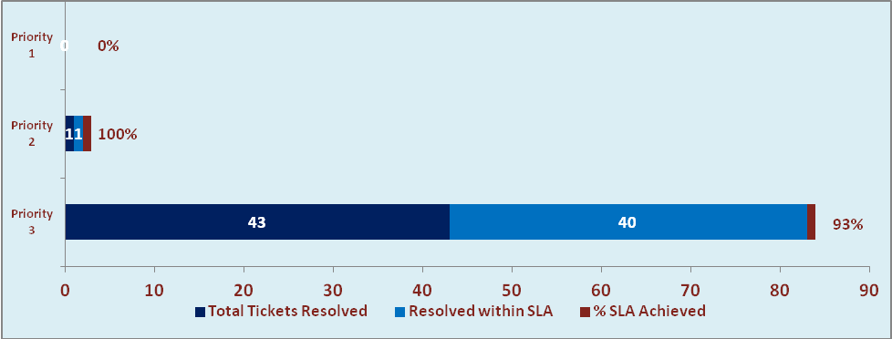

- Potential Bottlenecks

- The current Oracle version needs upgrade. The current version has bugs and in case of critical issues, Oracle does not respond properly due to old version.
- Lack of DR site can lead to major downtime in case of any breakdown.

