WEEKLY STATUS REPORT

From | ERUDITE IT PROFESSIONALS PVT. LTD
Period | 08th June -2015 to 13th June -2015
Project | AUPL Services Support

- Weekly Calls Resolution Status (08TH June -2015 to 13TH June -2015)

  - Current Status (Including Backlog)

Group | Total Opened Including Backlog | Total Resolved | Pending
Priority 1 | 0 | 0 | 0
Priority 2 | 02 | 02 | 0
Priority 3 | 20 | 17 | 3
Total | 22 | 19 | 3

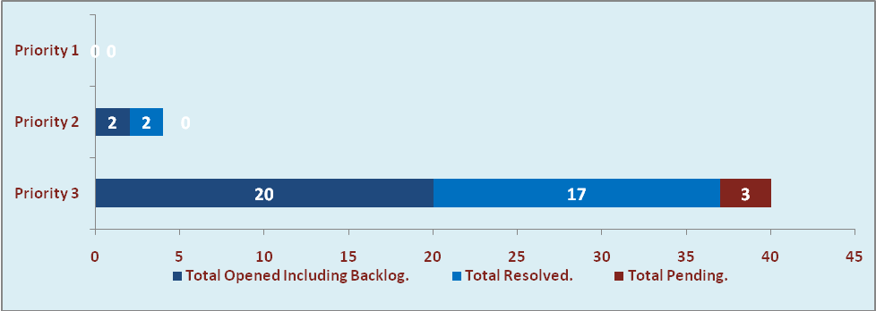

  - Current Tickets Status Distribution for the Week (08th June -2015 to 13th June -2015)

Distribution | Tickets
Finance | 3
Purchasing | 1
System/DBA | 2
SMS | 2
HRMS | 1
Custom | 8

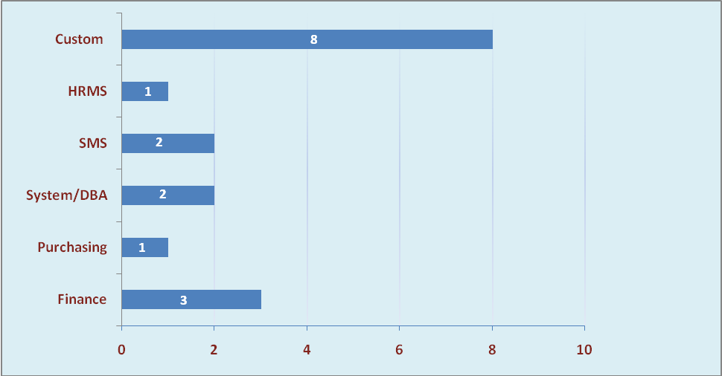

1.3 SLA Summary

Group | Total Tickets Resolved | Resolved within SLA | % SLA Achieved
Priority 1 | 0 | 0 | 0%
Priority 2 | 2 | 2 | 100%
Priority 3 | 17 | 15 | 88%
Total | 19 | 17 | 89%

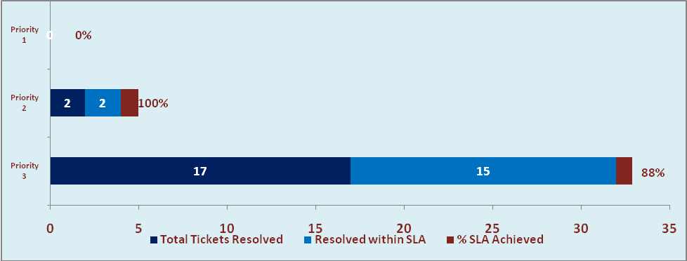

- Developments & Other Efforts

Hours | Effort (Hrs.) | Status | Delivered
Cir Billing Report (5 reports with and without variant) | 36 | Production | 08th Jun-2015
Total Efforts | 36

- Potential Bottlenecks

- The current Oracle version needs upgrade. The current version has bugs and in case of critical issues, Oracle does not respond properly due to old version.
- Lack of DR site can lead to major downtime in case of any breakdown.

