WEEKLY STATUS REPORT

From | ERUDITE IT PROFESSIONALS PVT. LTD
Period | 15th June -2015 to 20th June -2015
Project | AUPL Services Support

- Weekly Calls Resolution Status (15TH June -2015 to 20TH June -2015)

  - Current Status (Including Backlog)

Group | Total Opened Including Backlog | Total Resolved | Pending
Priority 1 | 1 | 1 | 0
Priority 2 | 4 | 4 | 0
Priority 3 | 19 | 16 | 3
Total | 24 | 21 | 3

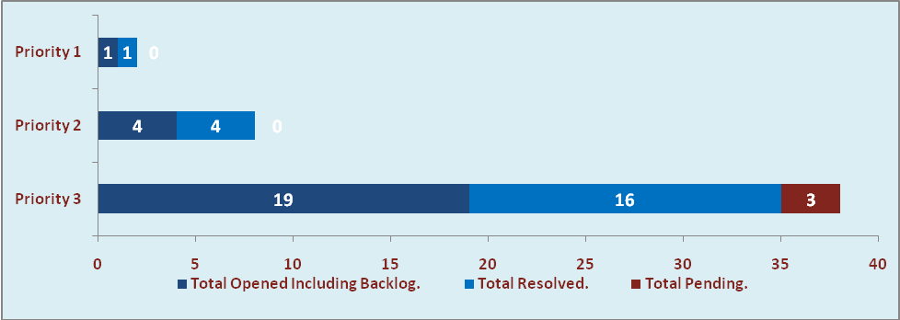

  - Current Tickets Status Distribution for the Week (15th June -2015 to 20th June -2015)

Distribution | Tickets
Finance | 5
Purchasing | 1
System/DBA | 3
SMS | 1
HRMS | 0
Custom | 9

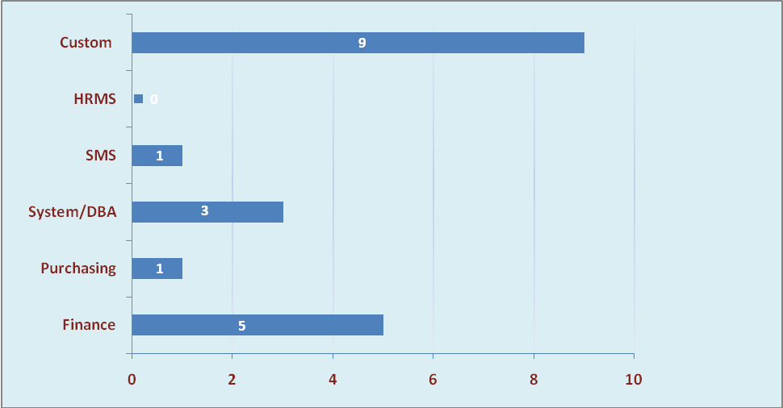

1.3 SLA Summary

Group | Total Tickets Resolved | Resolved within SLA | % SLA Achieved
Priority 1 | 1 | 1 | 100%
Priority 2 | 4 | 4 | 100%
Priority 3 | 16 | 14 | 88%
Total | 21 | 19 | 90%

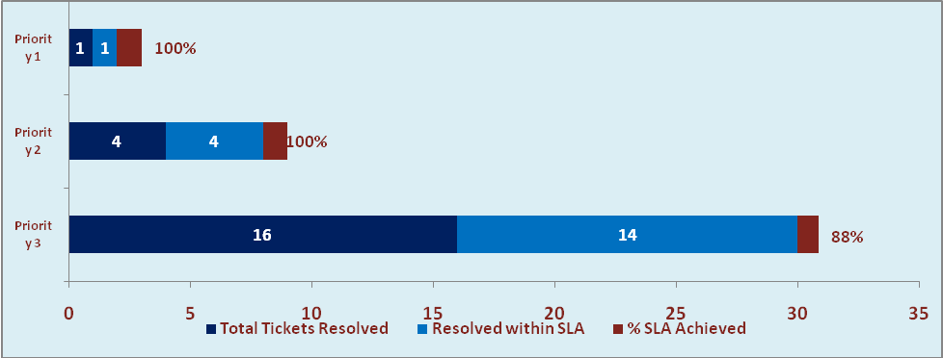

- Potential Bottlenecks

- The current Oracle version needs upgrade. The current version has bugs and in case of critical issues, Oracle does not respond properly due to old version.
- Lack of DR site can lead to major downtime in case of any breakdown.

