WEEKLY STATUS REPORT

From | ERUDITE IT PROFESSIONALS PVT. LTD.
Period | 01-Dec-2014 to 06-Dec-2014
Project | AUPL Services Support

- Weekly Calls Resolution Status (01-Dec-2014 to 06-Dec-2014)

  - Current Status (Including Backlog)

Group | Total Opened Including Backlog | Total Resolved | Pending
Priority 1 | 0 | 0 | 0
Priority 2 | 2 | 2 | 0
Priority 3 | 65 | 51 | 14
Total | 67 | 53 | 14

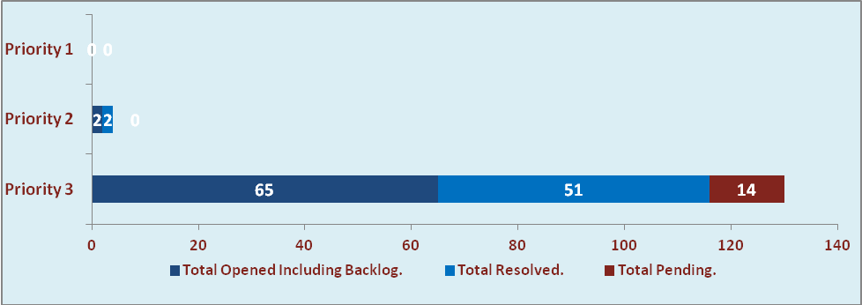

1.2 Current Tickets Status Distribution for the Week (01-Dec-2014 to 06-Dec-2014)

Distribution | Tickets
Finance | 28
Purchasing | 9
HRMS | 5
WM | 2
Adpro | 2
DBA | 7
Custom | 8

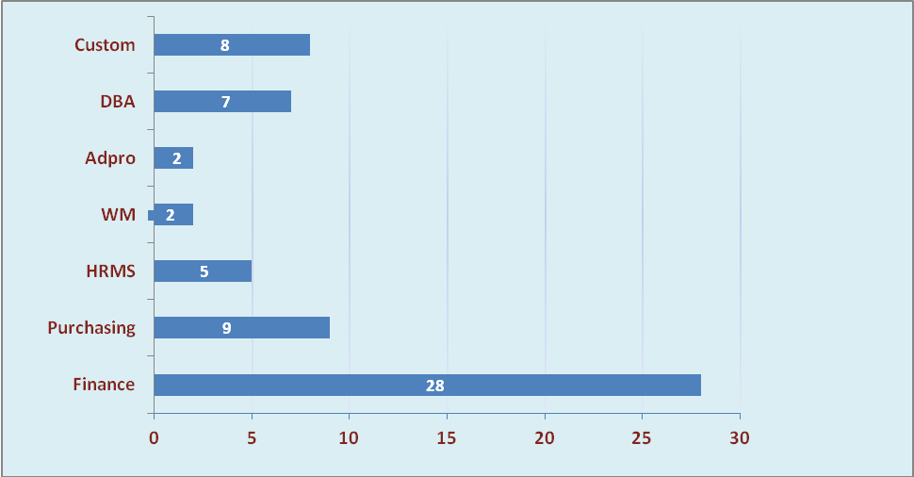

1.3 SLA Summary

Group | Total Tickets Resolved | Resolved within SLA | % SLA Achieved
Priority 1 | 0 | 0 | 0
Priority 2 | 2 | 2 | 100%
Priority 3 | 51 | 49 | 96%
Total | 53 | 51 | 96%

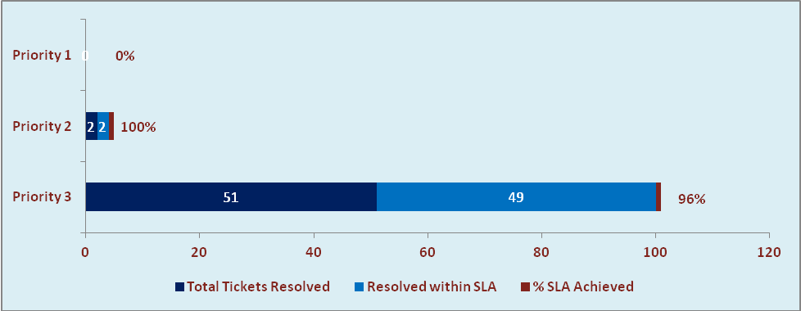

- Developments & Other Efforts

Hours | Effort (Hrs.) | Status | Date
Auto PO Closure (XXAU_AUTO_POCLOSE)- | 1 | Migrated to Production | 04-12-2014
Order Management Setup and Created New Reports on Test Instance (Bill Register, CN Register, Invoice/Challan) | 45 | Testing Instance | 06-12-2014
Consumption report with value | 5 | Work In progress
Total Efforts | 51

- Potential Bottlenecks

- The current Oracle version needs upgrade. The current version has bugs and in case of critical issues, Oracle does not respond properly due to old version.
- Lack of DR site can lead to major downtime in case of any breakdown.

