WEEKLY STATUS REPORT

From | ERUDITE IT PROFESSIONALS PVT. LTD.
Period | 15-Dec-2014 to 20-Dec-2014
Project | AUPL Services Support

- Weekly Calls Resolution Status (15-Dec-2014 to 20-Dec-2014)

  - Current Status (Including Backlog)

Group | Total Opened Including Backlog | Total Resolved | Pending
Priority 1 | 0 | 0 | 0
Priority 2 | 0 | 0 | 0
Priority 3 | 41 | 35 | 6
Total | 41 | 35 | 6

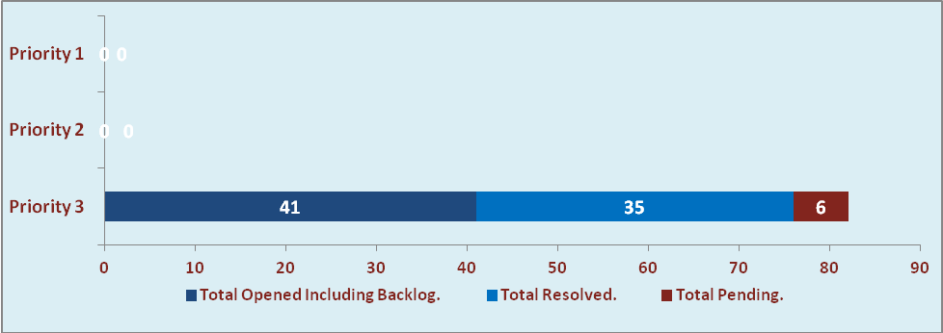

  - Current Tickets Status Distribution for the Week (15-Dec-2014 to 20-Dec-2014)

Distribution | Tickets
Finance | 17
Purchasing | 8
HRMS | 2
DBA | 6
Custom | 3

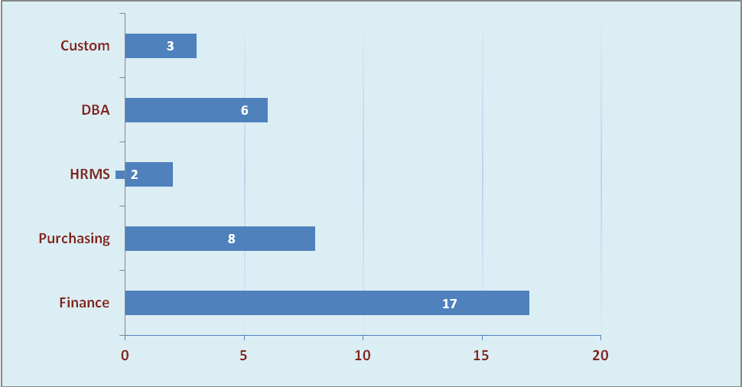

1.3 SLA Summary

Group | Total Tickets Resolved | Resolved within SLA | % SLA Achieved
Priority 1 | 0 | 0 | 0%
Priority 2 | 0 | 0 | 0%
Priority 3 | 35 | 32 | 91%
Total | 35 | 32 | 91%

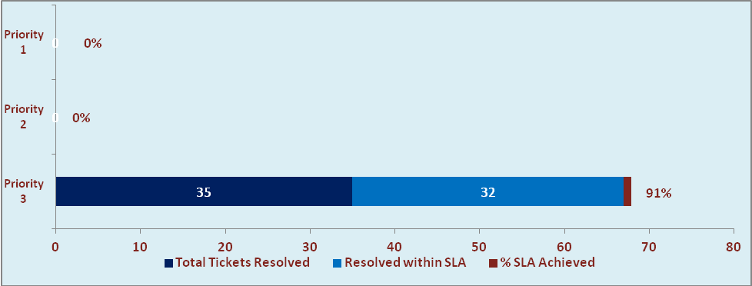

- Developments & Other Efforts

Hours | Effort (Hrs.) | Status | Completion Date
Oracle ERP DB migration to 64 bit OS on Blade Servers | 80 | Production | 21-Dec-2014
Amar Ujala List of confirmatory Report | 2 | Production | 20-Dec-2014
Total Efforts | 82

- Major Highlights

- Oracle ERP DB has been successfully migrated to 64 bit OS on Blade servers.

- Potential Bottlenecks

- The current Oracle version needs upgrade. The current version has bugs and in case of critical issues, Oracle does not respond properly due to old version.
- Lack of DR site can lead to major downtime in case of any breakdown.

