Process
For
Email configuration using Outlook

Prepared by: Harpreet Randhawa
Version 1.0
Dated 03/11/14

TABLE OF CONTENT
- Document history……………………………………………………………………3
- Document Overview…………………………………………………………………4

  - SCOPE………………………………………………………………………………………………………………….4
  - PURPOSE…………………………………………………………………………………………………………….4
  - PREQUISITES………………………………………………………………………………………………………..4

- PROCEDURES……………………………………………………………………………….5
- REFERENCES………………………………………………………………………………..9

- Document History

This Document is subject to change control and as such any amendments must be carried out
Through the document change management process and all approvers must be agree on
proposed amendments.
Document Version | SOP Name | Revision Date | Title | Created By
V.1 | DTLT001 | 11/07/14 | Email Configuration using Outlook | Surendra Rayudu
2. Reviewer
This document should be reviewed by the following reviewers:

Name | Title | Review Date
Ayushman Sinha | Corporate IT Head | 11/03/14
3. Approver
This document requires following approvals.

Name | Title | Review Date
Ayushman Sinha | Corporate IT Head | 11/03/14

2. Document Overview
2.1 Scope
This document covers all the steps to required to configure emails using outlook.
2.2 Purpose

This document is useful to configure an Employee/Generic Email ID using MS Outlook
2.3 Prerequisites

MS Office to be installed before you start configuring the Email ID

3. PROCEDURES:
Step1: Goto Control Panel → Double Click on Mail icon

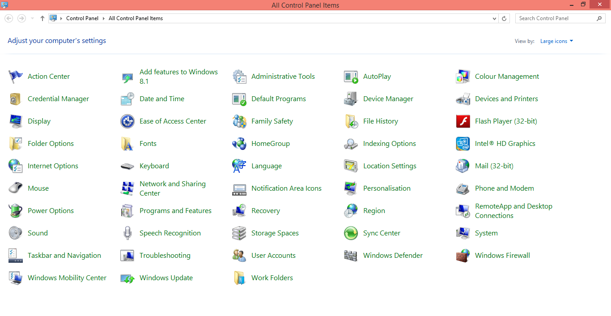

Step 2: Click on Show Profiles:

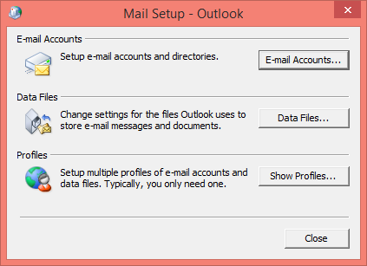

Step 3: Click on Add

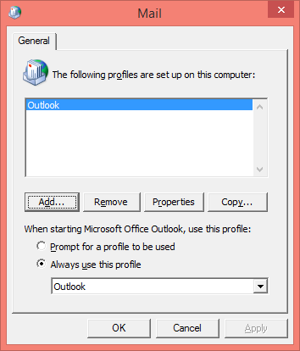

Step 4: Provide a valid name to the profile and click on OK

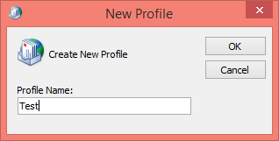

Step 5: Select Manually configure server settings or additional server types and click on Next

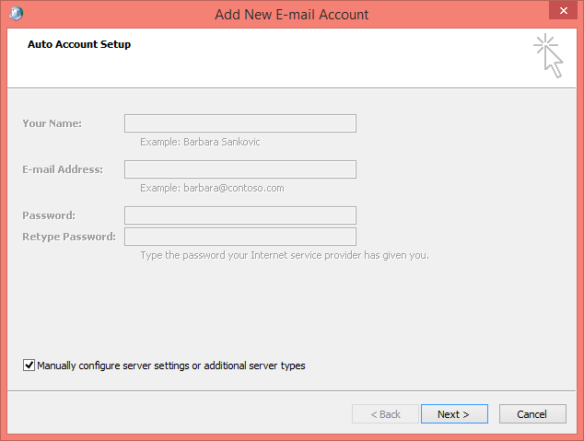

Step 6: Select Internet E-mail and click on Next

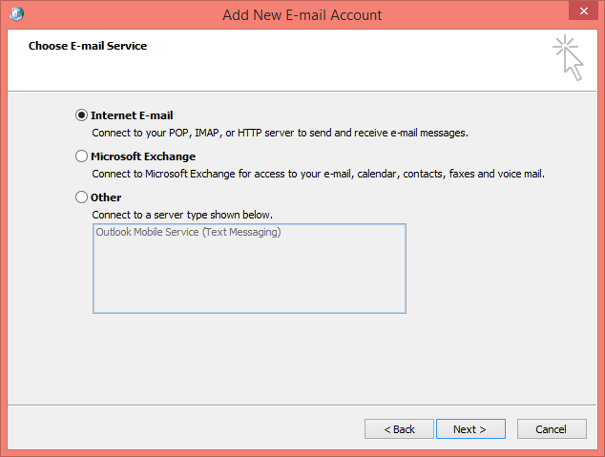
Step 7: Fill in the relevant details of user and server details and click on Test Account Settings. After successful execution of Test settings click on Next

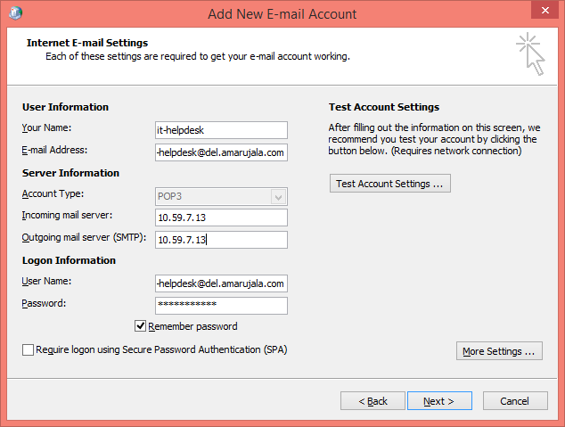

Step 8: Click on Finish to complete the configuration

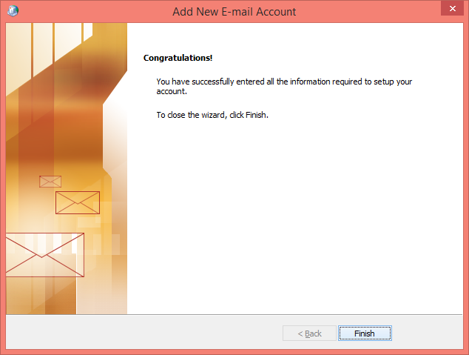

4. REFERENCES:
After that check, if the mail has been configure successfully

If not, feel free to contact IT Helpdesk in case of any technical issue

