**HOSPITAL MANAGEMENT SYSTEM**

**By**

**RAJAGURU R.H.M.S.N.**

**2018/E/099**

**January, 2022**

**INDIVIDUAL DATABASE APPLICATION ASSESSMENT**

**EC5070 DATABASE SYSTEMS**

**SEMESTER - 5**

**DEPARTMENT OF COMPUTER ENGINEERING**

**UNIVERSITY OF JAFFNA**

**1. PROBLEM STATEMENT**

**1.1. OVERVIEW**

In a hospital there are many records have to be stored including patients' records, staff details as well as facilities very correctly and safely, and also at the end of the day we have to calculate the income and number of patients visited that day. When we are doing them in manual way there can be occurred many errors. Further there is number of percentage to misplace the data in manual system. So we need to find best and efficient solutions for them.

**1.2. SOLUTION**

The primary success criterion of this project is to offer better and efficient service to patients by looking their previous medical conditions and reports. Further manage the hospital staff and facilities in a best way.

The main scope in this project is to avoid the misplacing and destroying of medical reports and other records of patients and staff, and also to record each patient's health condition safety who beyond relevant area.

**1.3. FUNCTIONALITIES**

This solution mainly focused on hospital clinics management. There will be a database for recording patients' details, doctors' details that responsible for each clinic and other staff details and details of laboratory and other facilities. From this database patients can have an idea about available doctors and facilities. Further doctors can identify the patient's conditions and can easily define treatments. Rather than maintaining manual records, it is easy to use database because it will reach to details very quickly. We can protect records very safety than manual records.

Health sector is a very important part of a country. The health records of people should be very correct and safe. As we know by experience, writing records in a paper is not that much safety because it can be destroyed by anything. So this database gives good solution for this kind of issues.

**1.4. FUTURE IMPLEMENTATIONS**

In Sri Lanka, normally hospitals record data in manual way. They keep up books and papers to record patients’ health records. But in this method, we can see there are many disadvantages such as time wasting, misplacing and destroying records and money wasting. But we can replace a database system for this manual method. It will help to doctors, hospital staff as well as patients. Doctors can easily reach to patients’ health records, patients can know about available facilities without coming to hospitals and hospital management can easily manage staff and other activities. Further hospital management can store data safety by using this method.

We can update the database when needed to be updated. Further we can add new records and remove records as required. And also we can improve the database as covering whole units in a hospital.

**2. KEY CHALLENGES FACED**

* First I had to identify the management system of a hospital.
* When converting this real-world problem into the DBMS scope.
* When using more functionality it was too complicated and computer was trying to crash.

**3. DATABASE DESIGN**

**3.1 ER DIAGRAM**

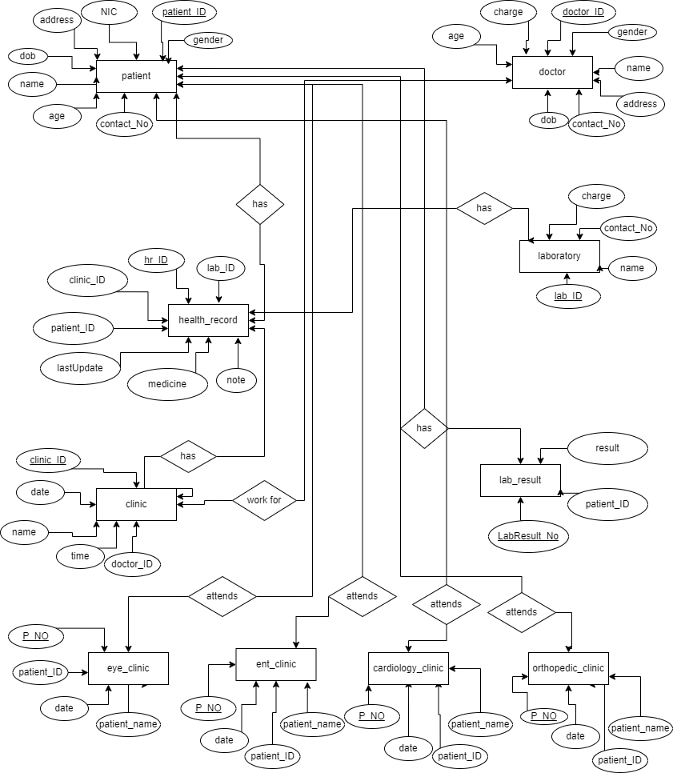

**3.2 RELATIONAL SCHEMA**

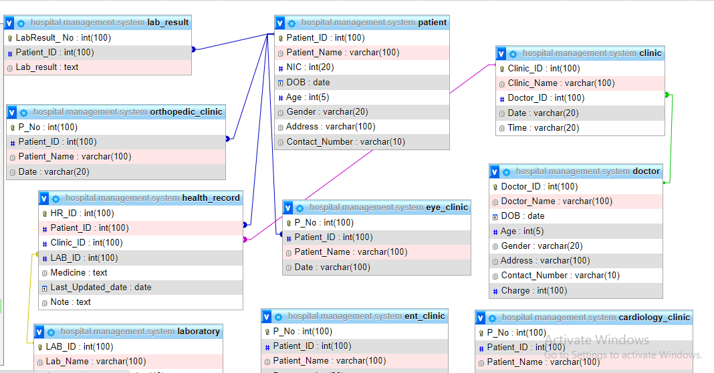

**4. SAMPLE REPORTS**

**4.1**

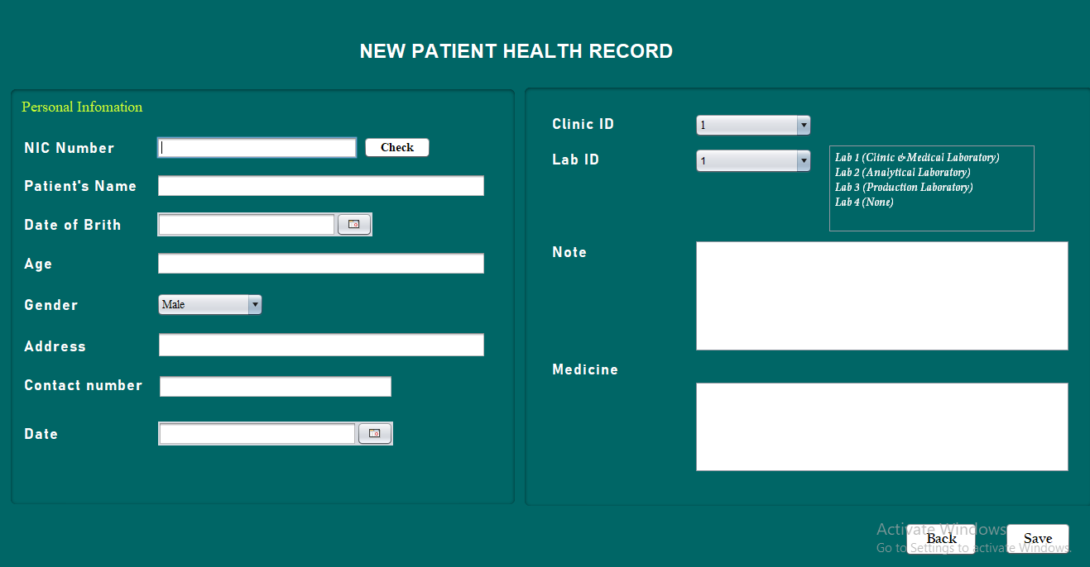

**4.2**

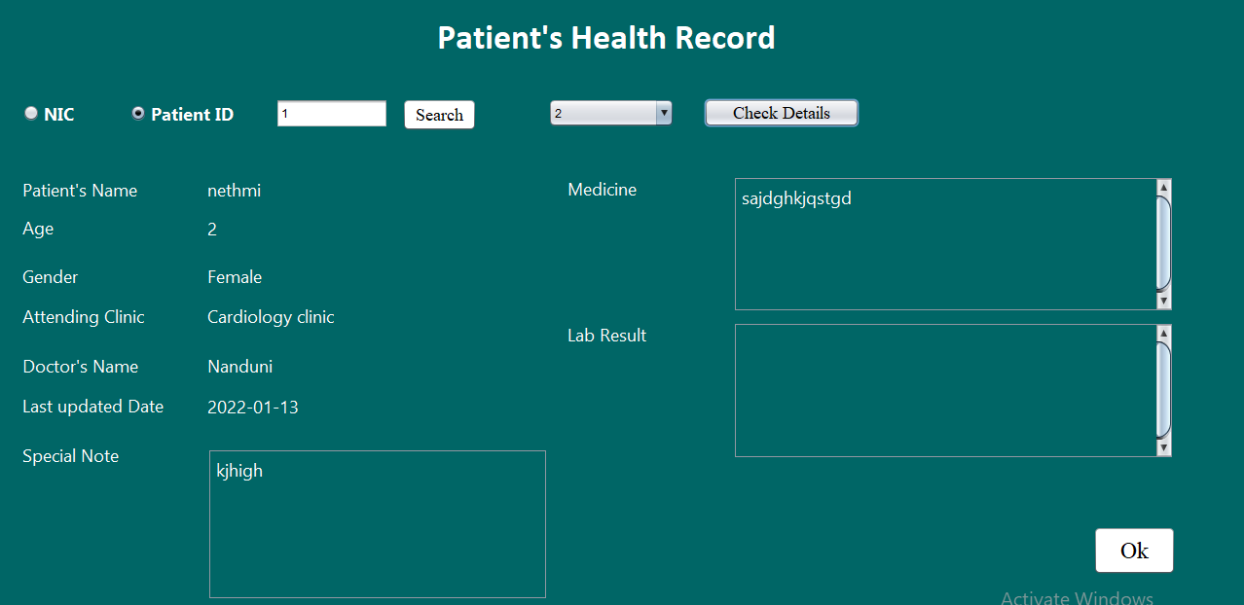

**5. PROS AND CONS OF THE DB DESIGN.**

**5.1 Pros**

* Reduce the data redundancy
* Can manage everything using one software

**5.2 Cons**

* Less security