

SRI LANKA INSTITUTE OF INFORMATION TECHNOLOGY

[**Enterprise Standards and Best Practices for IT Infrastructure**](http://courseweb.sliit.lk/course/view.php?id=137)

**4th Year 2nd Semester 2014**

Name: D.S.M.W Samarakoon

SLIIT ID: IT13044732

Practical Session: WE

Practical Number : Lab 1

Date of Submission:

Date of Evaluation : _____________________

Evaluators Signature : _____________________

**Introduction to AWS**

1. Create an AWS(Amazon Web Services) account.
2. Login to AWS and go to EC2.
3. Create one Linux box.
4. Create one Windows box.
5. Windows Box

Remote desktop

ssh

1. Linux box

Remote desktop

ssh

**Creating window box(Remote Desktop)**

1. Create an account in Amazon Web Server and log into that.

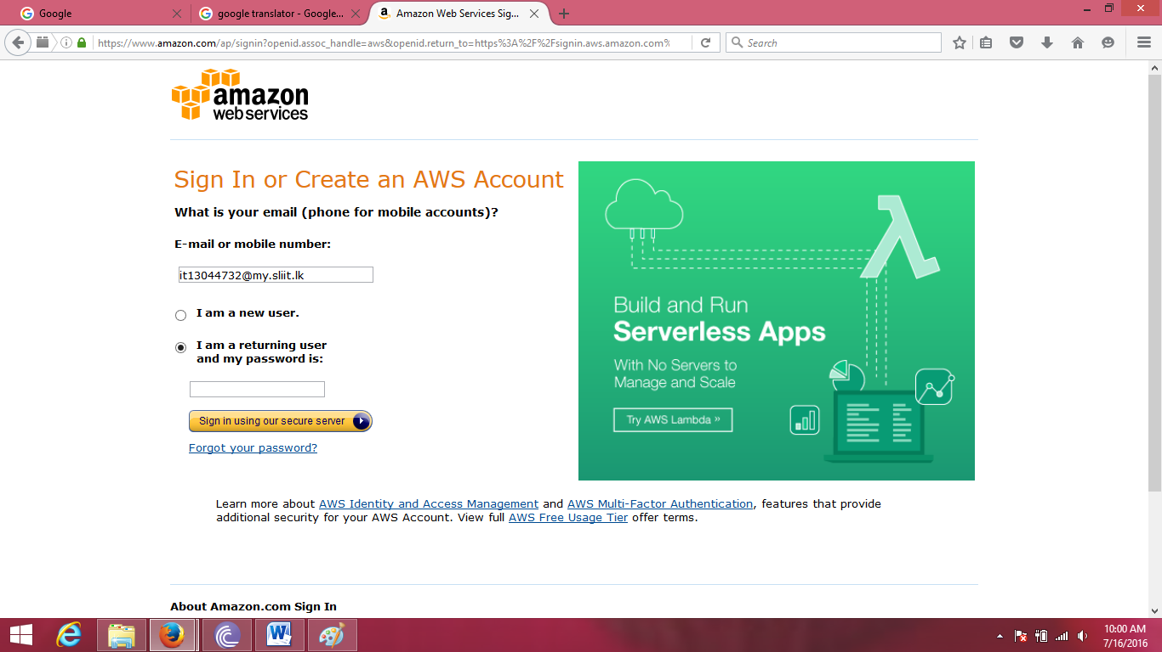

1. Then under the Amazon web services choose the EC2 as following.

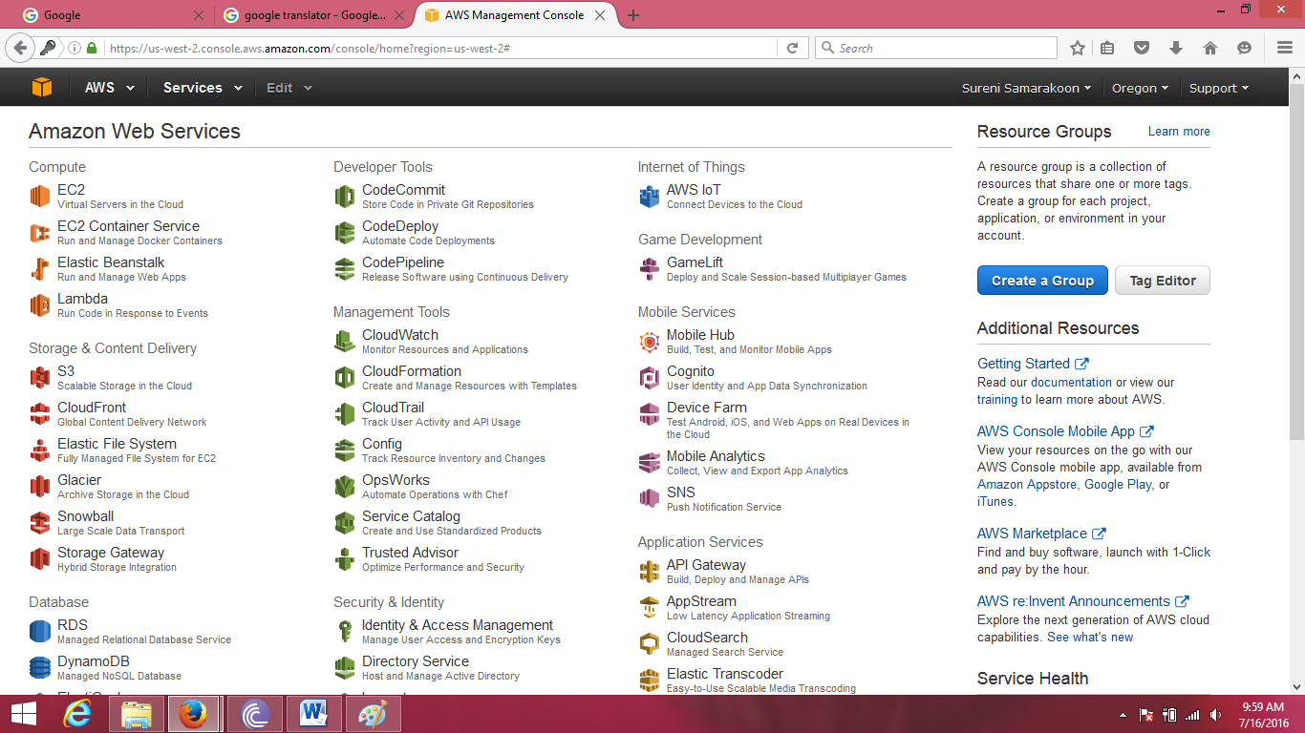

1. Then launch a instance using EC2.(The blue color button)

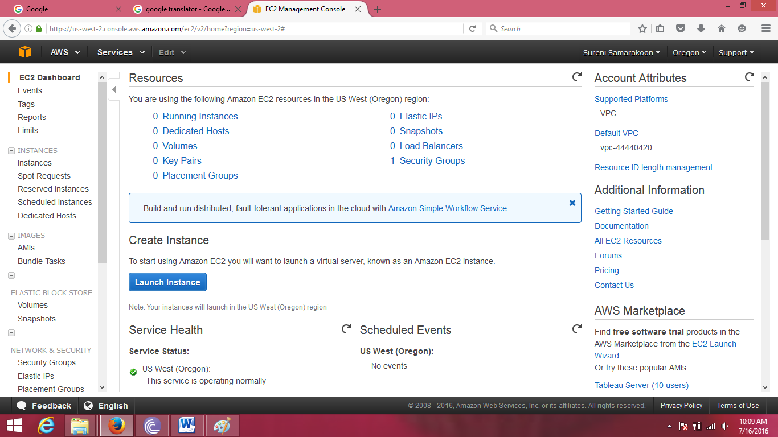

1. Then choose the Amazon Machine Image as Microsoft Windows Server 2012 R2 Base as follow.

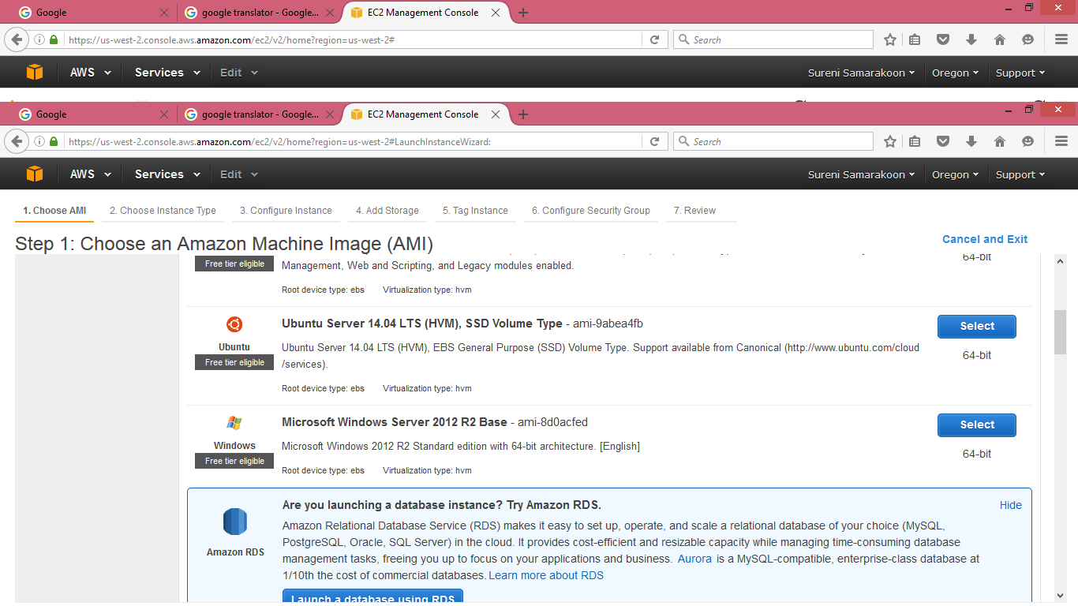

1. Then choose an instance type. Here we kept the default settings and launched the instance as it is.

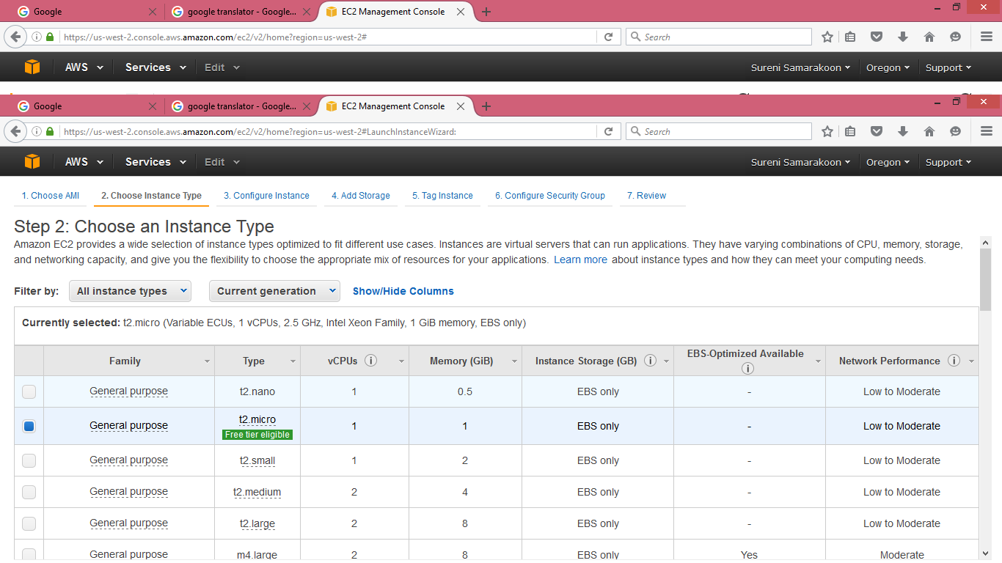

1. Review and launch the instance. Review and launch as it is.

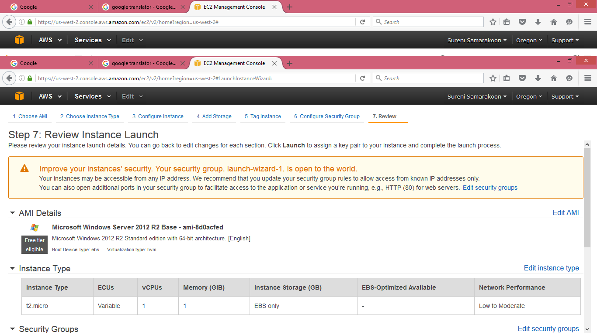

1. After launching we should create an key pair as follows.

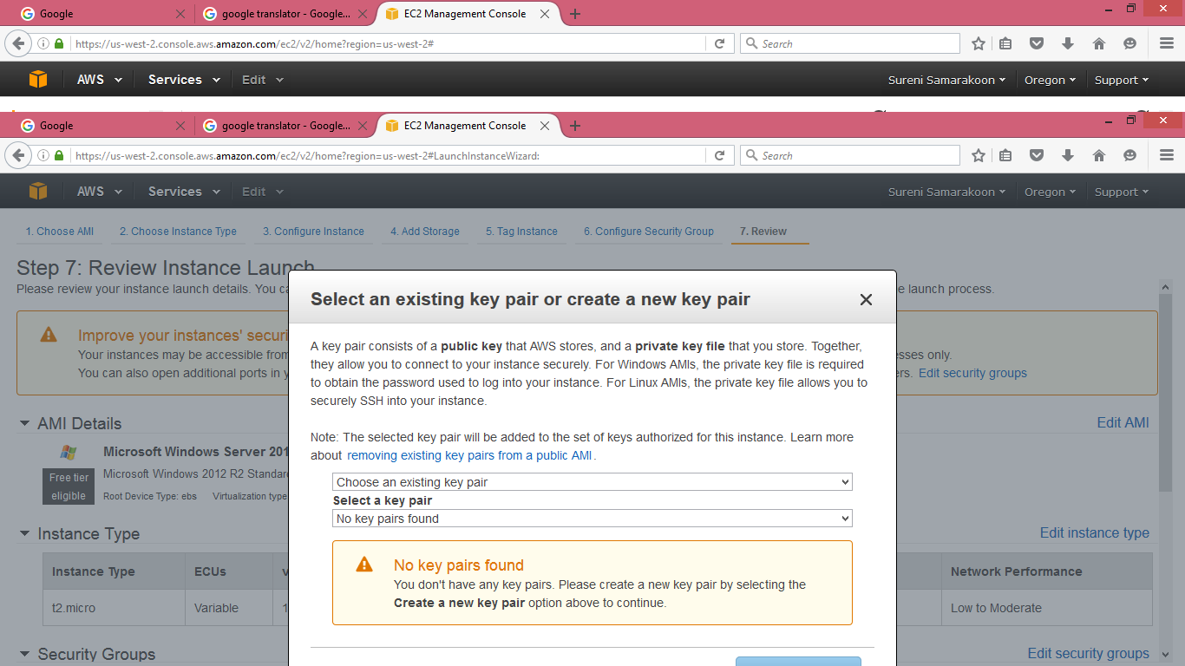

1. After creating a new key pair download that created key pair.

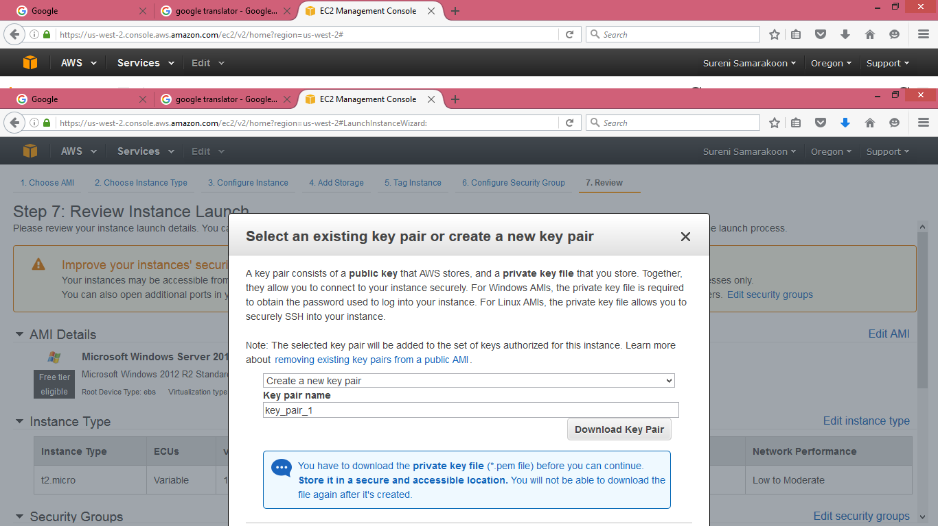

1. After creating an instance you will get a window as below by mentioning the state as running.

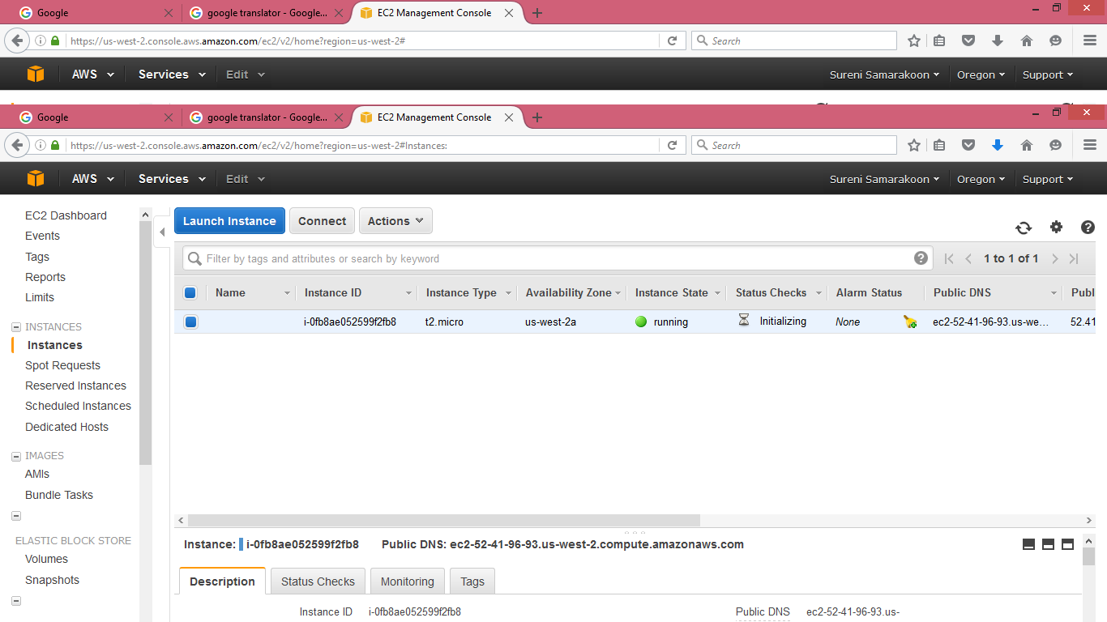

1. Connect the launched instance by clicking connect button.

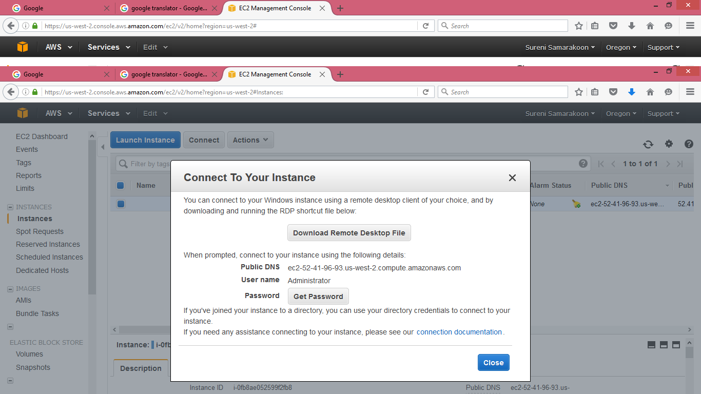

1. Click the “Get Password” button and brows the created new key pair we downloaded earlier and Click the “Decrypt Password” button.

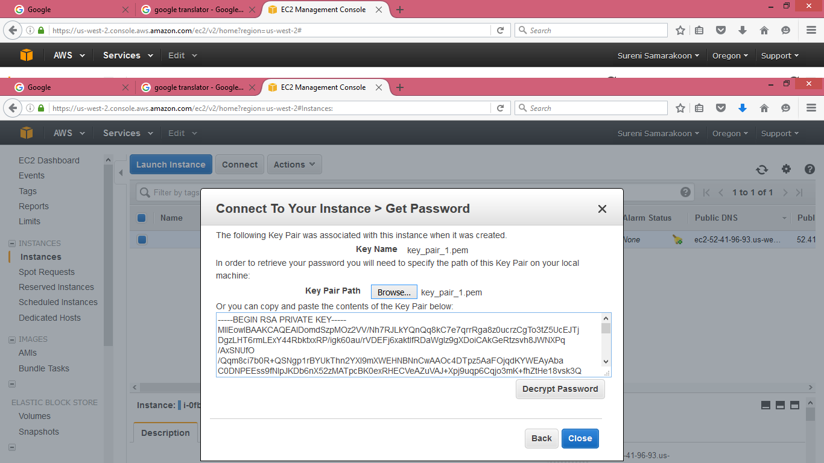

1. After decrypting the password you can see the followings and there you have to note User name and password of the instance to connect to the Remote Desktop connection.

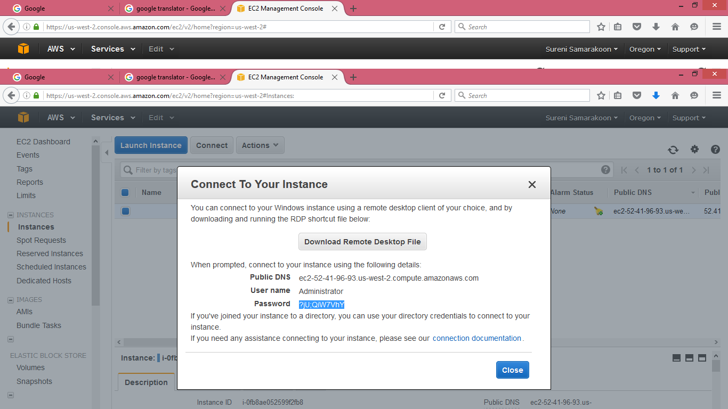

1. Then connect to the Remote Desktop connection by using Public IP address.

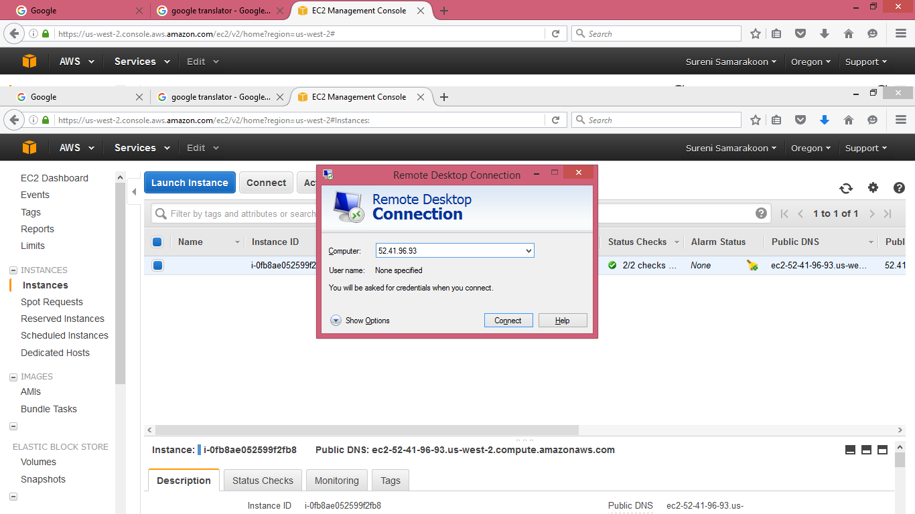

1. After connecting to the remote desktop connection appears the following window.

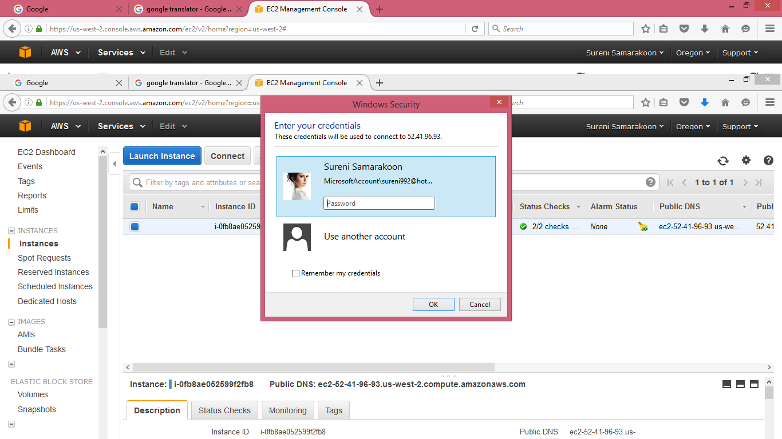

1. Use another account and give the User name and Password that we noted earlier when connecting to the instance.

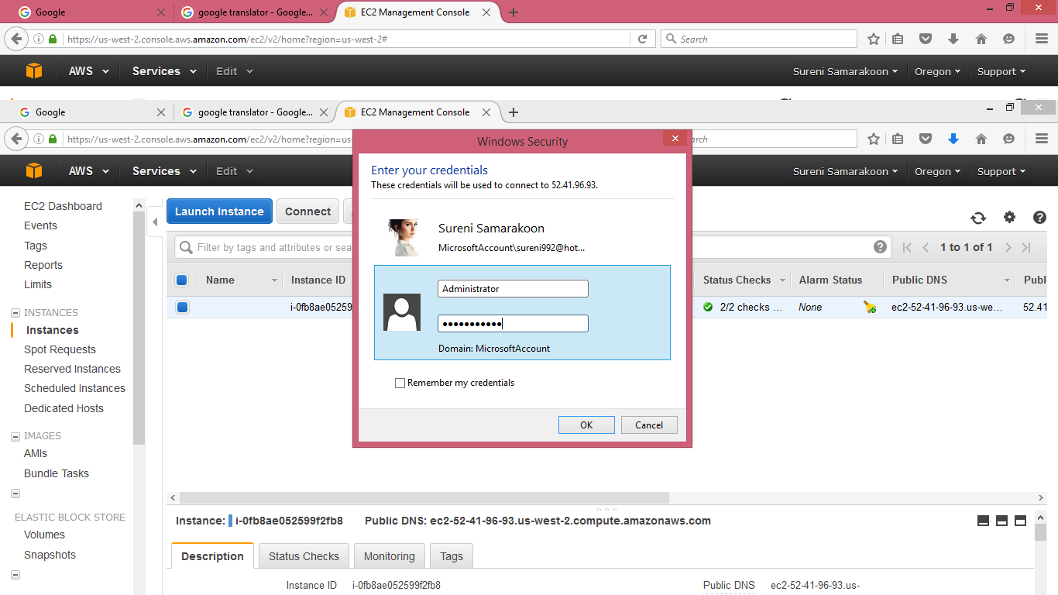

1. After clicking OK button you will get a widow as follows.

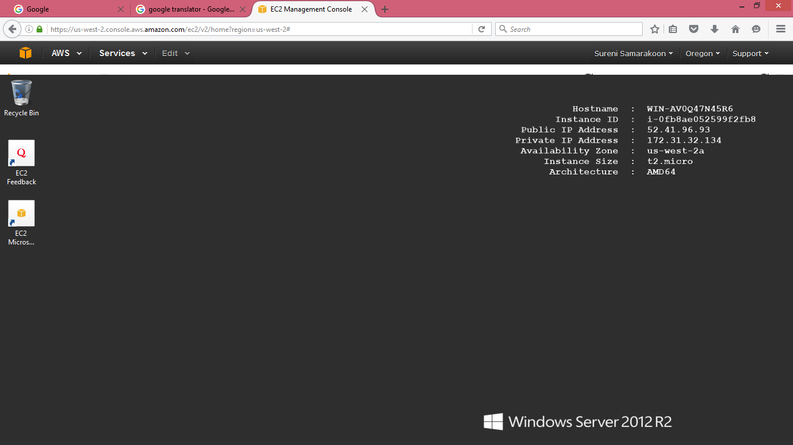

1. If you want to terminate the instance go to the AWS and do the followings.

