

SRI LANKA INSTITUTE OF INFORMATION TECHNOLOGY

[**Enterprise Standards and Best Practices for IT Infrastructure**](http://courseweb.sliit.lk/course/view.php?id=137)

**4th Year 2nd Semester 2014**

Name: D.S.M.W Samarakoon

SLIIT ID: IT13044732

Practical Session: WE

Practical Number : Lab 1

Date of Submission:

Date of Evaluation : _____________________

Evaluators Signature : _____________________

**Creating a DB Instance in SQL Server using AWS**

1. Choose the RDS from the Database and double click on that.

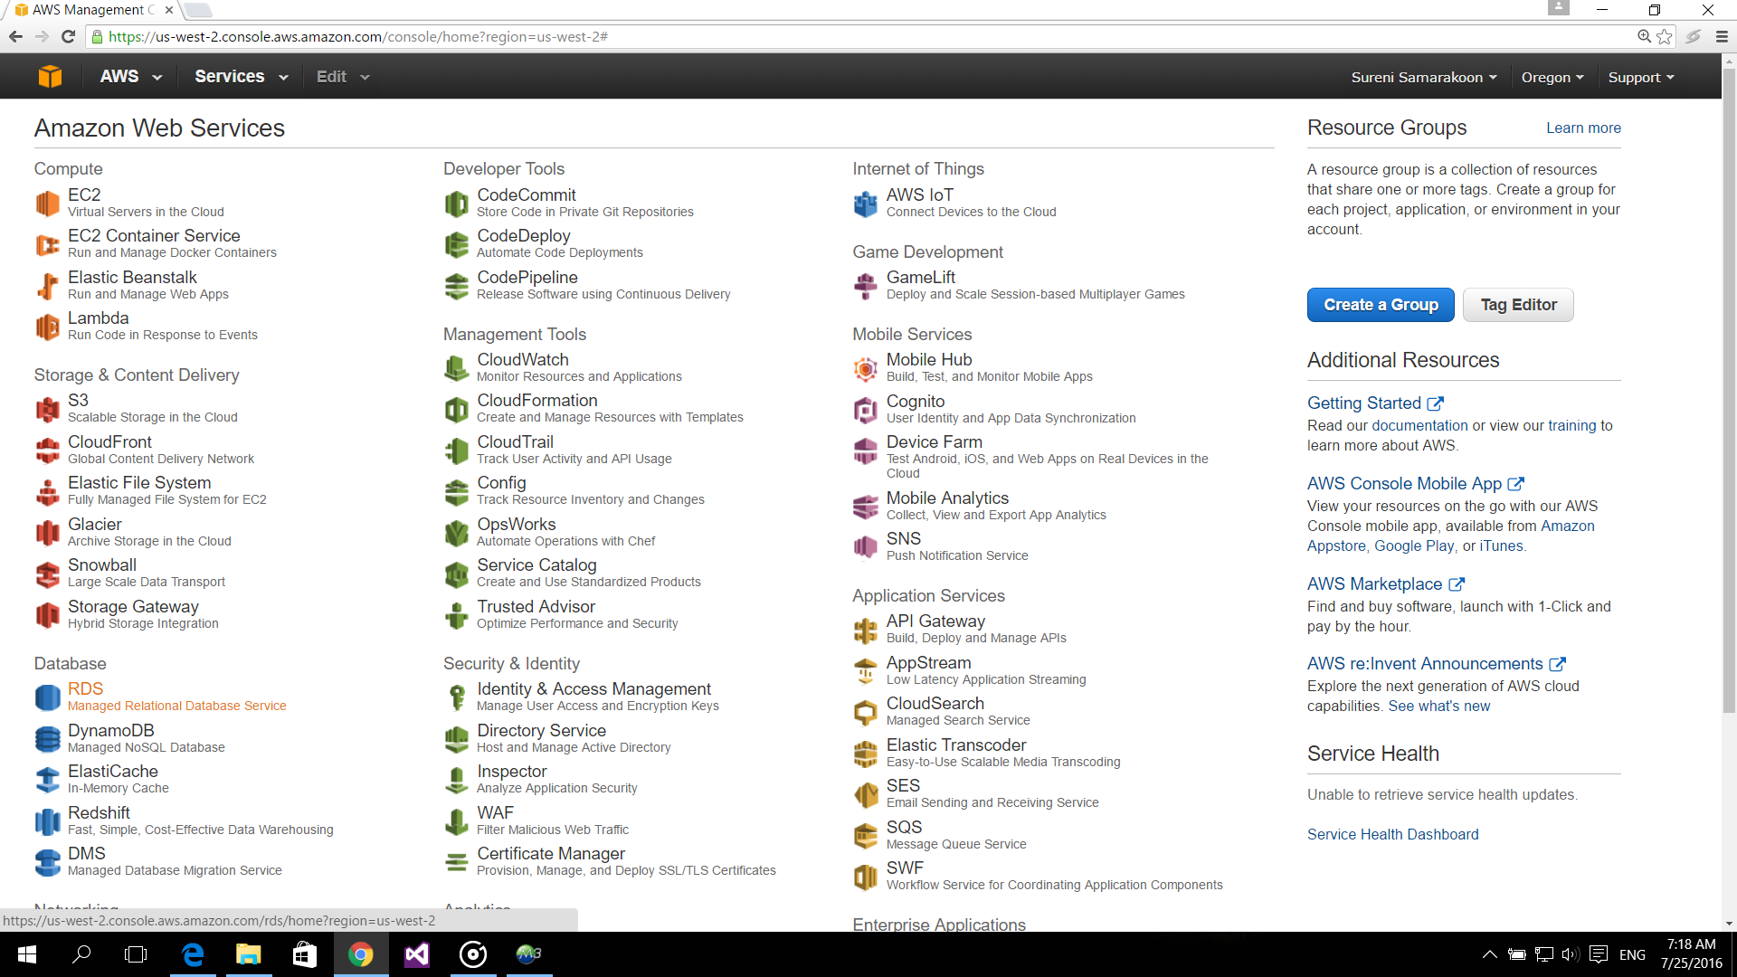

1. Then click on the button named as Launch DB Instance.

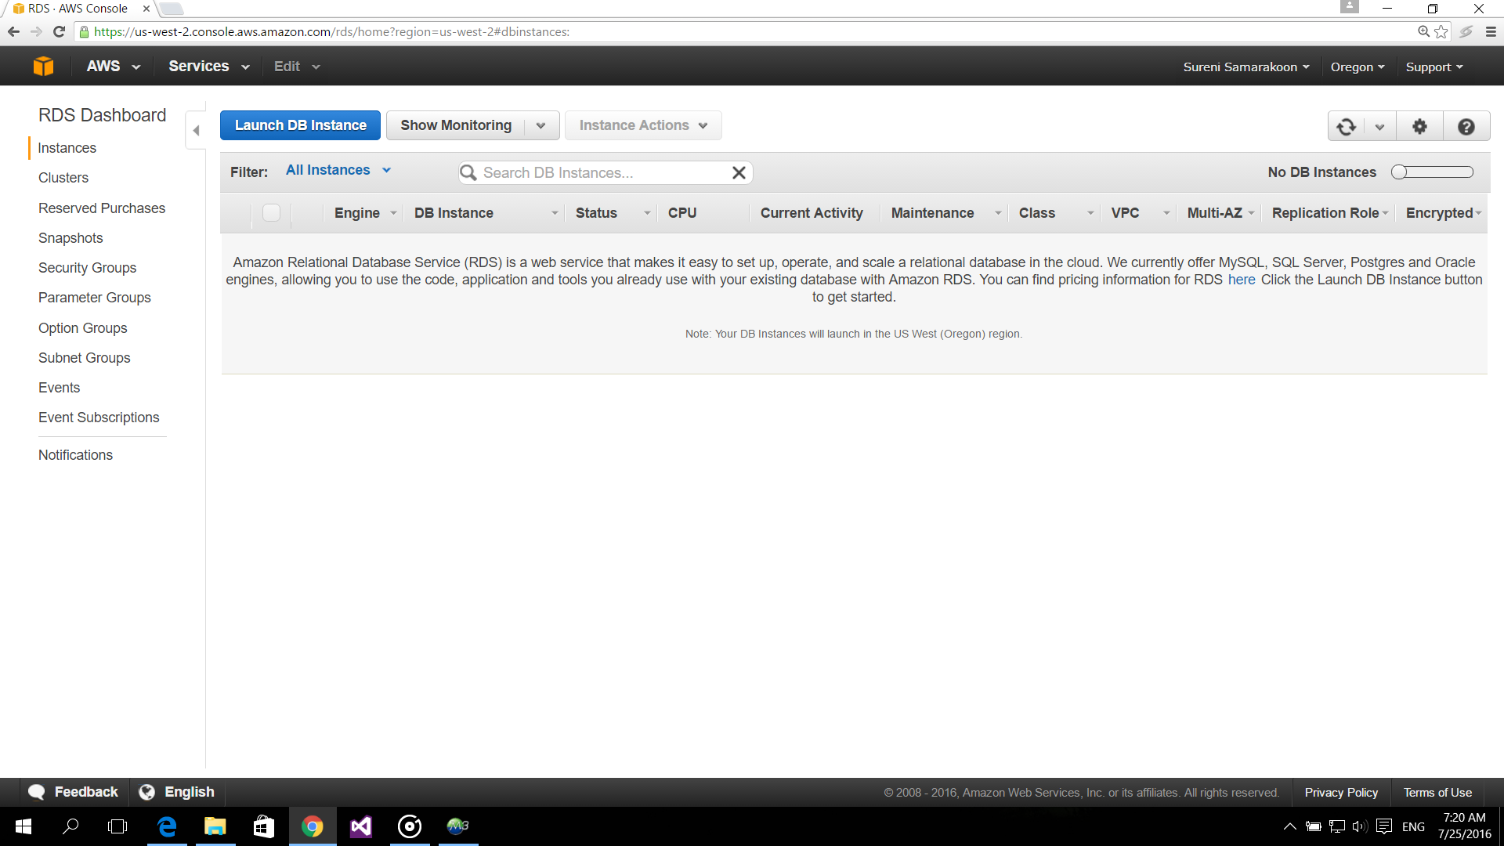

1. Select the DB Engine as MySql.

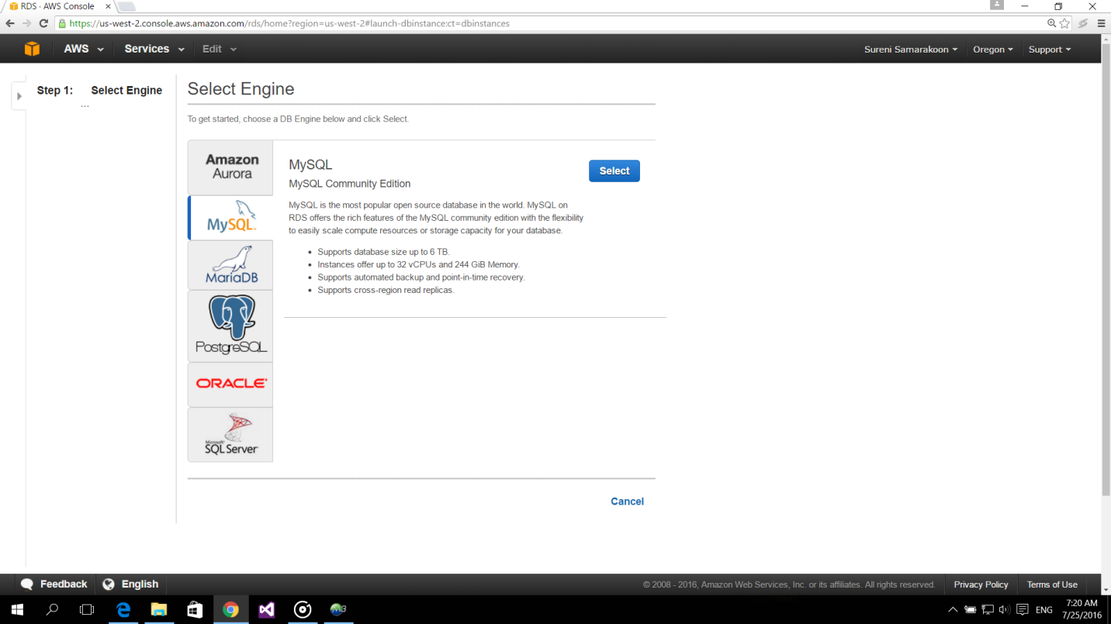

1. Then select the production call MySql as follows and click on “Next Step” button.

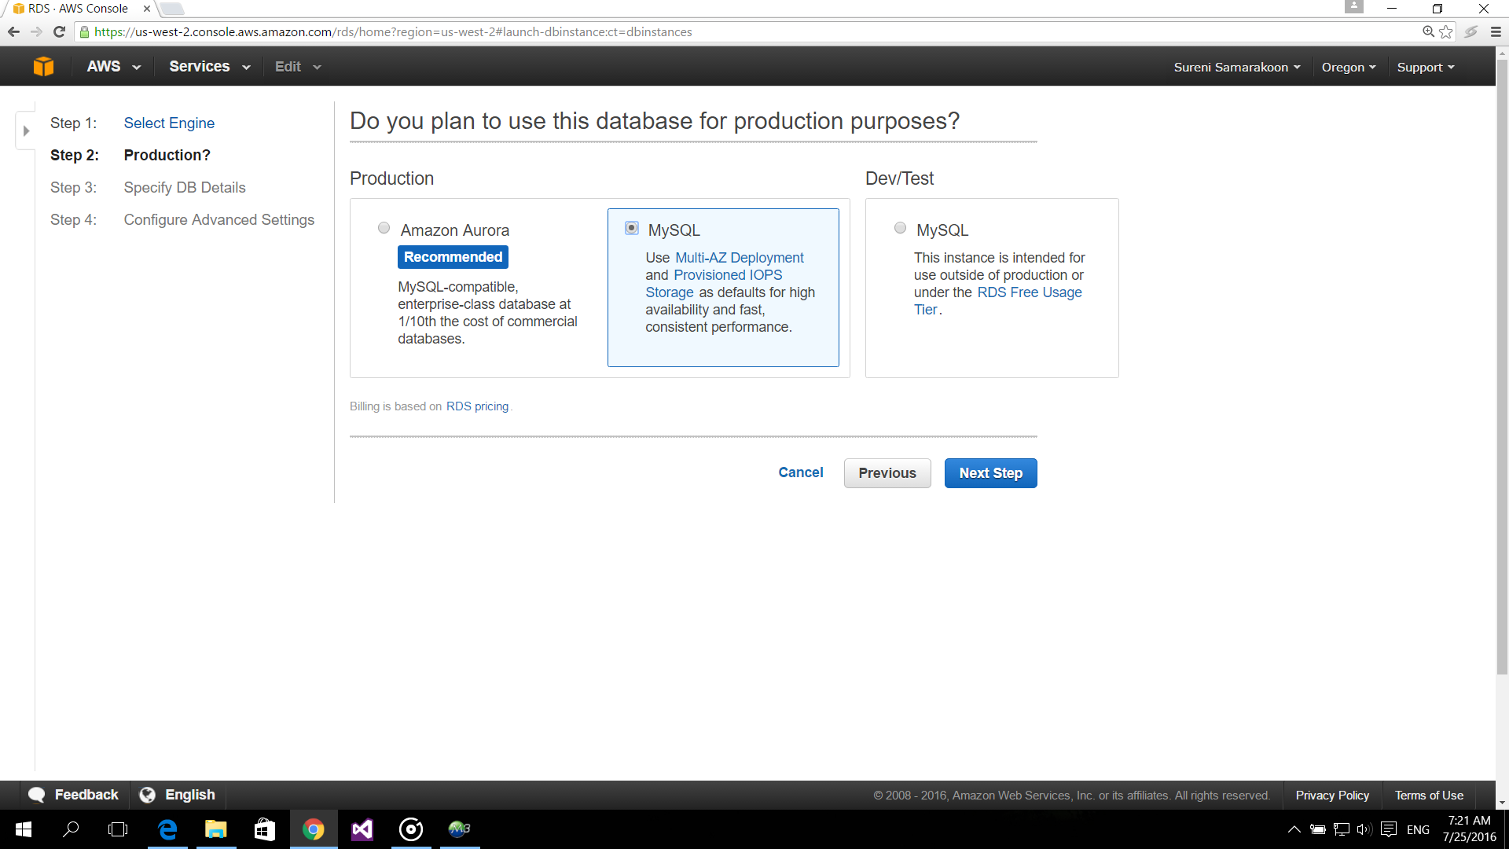

1. Specify the DB details as follows.

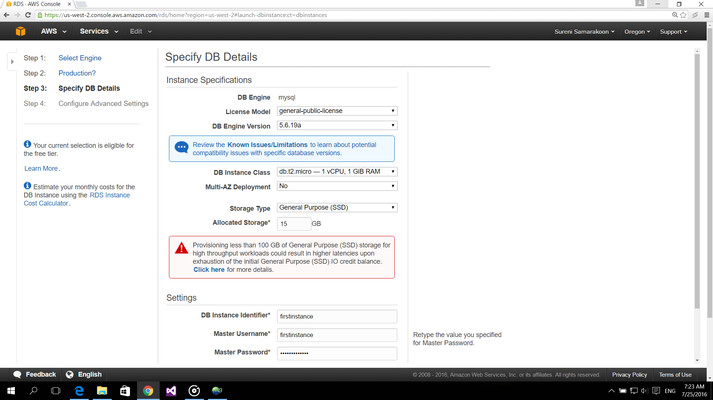

1. In the setting section give the DB instance identifier, Master username and Master password as follows.

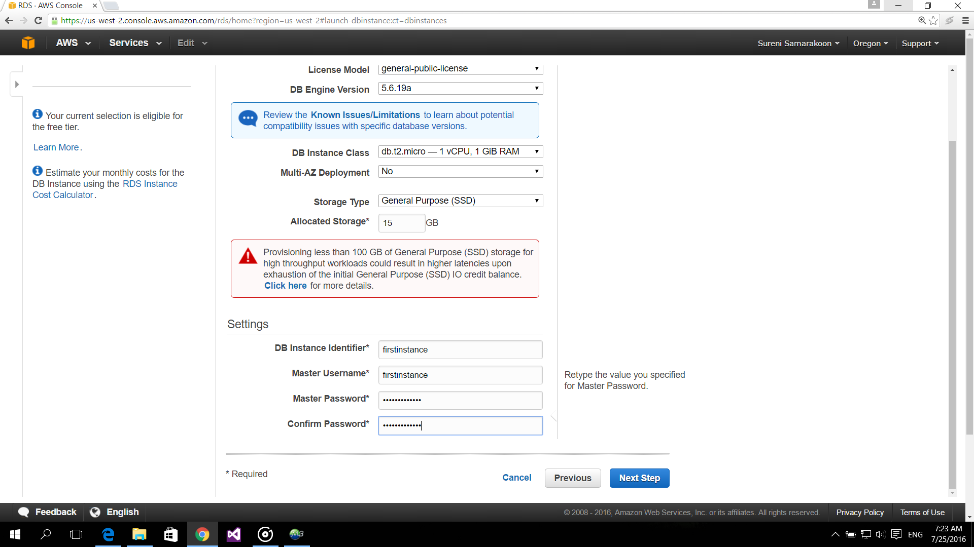

1. Then configure the advanced settings as follow and click on the “Launch DB Instance” button.

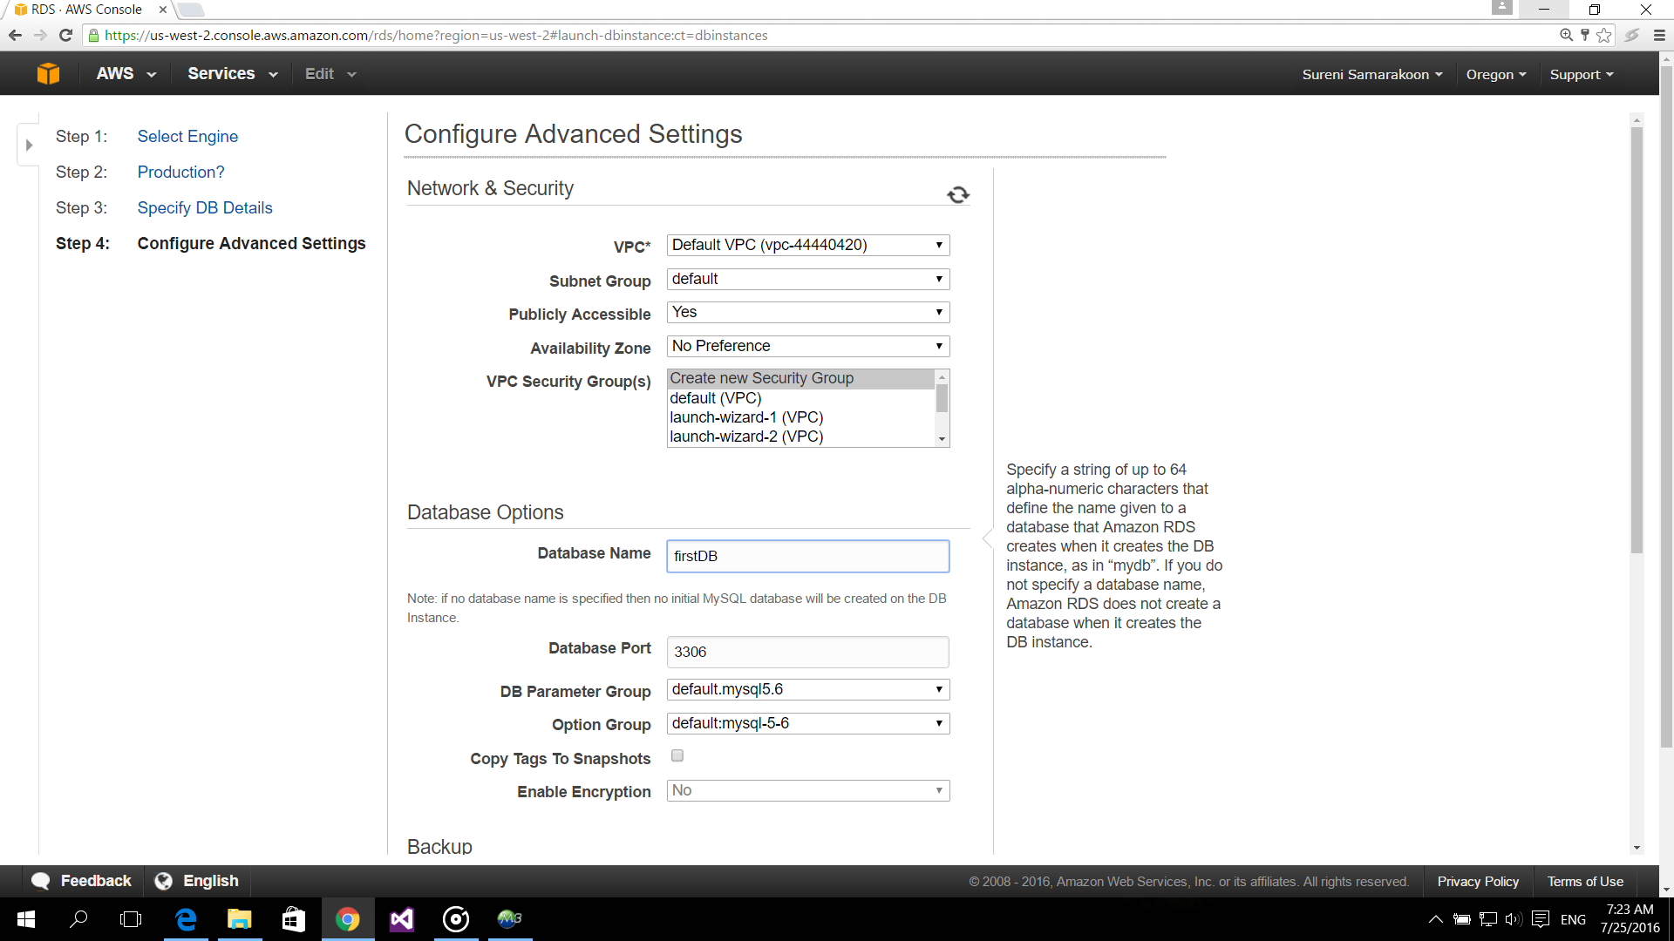

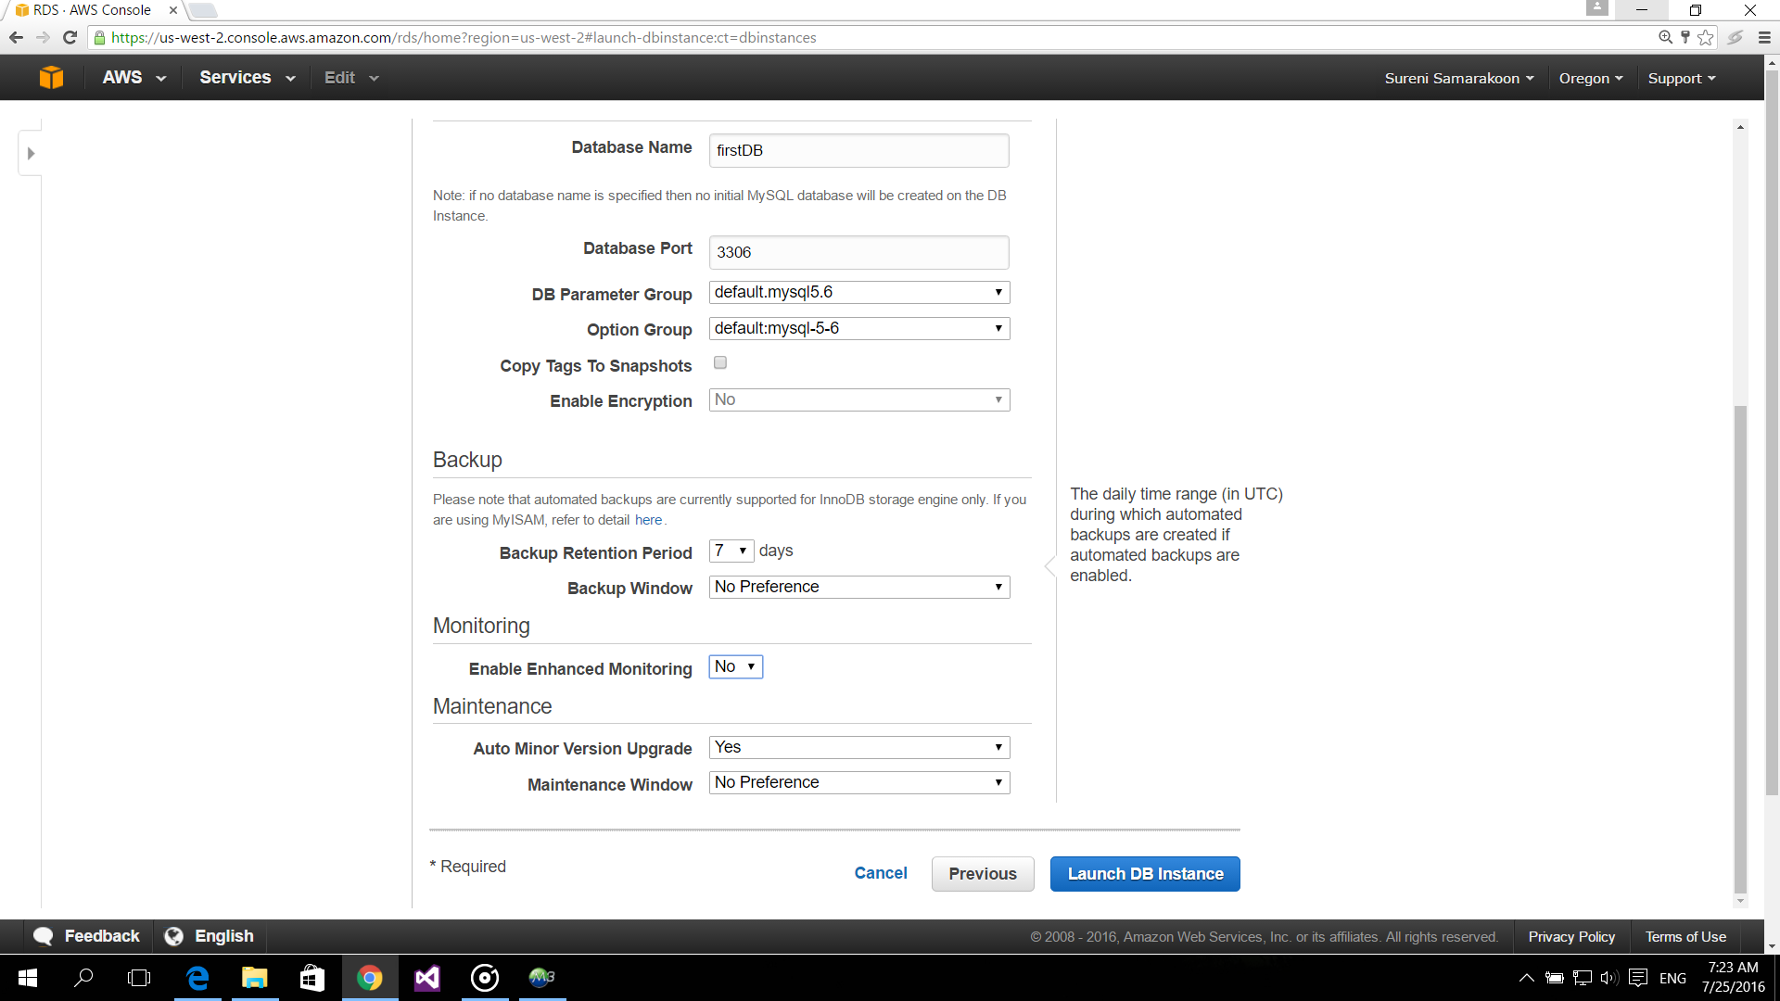

1. After getting the window as following click on the blue button named as “View Your DB Instance”.

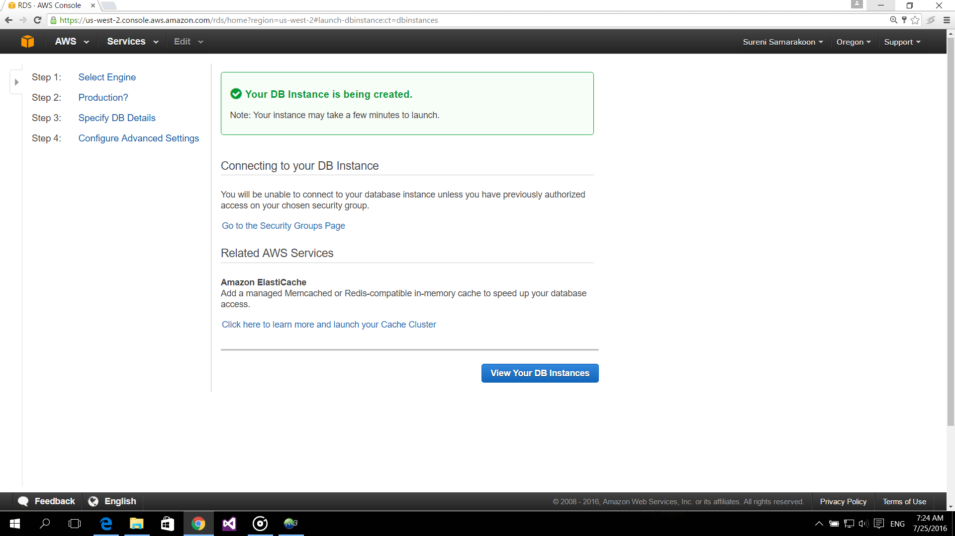

1. Then you can see your DB instance creating as follows.

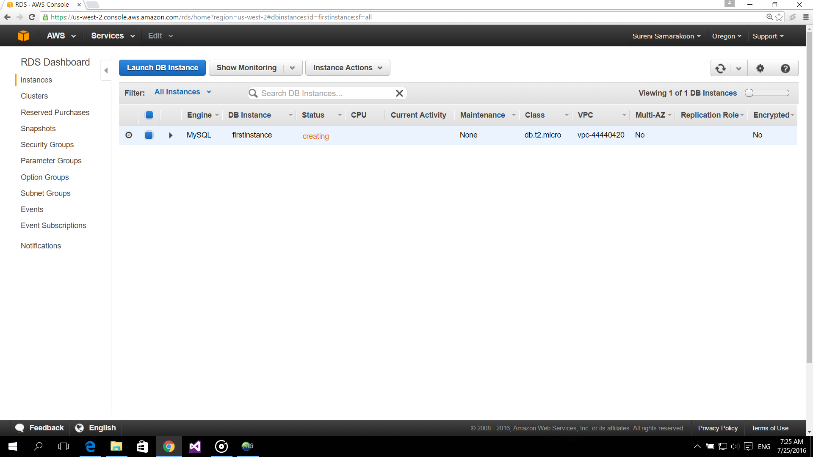

1. Then backing up and the availability of your DB Instance are showing in the windows as follows with details.

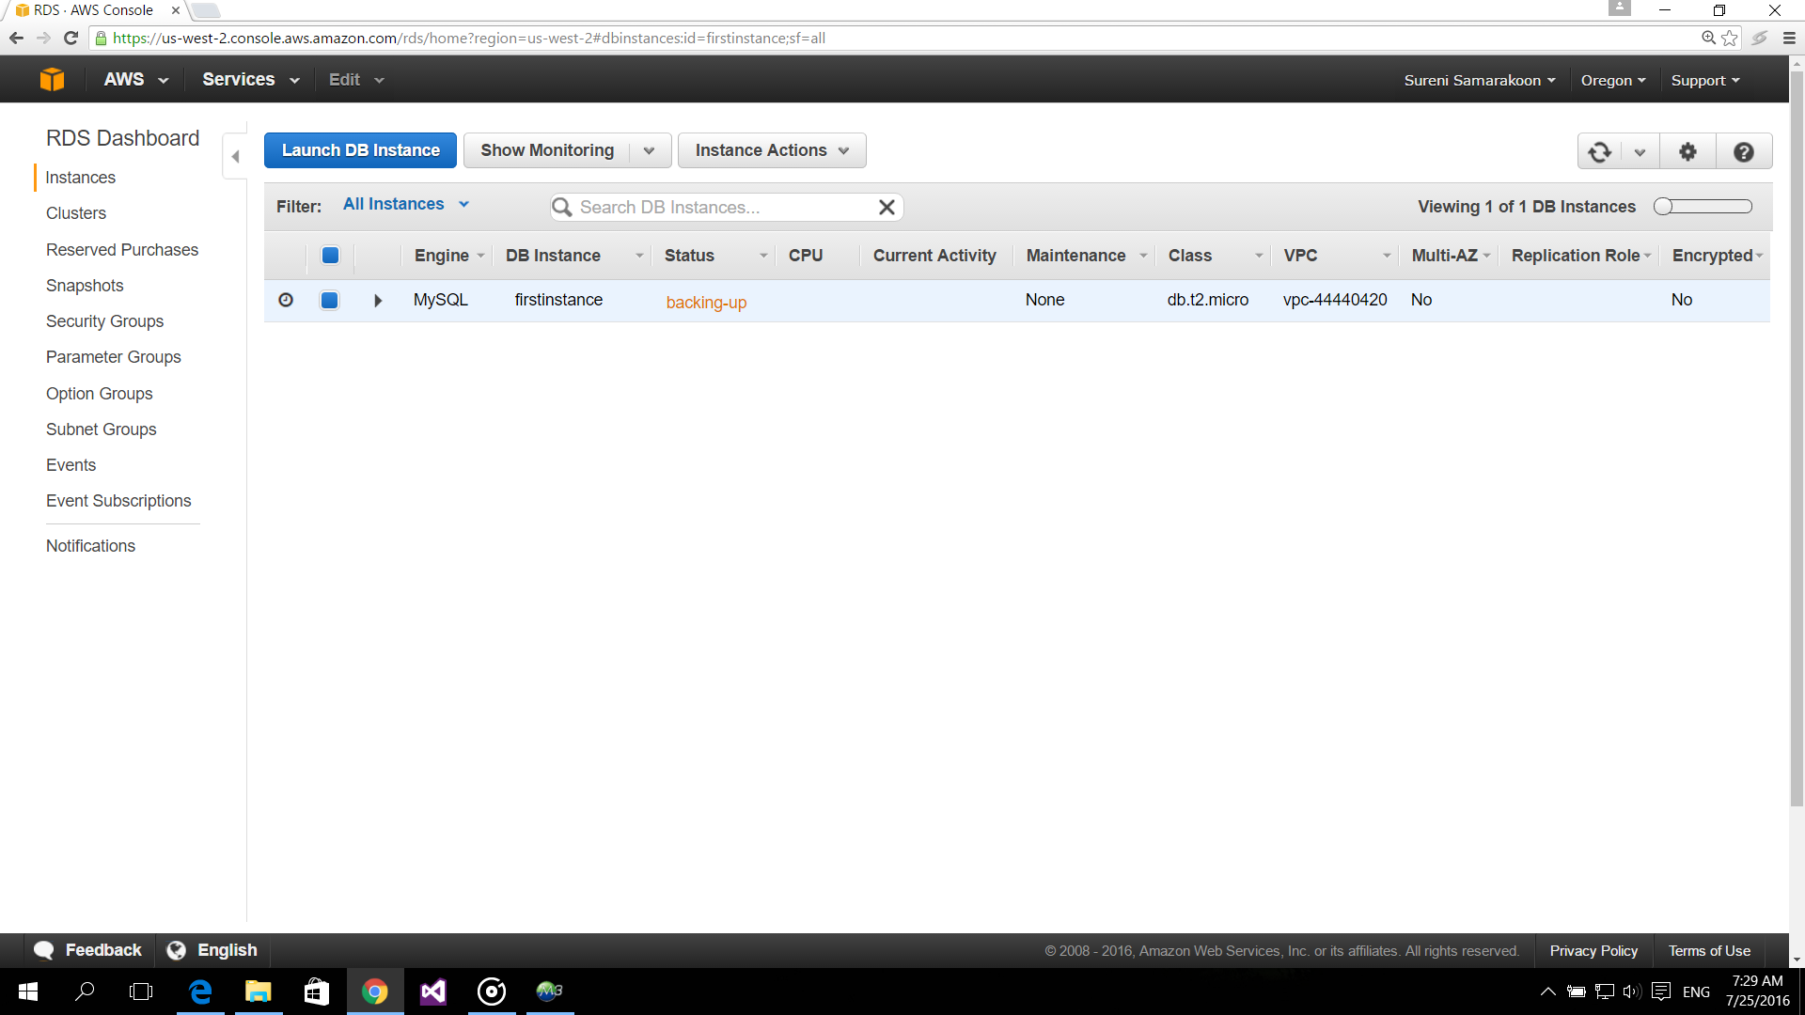

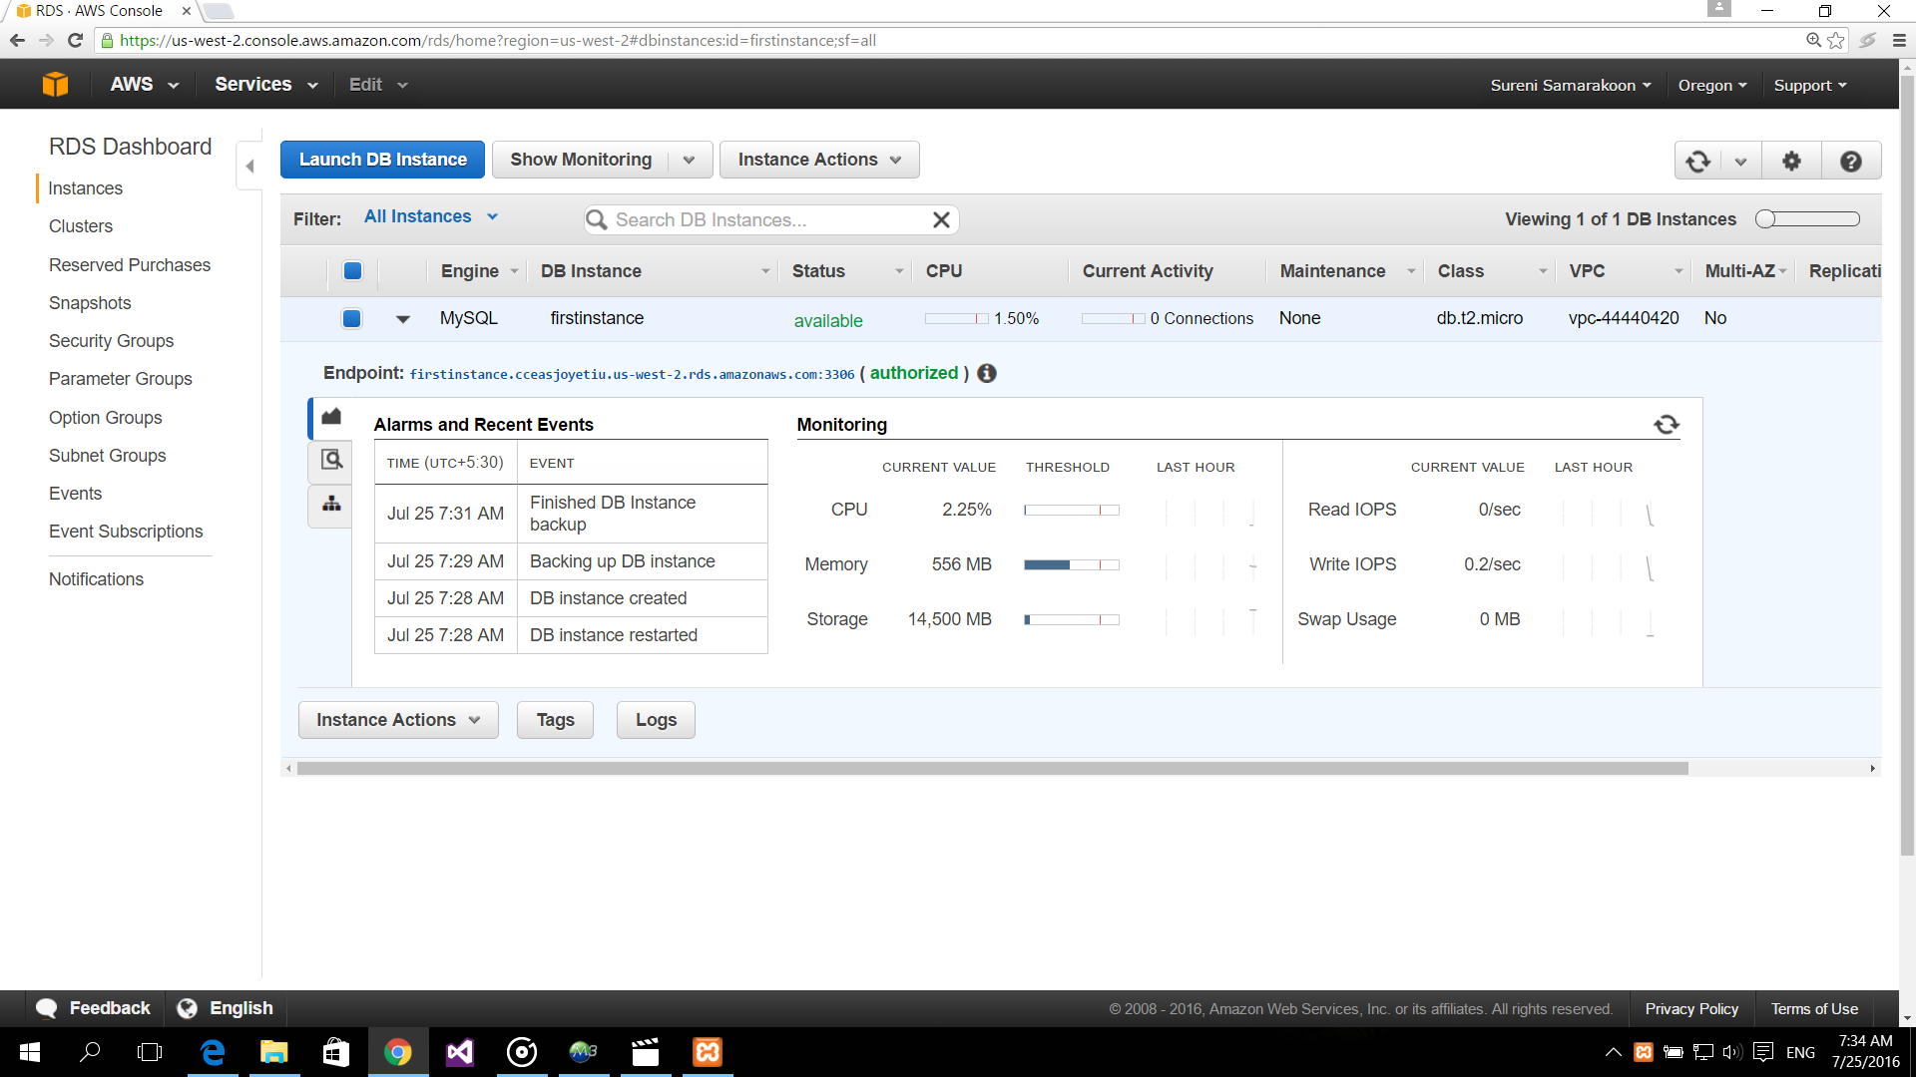

1. If your DB Instance created correctly the following widows show in order.

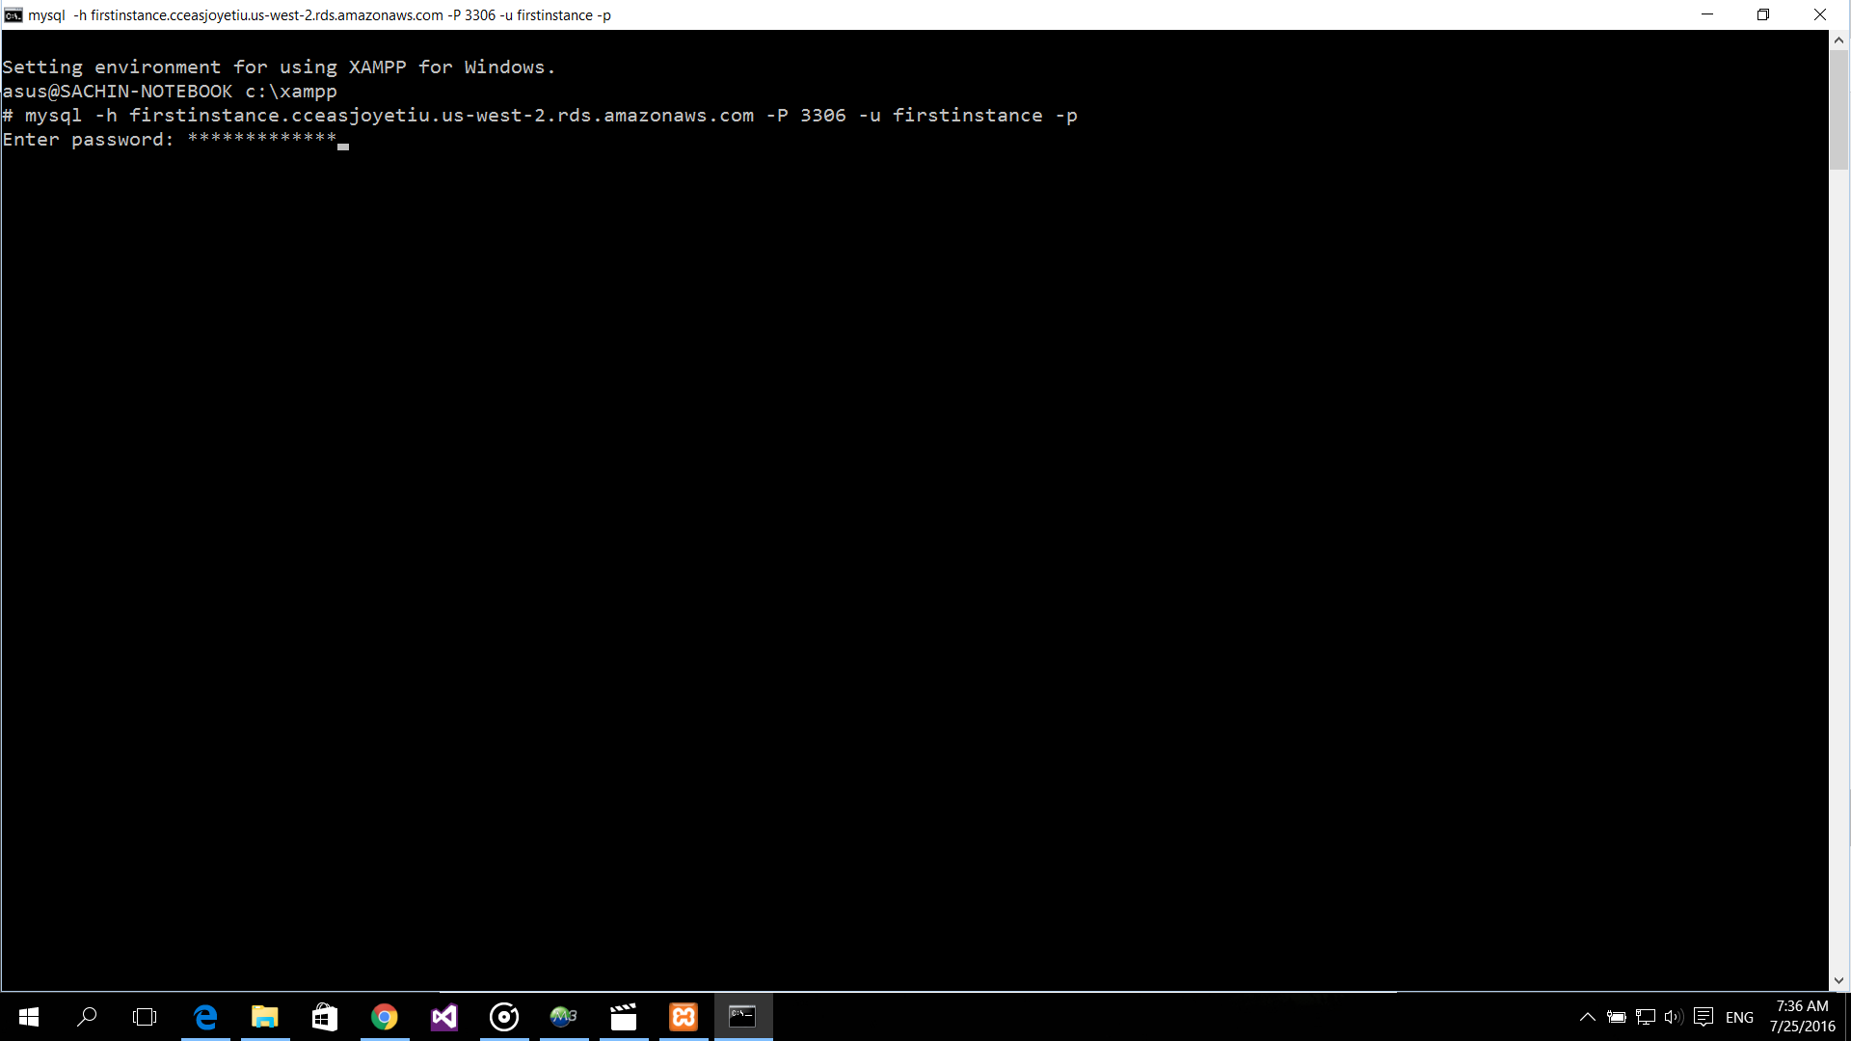

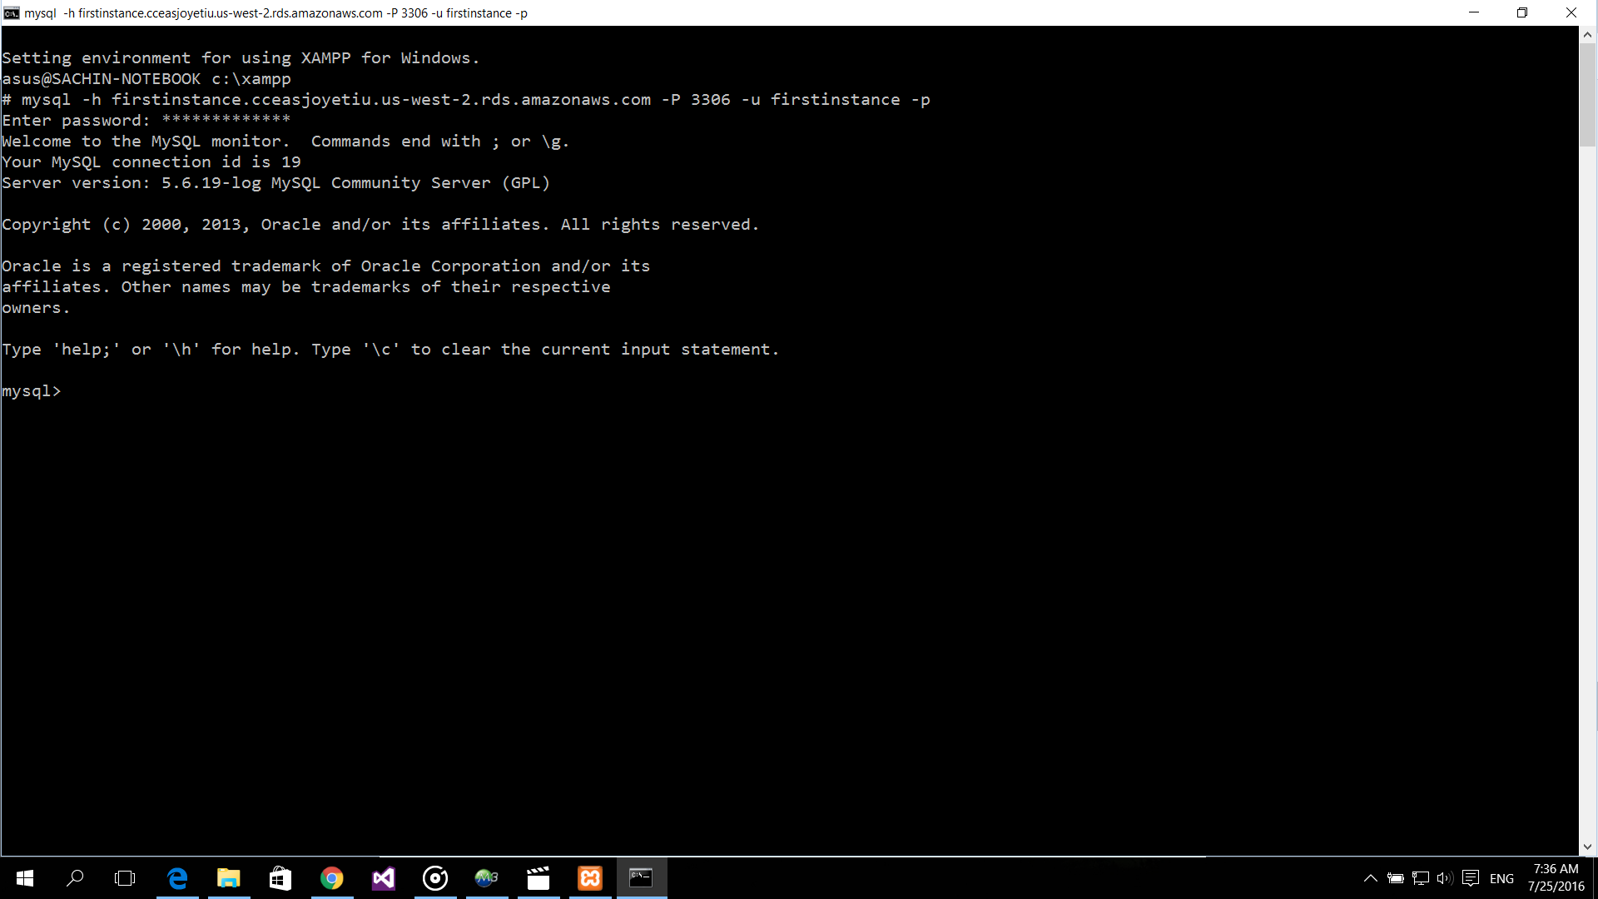

1. After you check your DB Instance work properly, you can shut down your DB instance as follows.

