

SRI LANKA INSTITUTE OF INFORMATION TECHNOLOGY

[**Enterprise Standards and Best Practices for IT Infrastructure**](http://courseweb.sliit.lk/course/view.php?id=137)

**4th Year 2nd Semester 2016**

Name: Samarakoon D.S.M.W.

SLIIT ID: IT13044732

Practical Session: WE

Practical Number : Lab 4

Date of Submission: 15.08.2016

**Lab 04 –** Installation of ESXi 5 (VMware Hypervisor Installation)

Installation of ESXi 5 (VMware Hypervisor Installation)

Step 01: Install VMware Workstation to get started with installing ESXi 5.

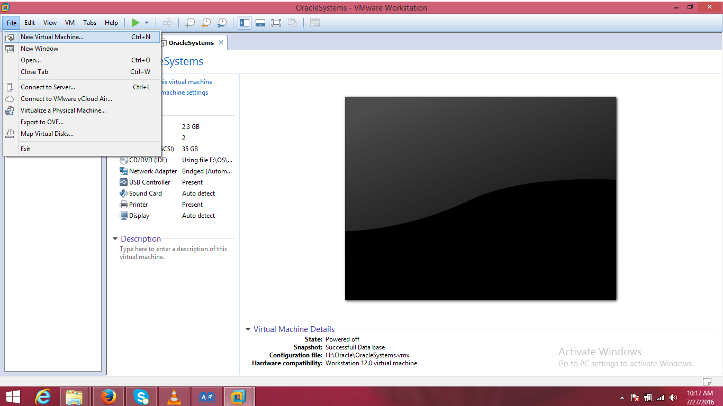

Step 02: Select ‘Create a New Virtual Machine’ from ‘Home’ tab.

Choose ‘Typical’ and click ‘Next’.

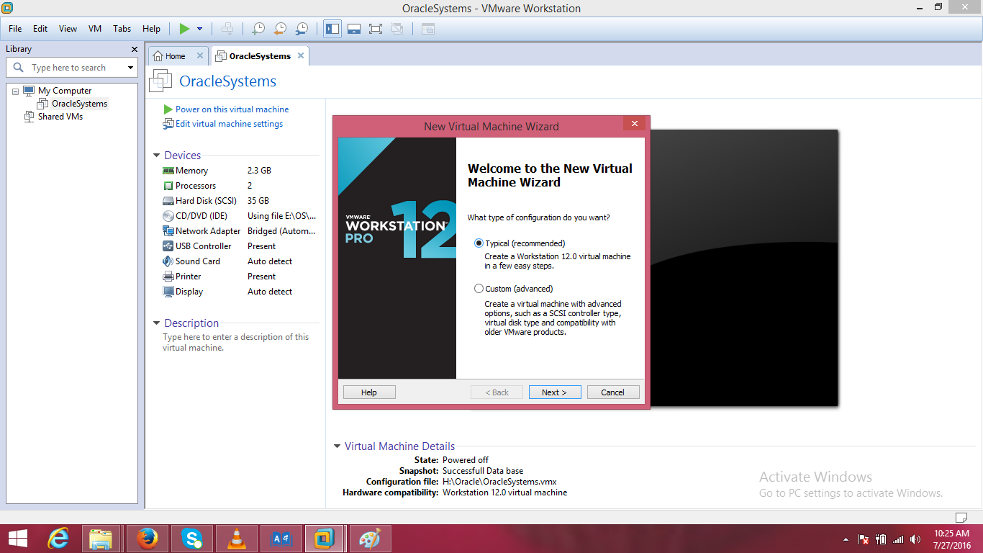

Step 03: Select ‘Installer disk image file (iso)’ from next window.

Browse for the ESXi 5 iso and click ‘Next’.

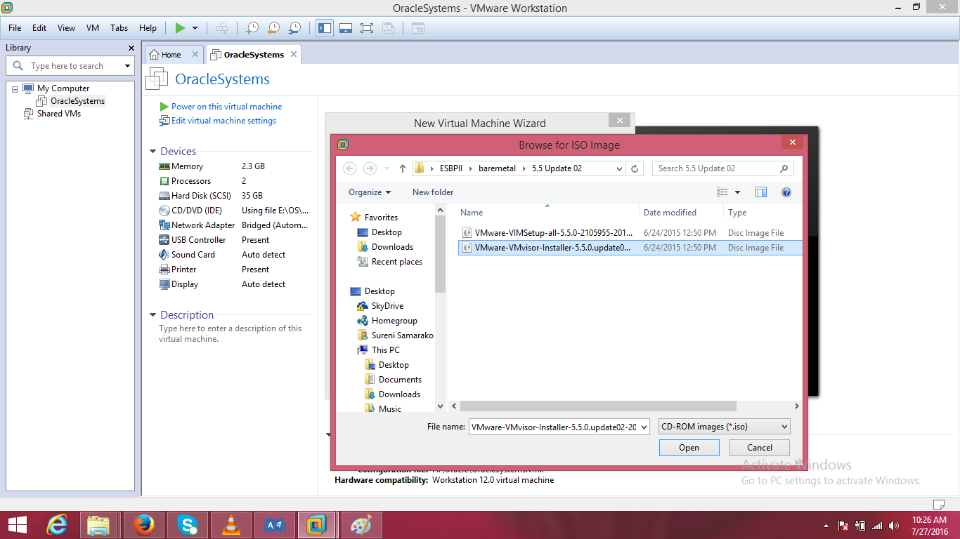

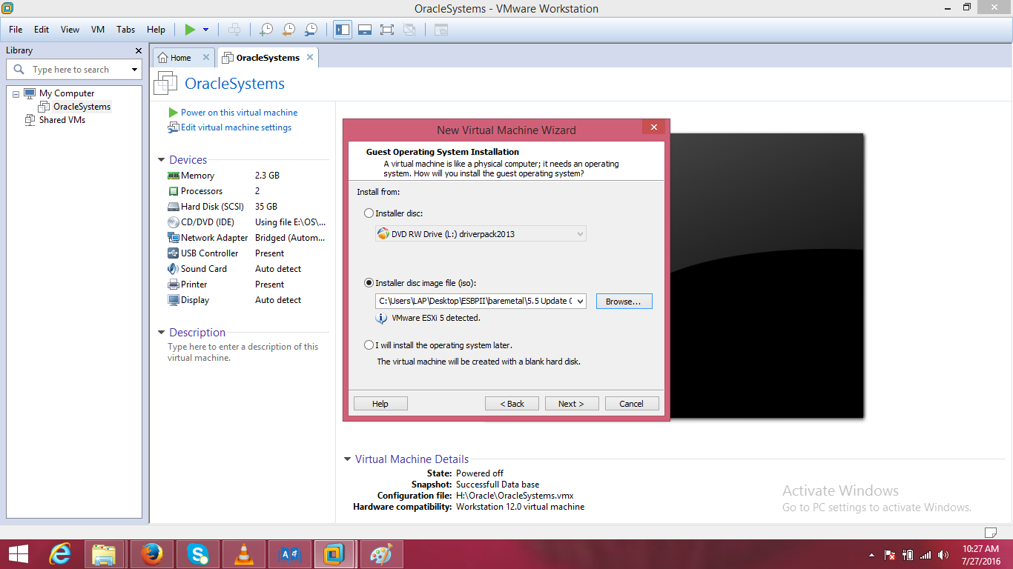

Step 04: Provide a name for the virtual machine.

Browse for a location to save and click ‘Next’.

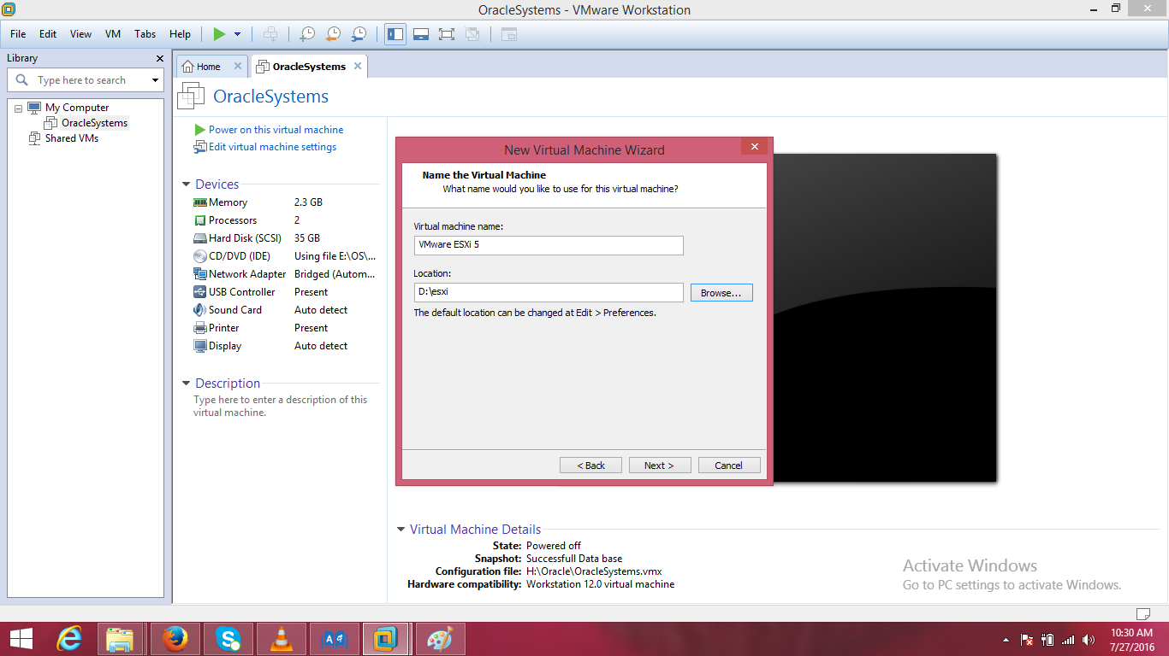

Step 05: Specify the disk capacity.

Keep the recommended size for VMware ESXi 5 as it is. (40 GB)

Choose ‘Store virtual disk as a single file’ and click ‘Next’.

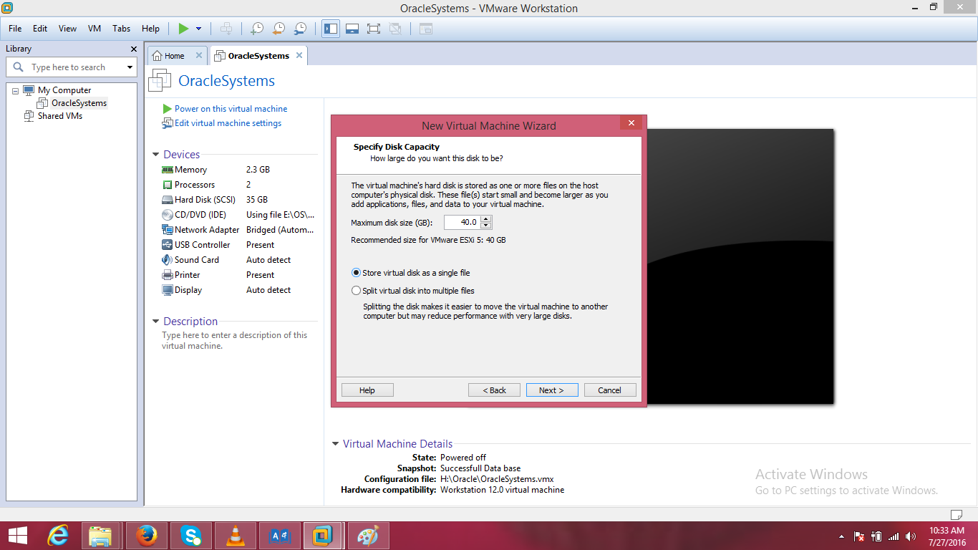

Step 06: Select ‘Power on this virtual machine after creation’.

Check the settings and click ‘Finish’.

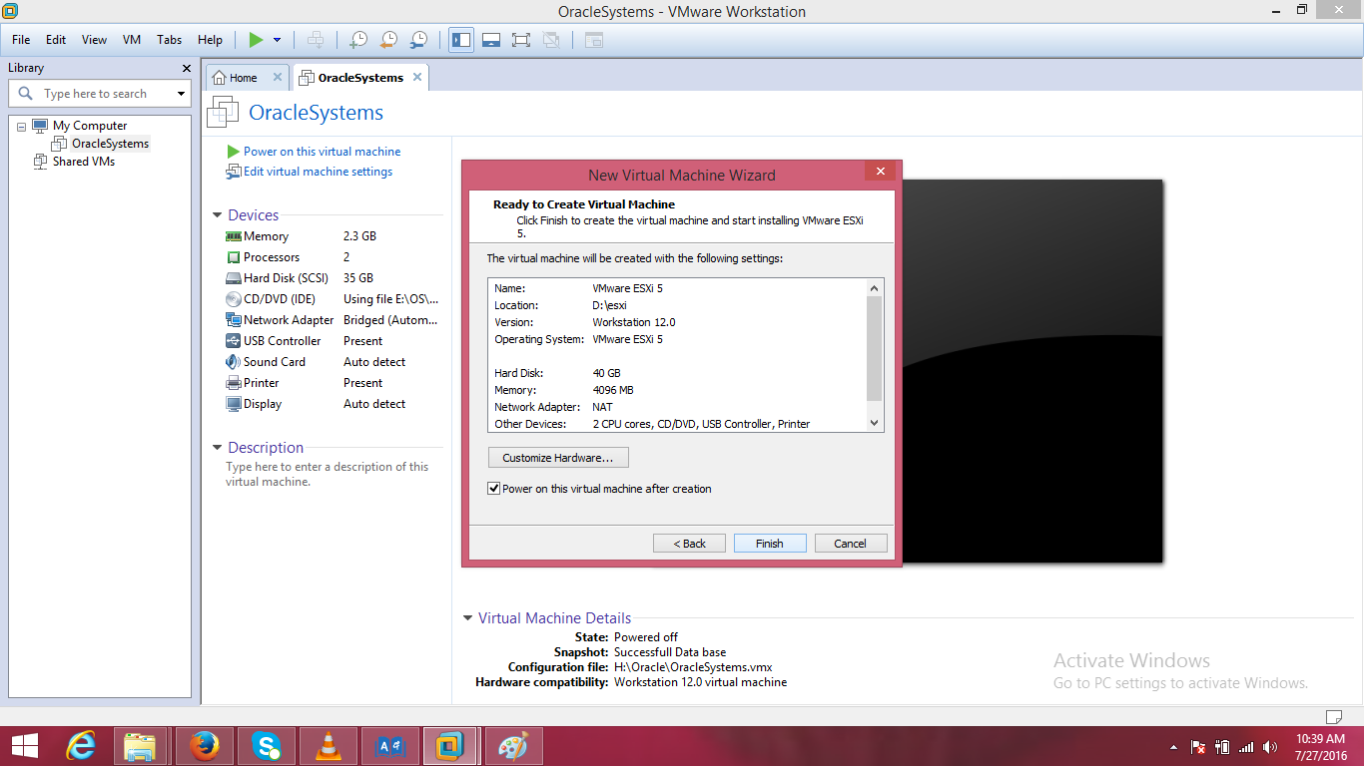

Step 07: Wait 5 seconds for automatic boot.

Then the installation will continue.

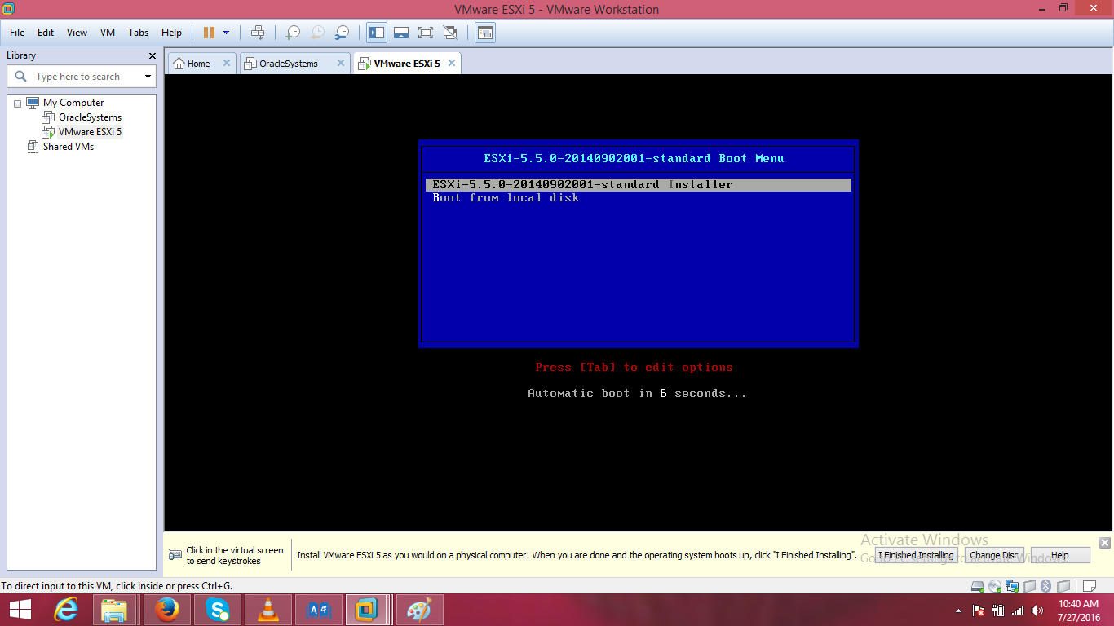

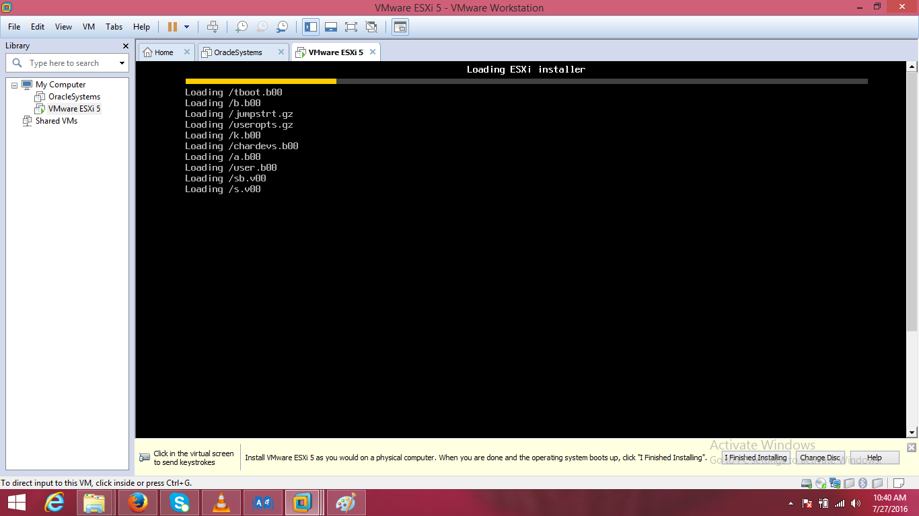

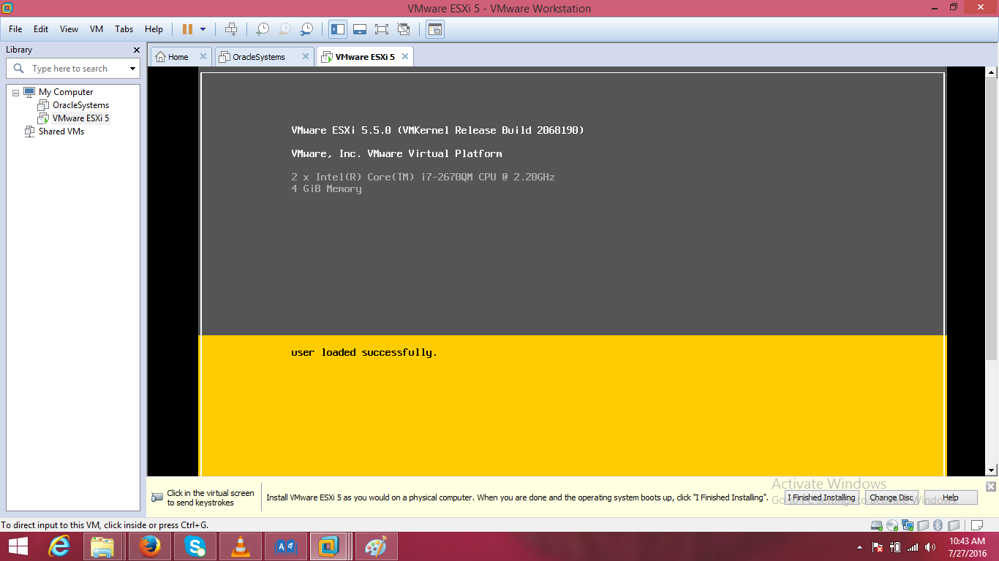

Step 08: Press ‘Enter’ button to continue installation.

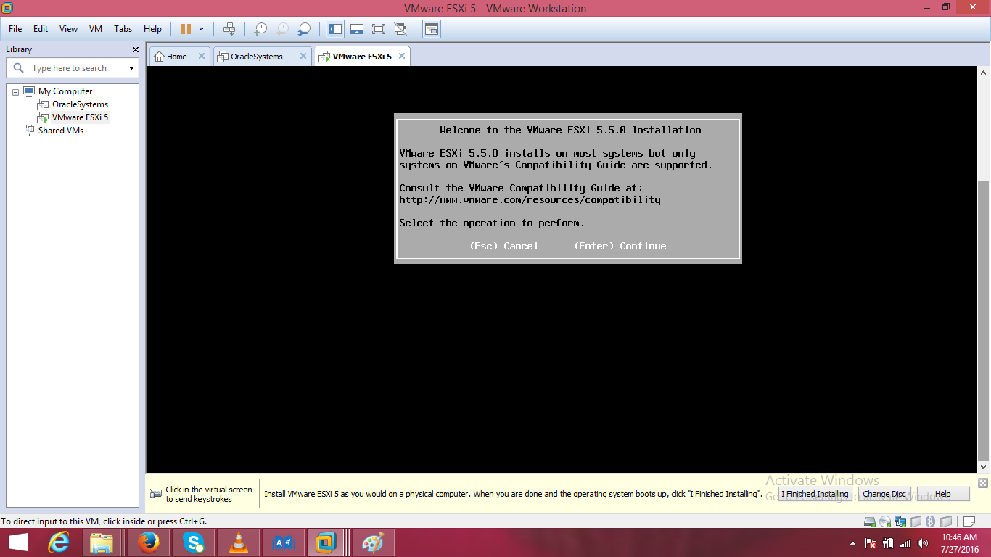

Step 09: Press ‘F11’ to accept VMware End User License Agreement and continue.

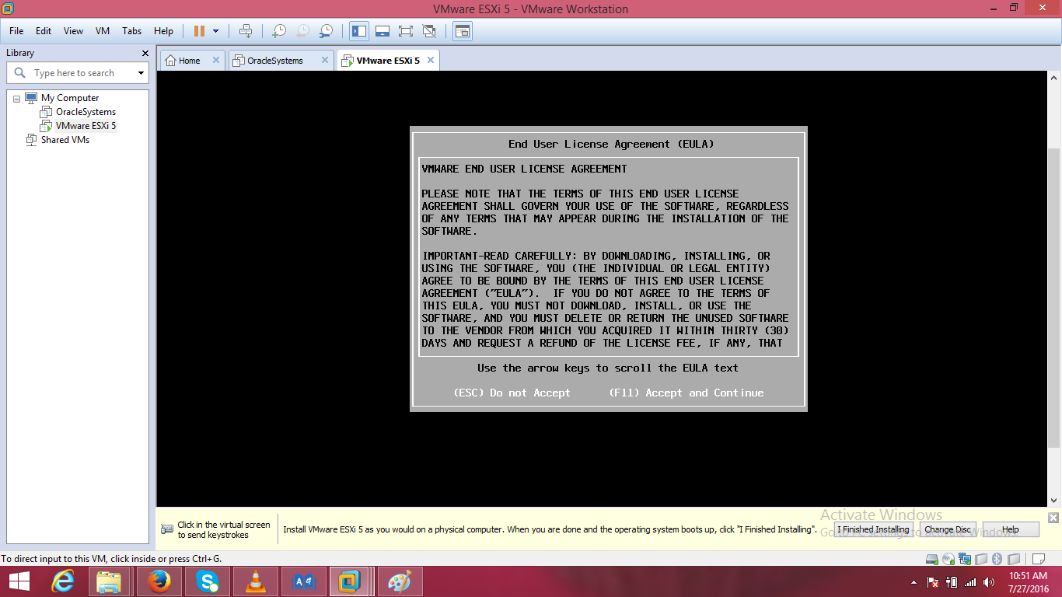

Step 10: Press ‘Enter’ to continue.

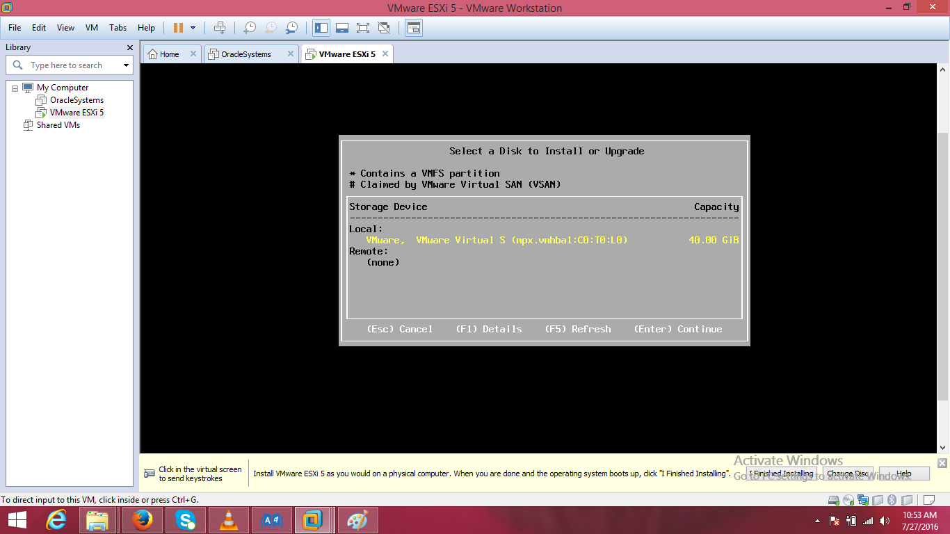

Step 11: Select the keyboard layout and press ‘Enter’ to continue.

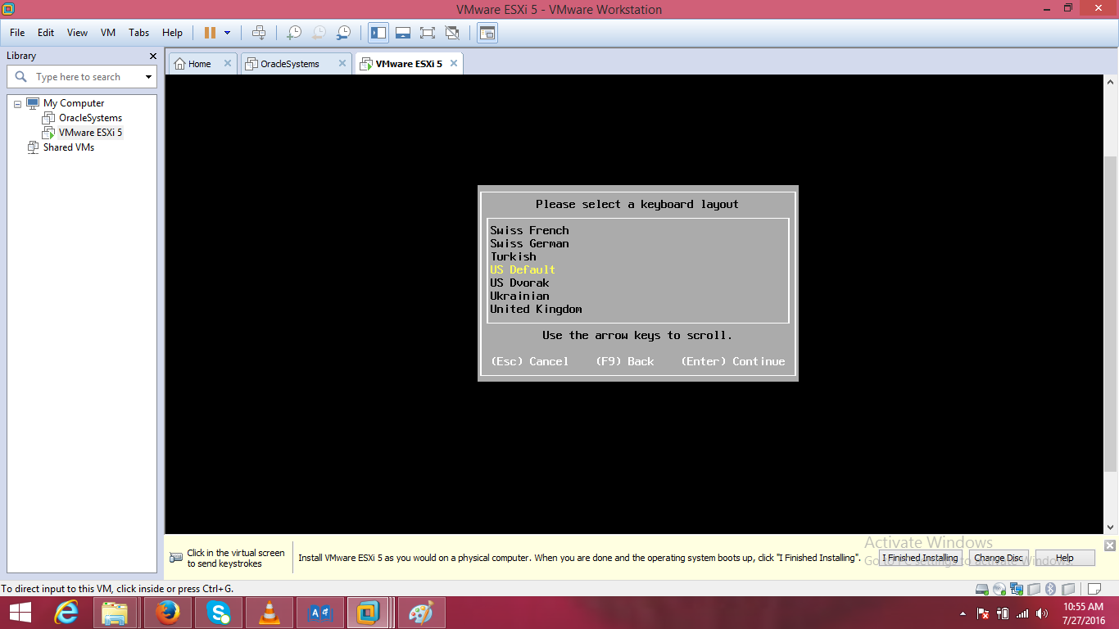

Step 12: Provide a root password and press ‘Enter’ to continue.

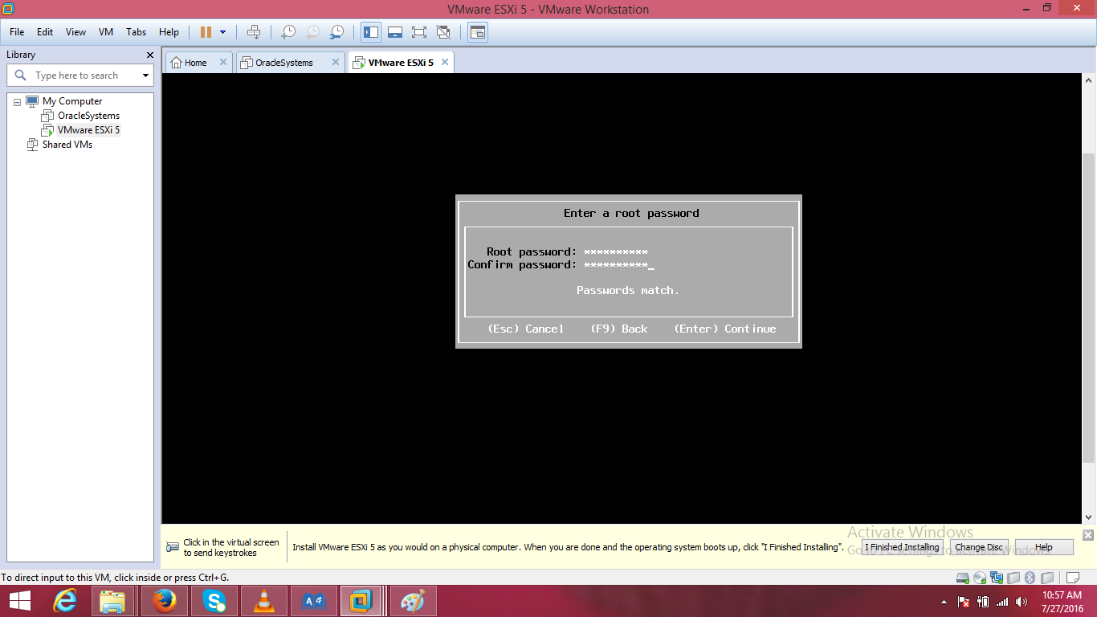

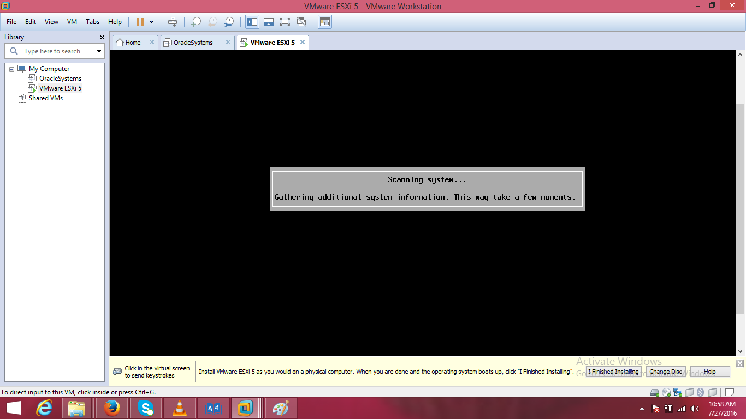

Step 13: Press ‘F11’ to confirm install.

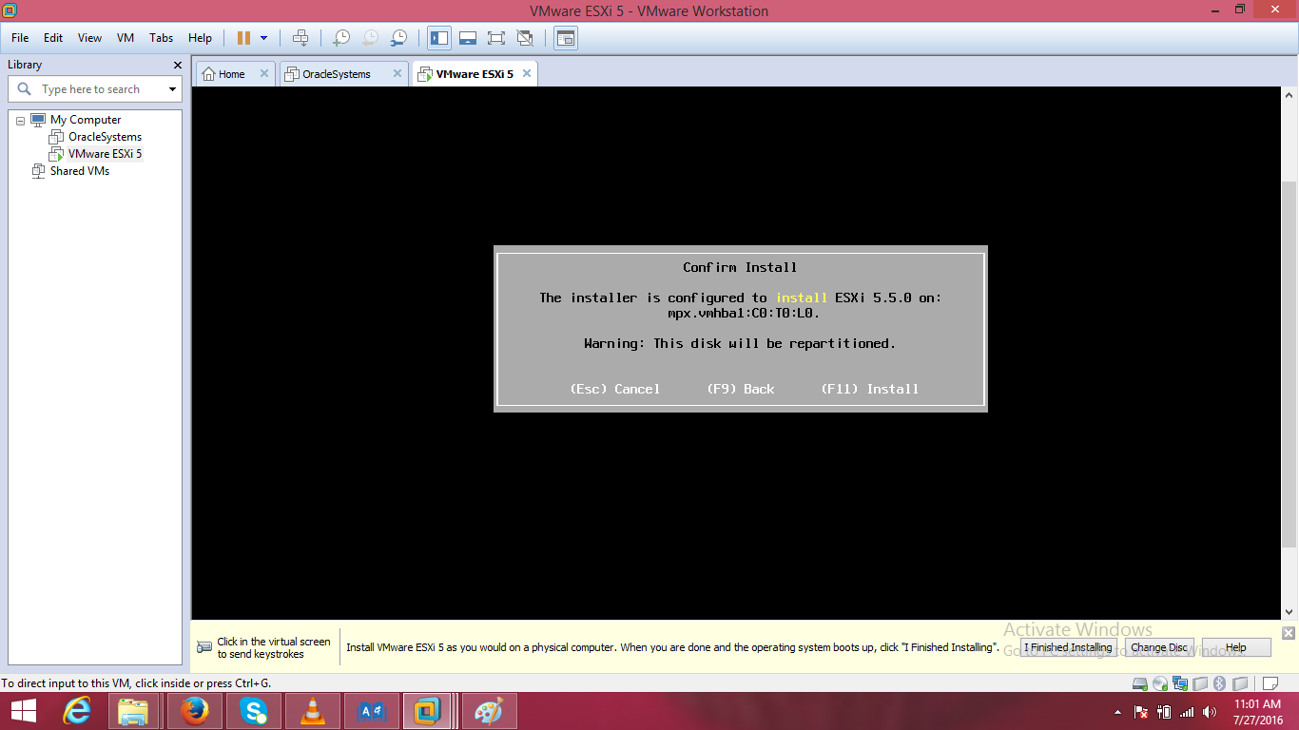

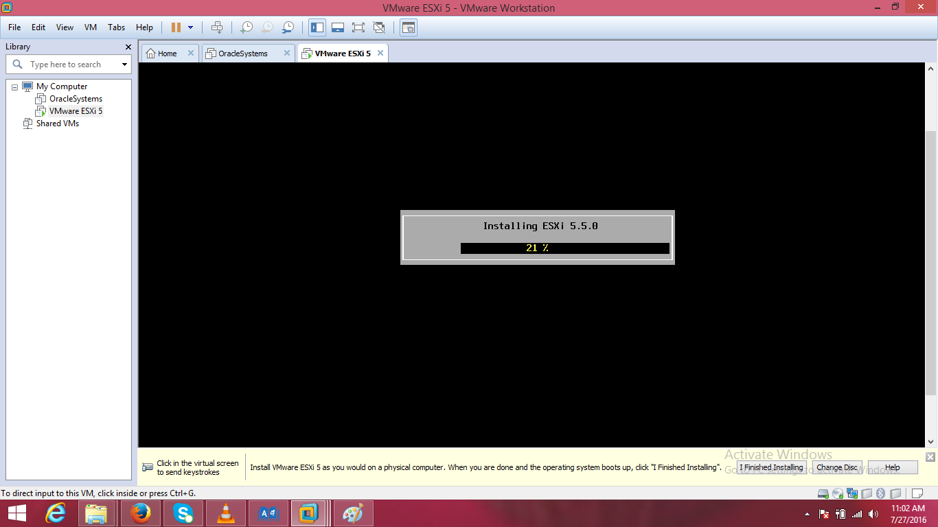

Step 14: Press ‘Enter’ to reboot from ‘Installation Complete’ window.

