1. In the power BI, click on [**Get Data**](https://docs.microsoft.com/en-us/power-bi/service-desktop-files) in **Home tab** and select the source from **Web**. Paste the website url to the url text box and proceed with **OK**

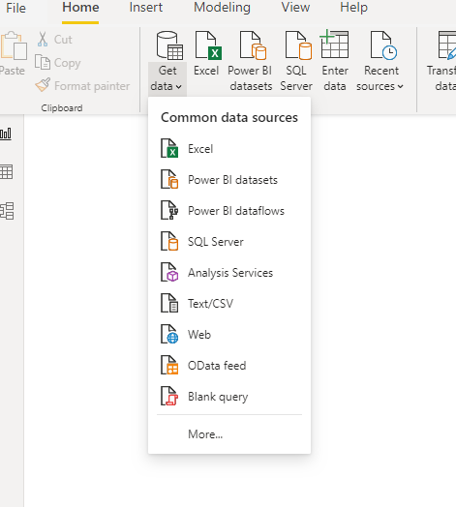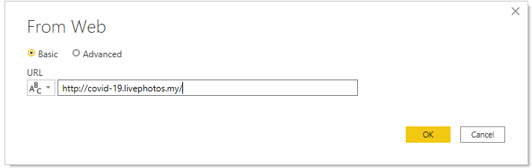

1. The **Navigator** will display all the tables available in the web page. The table selector can be previewed in the **Table View** box. If the table selected in good shape , then continue by clicking **Load** and if it is not in good shape, the table can be reshaped and clean by clicking **Transform Data.**

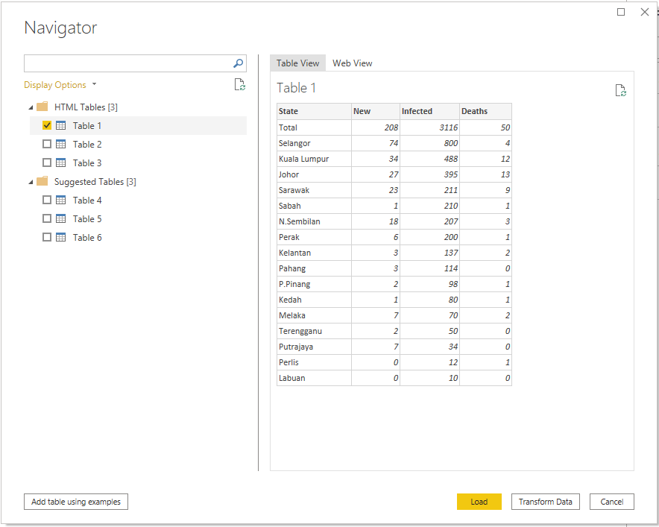

1. Once the **Transform Data** is clicked, the table will load into the [**Power Query Editor**](https://docs.microsoft.com/en-us/power-query/power-query-quickstart-using-power-bi). After done with reshaping and cleaning on the data. The table will be load Power BI Desktop **Report view** by clicking **Close & Apply** in the Home tab of the ribbon.

