**IoT Traffic management system**

**Team members:**

AU910421106004-Bharathi.G

AU910421106007-T.G.Hariharan

AU910421106018-S.Ragulkrishnan-

AU910421106027-Surenthiran.S

**Abstract:**

Traffic congestion is one of the main problems faced by cities and metropolitan areas, and it has inspired research for more than four decades. Nonetheless, with the problem continuing to grow, there is still room for finding improved solutions. In particular, short-term traffic forecasting is a key element in proactive traffic management, e.g., mitigating the negative effect of impending congestion through appropriate capacity allocation at signalized intersections.

**Integrating Historical Traffic Data**

Integrating historical traffic data typically involves collecting and analyzing past traffic information for a specific location or route. This data can be valuable for various purposes, such as urban planning, transportation management, and predictive analytics. Here's a high-level overview of the process:

**Data Collection:**Identify the source of historical traffic data. This can include government agencies, private companies, or traffic monitoring systems.Gather historical data, which may include traffic flow, congestion levels, accidents, weather conditions, and more.

**Data Preprocessing:**Clean and format the collected data to ensure consistency and accuracy.Handle missing or erroneous data points.Convert data into a standardized format for analysis.

**Storage:**Store the historical traffic data in a database or data warehouse for easy access and retrieval.

**Analysis and Visualization:**Use data analysis tools and techniques to extract insights from the historical data.Create visualizations, such as charts and maps, to make the data more understandable.

**Integration:**Integrate the historical traffic data into relevant applications or systems, such as traffic management software, navigation apps, or predictive models.Ensure that the integrated data is updated regularly to provide real-time insights.

**Predictive Modeling:**Utilize historical traffic data to build predictive models for traffic forecasting, which can help in planning for future events and optimizing routes.

**Decision-Making:**Make informed decisions based on the insights gained from historical traffic data, whether it's for optimizing traffic flow, improving infrastructure, or enhancing public transportation systems.

**Continuous Monitoring**:Continuously monitor and update historical traffic data to account for changing conditions and trends.

The specific tools and technologies used for integrating historical traffic data can vary, depending on the scale of the project and the intended applications. It's essential to have a well-defined strategy for data integration and utilization to make the most of historical traffic data.

**Machine Learning alogorithm**

Machine learning algorithms can be highly effective in predicting congestion patterns in traffic. These algorithms can analyze historical traffic data, real-time information, and other relevant factors to forecast when and where congestion is likely to occur. Here are some commonly used machine learning algorithms for this purpose:

**Linear Regression**: Linear regression can be used to model the relationship between various traffic-related features (e.g., time of day, weather conditions, special events) and traffic congestion levels. It provides a basic yet valuable prediction of congestion.

**Time Series Analysis**: Time series models like ARIMA (AutoRegressive Integrated Moving Average) are suitable for predicting congestion patterns over time, especially when dealing with historical traffic data.

**Random Forest**: Random Forest is an ensemble learning technique that can handle complex relationships between multiple variables. It's effective for predicting traffic congestion by considering various factors like weather, road conditions, and historical data.

**Gradient Boosting**: Algorithms like XGBoost, LightGBM, and CatBoost are popular for predicting congestion. They are good at capturing non-linear relationships and handling large datasets.

**Neural Networks**: Deep learning techniques, particularly recurrent neural networks (RNNs) and long short-term memory networks (LSTMs), can capture temporal dependencies and perform well in time-series prediction, making them suitable for predicting congestion patterns.

**Support Vector Machines (SVM):** SVMs can be used for traffic prediction tasks, especially when there's a need to classify traffic into congestion and non-congestion states.

**Clustering Algorithms**: Algorithms like K-means clustering can be used to group areas with similar traffic patterns, helping in identifying congestion-prone zones.

**Anomaly Detection**: Anomaly detection algorithms, such as Isolation Forest or One-Class SVM, can help identify unusual traffic patterns that may lead to congestion.

**Reinforcement Learning**: Reinforcement learning can be applied to traffic management systems to make dynamic decisions in real time to alleviate congestion, such as traffic signal timing optimization.

It's important to note that the effectiveness of these algorithms depends on the quality and quantity of data, feature engineering, and the specific problem you're trying to solve. Real-time data feeds, historical traffic data, weather data, and other relevant information should be integrated to improve the accuracy of congestion predictions.

Additionally, a combination of these algorithms in an ensemble approach can often yield better results. The choice of algorithm depends on the specific use case and the available data.

**IoT Traffic monitoring system using python**

Creating an IoT traffic monitoring system using Python involves several components, including data collection from sensors or cameras, data processing, and potentially a cloud-based platform for analysis and visualization. Here's a simplified example to get you started. Note that this example doesn't cover every detail of a full-fledged system but provides a basic structure:

**Data Collection**:Interface with traffic sensors or cameras to capture data. You might use libraries like OpenCV for camera input or interface with specific sensor APIs.

**Data Processing**:Process the data to extract relevant information (e.g., vehicle count, speed, congestion). You may need computer vision techniques to analyze camera feeds.

Use Python libraries like NumPy and OpenCV for data manipulation and image processing.

**Data Transmission**:Send the processed data to a central server or a cloud platform. You can use MQTT, HTTP requests, or other protocols for communication.

If using cloud services, consider using AWS IoT, Azure IoT, or Google Cloud IoT for data transmission.

**Data Analysis**:On the server or cloud platform, write Python code to analyze and store the data. You can use frameworks like Flask or Django for web services and data storage.Implement algorithms to detect traffic patterns, congestion, or anomalies.

**Data Visualization**:Create a web-based dashboard to visualize the traffic data. You can use libraries like Matplotlib, Plotly, or front-end frameworks like React or Vue.js.

**Alerting and Reporting:**Implement mechanisms for real-time alerts or automated reports when specific traffic conditions are met.

Here's a simple Python code snippet for simulating data collection from a camera using OpenCV:

python

Copy code

import cv2

# Connect to the camera (replace '0' with the camera's device index)

cap = cv2.VideoCapture(0)

while True:

ret, frame = cap.read()

# Process the frame here (e.g., object detection, vehicle tracking)

# Send the processed data to the server/cloud

# Break the loop with a key press, or use a timer for continuous operation

if cv2.waitKey(1) & 0xFF == ord('q'):

break

cap.release()

cv2.destroyAllWindows()

Please note that building a full-fledged IoT traffic monitoring system is a complex task, and the code above is just a starting point. You'll need to adapt and expand it based on your specific requirements and the hardware and software components you're working with.

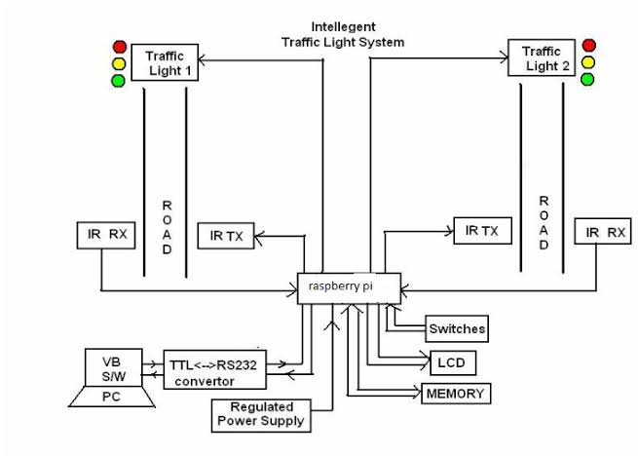

**Features:**

•Short-term traffic forecasting is a key element in mitigating the negative effect of impending urban congestion.

•A machine learning process for reliably predicting impending congestion was developed by using feature engineering.

•Aggregative input variables were created by combining embedded and filter approaches with the use of expert knowledge.

•The proposed methodology significantly increases both the congestion identification rate and the robustness of the results.

•The final prediction model can be intuitively understood by traffic experts.

**Program for traffic control:**

import time

def control_traffic_lights():

while True:

# Simulate traffic flow analysis and decision-making logic here

# You might use sensors, cameras, or data from traffic sources

# Based on the analysis, update the traffic light signals

# Example: Red, Green, or Yellow signals for each direction

# Print the current state of the traffic lights

print("North-South: Green, East-West: Red") # Example

# Sleep to simulate a real-time system

time.sleep(30) # Adjust the timing as needed

if _name_ == "_main_":

control_traffic_lights()

**Program for traffic monitoring:**

import random

import time

def generate_traffic_data():

# Simulate collecting traffic data from various sources

# In a real system, you would read data from sensors, cameras, or APIs

traffic_data = {

"timestamp": time.strftime("%Y-%m-%d %H:%M:%S"),

"vehicle_count": random.randint(0, 100),

"average_speed": random.uniform(20, 60),

"congestion_level": random.choice(["Low", "Moderate", "High"])

}

return traffic_data

def traffic_monitoring():

while True:

# Simulate collecting and analyzing traffic data

traffic_data = generate_traffic_data()

# Perform analysis on the collected data

print("Timestamp:", traffic_data["timestamp"]

print("Vehicle Count:", traffic_data["vehicle_count"])

print("Average Speed:", traffic_data["average_speed"])

print("Congestion Level:", traffic_data["congestion_level"])

# You can implement more advanced analysis here

# Sleep to simulate real-time data collection

time.sleep(10) # Adjust the timing as need

if _name_ == "_main_":

traffic_monitoring()