import os  
for dirname, _, filenames in os.walk('/kaggle/input'):  
 for filename in filenames:  
 print(os.path.join(dirname, filename))

import numpy as np  
import pandas as pd  
import seaborn as sns  
import matplotlib.pyplot as plt  
  
color_pal = sns.color_palette()  
plt.style.use('fivethirtyeight')

df = pd.read_csv('/content/drive/MyDrive/Historical Product Demand.csv')

df.head()

Product_Code Warehouse Product_Category Date Order_Demand  
0 Product_0993 Whse_J Category_028 2012/7/27 100   
1 Product_0979 Whse_J Category_028 2012/1/19 500   
2 Product_0979 Whse_J Category_028 2012/2/3 500   
3 Product_0979 Whse_J Category_028 2012/2/9 500   
4 Product_0979 Whse_J Category_028 2012/3/2 500

df.shape

(1048575, 5)

df.columns

Index(['Product_Code', 'Warehouse', 'Product_Category', 'Date',  
 'Order_Demand'],  
 dtype='object')

df.Product_Code.unique()

array(['Product_0993', 'Product_0979', 'Product_1159', ...,  
 'Product_0237', 'Product_0644', 'Product_0853'], dtype=object)

df.Warehouse.unique()

array(['Whse_J', 'Whse_S', 'Whse_C', 'Whse_A'], dtype=object)

df.Product_Category.nunique()

33

df.dtypes

Product_Code object  
Warehouse object  
Product_Category object  
Date object  
Order_Demand object  
dtype: object

def check_order_demand(x):  
 try:  
 int(x)  
 except:  
 return False  
 return True  
#Check where Order_demand is not an integer  
df[~df.Order_Demand.apply(lambda x: check_order_demand(x))].head(6)

Product_Code Warehouse Product_Category Date Order_Demand  
112290 Product_2169 Whse_A Category_024 2012/8/9 (1)  
112307 Product_2132 Whse_A Category_009 2012/11/1 (24)  
112308 Product_2144 Whse_A Category_009 2012/11/1 (24)  
112356 Product_2118 Whse_A Category_009 2012/3/7 (50)  
112357 Product_2120 Whse_A Category_009 2012/3/7 (100)  
112360 Product_1794 Whse_A Category_024 2012/6/28 (1)

def change_to_int(x):  
 try:  
 return int(x)  
 except:  
 return int(x[1:-1])  
check = '(10)'  
change_to_int(check)

10

df.Order_Demand = df.Order_Demand.apply(lambda x: change_to_int(x) )

df.describe()

Order_Demand  
count 1.048575e+06  
mean 4.906977e+03  
std 2.892678e+04  
min 0.000000e+00  
25% 2.000000e+01  
50% 3.000000e+02  
75% 2.000000e+03  
max 4.000000e+06

df = df.rename(columns = {'Product_Code': 'Code',  
 'Product_Category':'Category',  
 'Order_Demand':'Demand'})  
df.head()

Code Warehouse Category Date Demand  
0 Product_0993 Whse_J Category_028 2012/7/27 100  
1 Product_0979 Whse_J Category_028 2012/1/19 500  
2 Product_0979 Whse_J Category_028 2012/2/3 500  
3 Product_0979 Whse_J Category_028 2012/2/9 500  
4 Product_0979 Whse_J Category_028 2012/3/2 500

100 * df.isna().sum()[3]/ df.shape[0]

1.0718355863910545

df = df.dropna()  
df.isna().sum()

Code 0  
Warehouse 0  
Category 0  
Date 0  
Demand 0  
dtype: int64

df.Date.min(), df.Date.max()

('2011/1/8', '2017/1/9')

# Find the aggregate demand among the warehouses  
sns.countplot(x = 'Warehouse', data = df)

<Axes: xlabel='Warehouse', ylabel='count'>

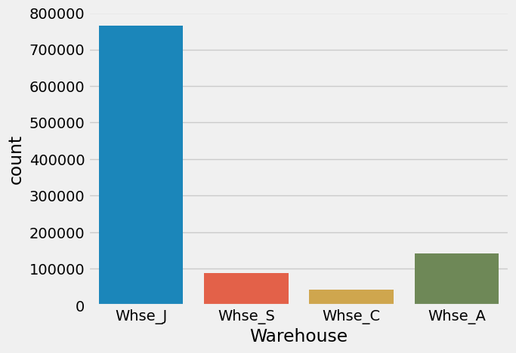

# Plot the 5 most popular category  
df.Category.value_counts().head(5).plot(kind = 'bar', color = color_pal[2])  
plt.xlabel('Category')  
plt.show()

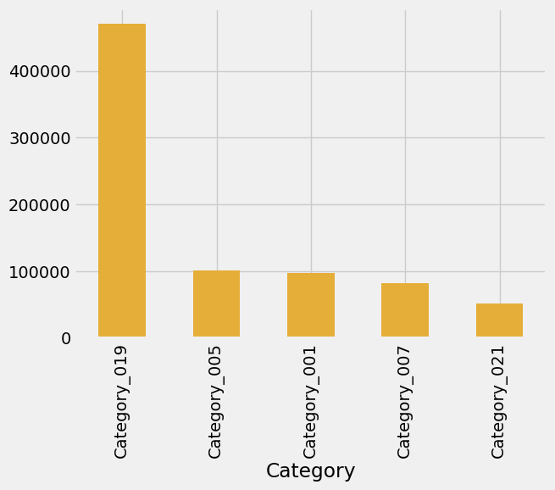

df.plot(kind = 'line',figsize=(15, 5),color = color_pal[0], title = 'Order Demand' )  
plt.show()

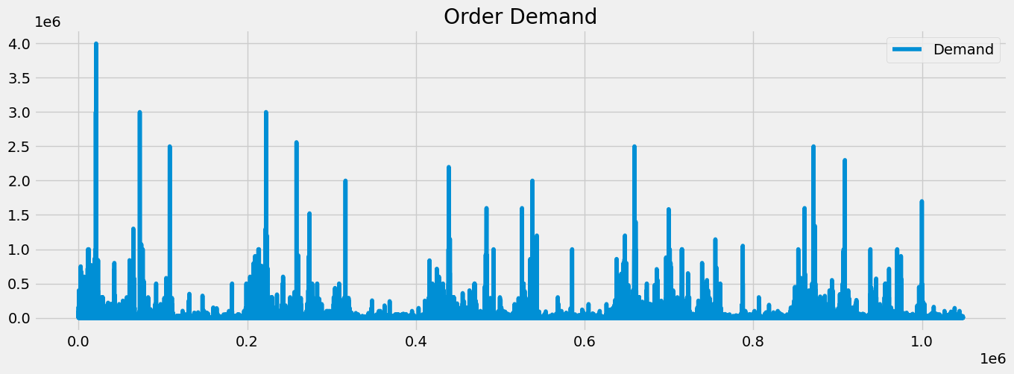

df.Demand.skew()

31.432925049321977

# Total Demand by Warehouse  
warehouse_Demand = df.groupby('Warehouse')['Demand'].sum()  
warehouse_Demand

Warehouse  
Whse_A 147877431  
Whse_C 585071404  
Whse_J 3363200396  
Whse_S 1038024700  
Name: Demand, dtype: int64

warehouse_Demand.plot(kind = 'barh', ylabel = 'Sum of the demand' )

<Axes: ylabel='Sum of the demand'>

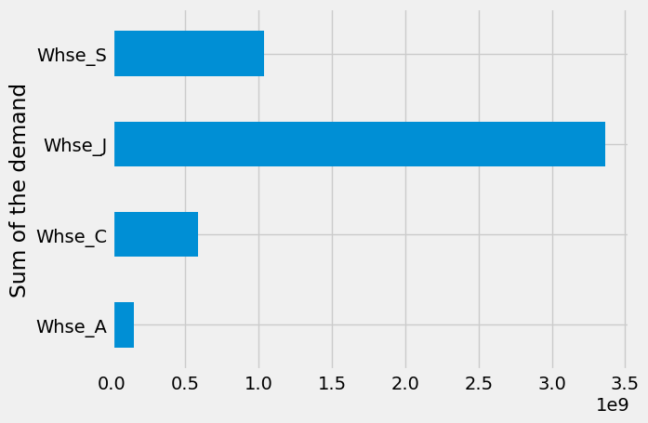

df.groupby('Warehouse')['Demand'].mean().plot(kind = 'barh')  
plt.show()

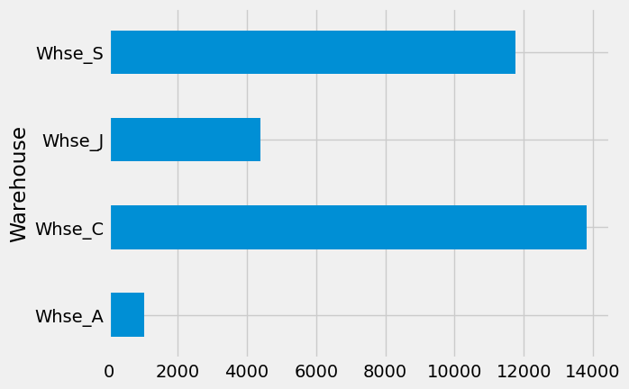

df.head()

Code Warehouse Category Date Demand  
0 Product_0993 Whse_J Category_028 2012/7/27 100  
1 Product_0979 Whse_J Category_028 2012/1/19 500  
2 Product_0979 Whse_J Category_028 2012/2/3 500  
3 Product_0979 Whse_J Category_028 2012/2/9 500  
4 Product_0979 Whse_J Category_028 2012/3/2 500

# features, Target variable  
Features = ['day_of_the_week', 'Quarter','Month', 'Year', 'Week']  
target = ['Demand']