RESEARCH PUBLICATION MANAGEMENT PORTAL

1. Introduction
Every year faculty members and students publish research papers in journals, conferences, book chapters and patents. In many colleges the details of these papers are still written in Excel sheets. When the number of records grows, it becomes hard to search them, check them and prepare reports.
This project is a Research Publication Management Portal made using the MERN Stack (MongoDB, Express, React and Node.js). A faculty member can register, log in and add the details of his or her publications. The admin can check these records, mark them as verified, edit or delete them and see department-wise reports. The idea is taken from the SIH 2025 problem statement Authenticity Validator for Academia.
This is a mini project made to learn the MERN Stack. It is not a full Research Information Management System.

2. Problem Statement
At present publication details are kept manually in Excel sheets. Because of this it is difficult to maintain the records, there is no proper way to verify them, and generating department-wise reports takes a lot of time. The problem is to build a simple portal using the MERN Stack where faculty members can add publication details and the administrator can verify and manage them.

3. Objectives
- To learn MERN Stack development.
- To practice CRUD operations.
- To understand user authentication.
- To learn REST API development.
- To manage publication records digitally.
- To practice React components and routing.

4. User Roles

Admin
The admin is the person who manages the whole portal. The admin can log in to the portal and view all the publications added by the faculty members. The admin verifies the submitted publications, edits their details if there is any mistake, and deletes a publication when it is not needed. The admin can also generate department-wise reports.

Faculty
The faculty member is the main user who adds the publication details. A faculty member first registers in the portal and then logs in with email and password. After login, the faculty can add new publications, update the details of existing publications, and view the history of his or her own publications along with their verification status.

5. Modules
Module | Name | What it does
1 | Faculty Registration | New faculty create an account.
2 | Login Authentication | Users log in and get a JWT token.
3 | Publication Management | Faculty add and update their publications.
4 | Publication Verification | Admin verifies the submitted publications.
5 | Publication Search | Search publications by title, year, type, etc.
6 | Faculty Dashboard | Faculty see their own publications and status.
7 | Admin Dashboard | Admin sees all records and reports.

6. Working Principle
- Faculty registers into the portal.
- Faculty logs into the application.
- Faculty adds publication details.
- MongoDB stores the publication records.
- Admin verifies the submitted publications.
- Faculty updates publication information if required.
- Admin manages the publication records.
- Reports are generated department-wise.

7. Technology Stack
Part | Technology
Frontend | ReactJS
Backend | NodeJS and ExpressJS
Database | MongoDB Atlas
API Testing | Postman
React is used to make the pages, Express and Node.js are used to make the REST APIs, MongoDB Atlas stores the data on the cloud, and Postman is used to test the APIs.

8. Database Design
The project uses two collections, Users and Publications.

Users
Field | Description
userId | Unique id of the user
name | Name of the user
email | Email used for login
password | Password (stored as hash)
role | admin or faculty

Publications
Field | Description
publicationId | Unique id of the publication
facultyId | Id of the faculty who added it
paperTitle | Title of the paper
publicationType | Journal, conference, book chapter or patent
journalConference | Name of the journal or conference
publicationYear | Year of publication
DOI | DOI of the paper
verificationStatus | Pending, Verified or Rejected

9. REST APIs
Method | Endpoint | Use
POST | /register | Register a user
POST | /login | Login and get token
GET | /publications | Get publications
POST | /publications | Add a publication
PUT | /publications/:id | Update a publication
DELETE | /publications/:id | Delete a publication

10. Frontend (React)

Pages
- Home
- Register
- Login
- Faculty Dashboard
- Add Publication
- My Publications
- Search Publications
- Admin Dashboard
- Manage Publications

React Concepts Used
- Components, JSX and Props
- State using useState()
- useEffect() to get data from the API when a page opens
- Forms and Events
- Lists
- Conditional Rendering to show different options to admin and faculty
- React Router
- CSS Styling

11. Backend (Express.js)

Express.js Concepts Used
- Routing
- Middleware
- REST API
- HTTP Methods (GET, POST, PUT, DELETE)
- Authentication
- JWT Login

How Login Works
When a user logs in, a JWT token is created. The user must send this token to use the protected routes.

12. MongoDB Concepts

Concepts Used
- CRUD and Collections
- find() to search records
- updateOne() to update or verify a publication
- deleteOne() to delete a publication
- aggregate() to make department-wise reports
- createIndex() to create indexes
- Atlas Connection to connect the server to the database

13. Implementation
Some important parts of the code are given below.

Publication schema
const publicationSchema = new mongoose.Schema({
facultyId: { type: mongoose.Schema.Types.ObjectId, ref: 'User' },
paperTitle: { type: String, required: true },
publicationType: String,
journalConference: String,
publicationYear: Number,
DOI: String,
verificationStatus: { type: String, default: 'Pending' }
});

Token checking middleware
function auth(req, res, next) {
const token = req.headers.authorization?.split(' ')[1];
if (!token) return res.status(401).json({ msg: 'No token' });
try {
req.user = jwt.verify(token, process.env.JWT_SECRET);
next();
} catch (err) {
res.status(401).json({ msg: 'Invalid token' });
}
}

Add publication API
router.post('/publications', auth, async (req, res) => {
const pub = new Publication({ ...req.body, facultyId: req.user.id });
await pub.save();
res.status(201).json(pub);
});

Getting data in React
const [pubs, setPubs] = useState([]);

useEffect(() => {
fetch('/publications', {
headers: { Authorization: 'Bearer ' + token }
})
.then(res => res.json())
.then(data => setPubs(data));
}, []);

14. Output Screenshots

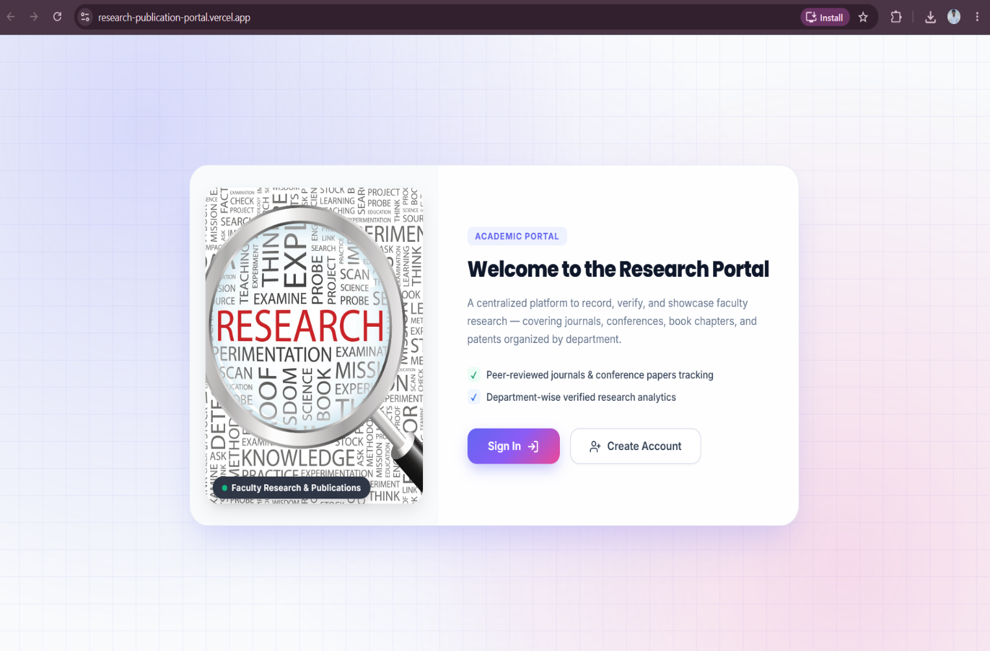
Home Page

Register Page

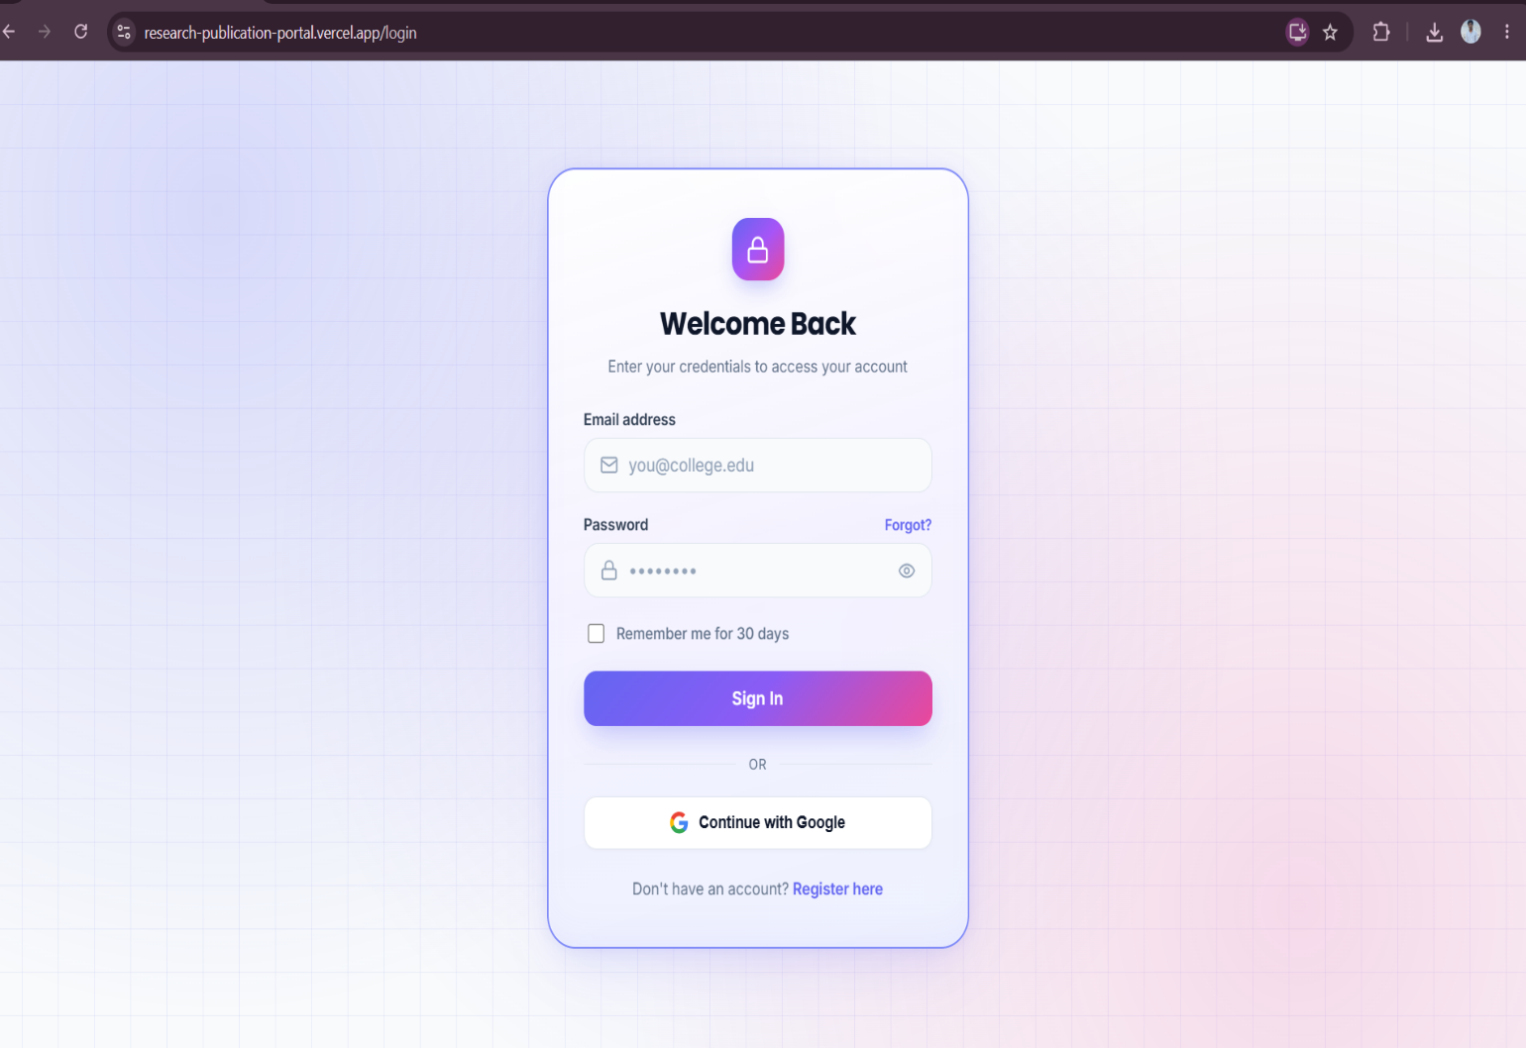
Login Page

Faculty Dashboard
[ Insert Screenshot Here ]
Add Publication Page
[ Insert Screenshot Here ]
My Publications Page
[ Insert Screenshot Here ]
Search Publications Page
[ Insert Screenshot Here ]
Admin Dashboard
[ Insert Screenshot Here ]
Manage Publications Page

15. Testing
The APIs were tested in Postman. Some test cases are given below.
No. | Test | Expected result
1 | Register a faculty | User is created
2 | Login with correct details | Token is returned
3 | Login with wrong password | Error message
4 | Add a publication | Publication is saved
5 | Add publication without login | Access denied
6 | Update a publication | Record is updated
7 | Admin verifies a publication | Status changes to Verified
8 | Admin deletes a publication | Record is deleted
9 | Search by year | Matching publications are shown

16. Expected Output
The completed application allows faculty registration, secure login, adding research publications, updating publication details, searching publications, publication verification, a faculty dashboard, an admin dashboard and secure storage of data in MongoDB Atlas.

17. Conclusion
The Research Publication Management Portal makes it easy to store and manage publication records instead of using Excel sheets. Faculty can add and update their papers and the admin can verify them and see department-wise reports. While making this project I learned React components and routing, REST APIs with Express, JWT login and CRUD operations with MongoDB Atlas.

18. Future Scope
- Checking the DOI automatically.
- Downloading reports as PDF or Excel.
- Email message when a publication is verified.
- Charts for publications by year and type.
- Uploading the paper PDF.

19. References
- React documentation – https://react.dev
- Node.js documentation – https://nodejs.org
- Express documentation – https://expressjs.com
- MongoDB Atlas documentation – https://www.mongodb.com/docs/atlas
- JWT – https://jwt.io
- Postman – https://learning.postman.com

