BAIF – Hackthon Test cases
S.no | Test Case | Description | Tool/Software | Result
1 | Transcription | Able to transcript input audio into text format | Wishper Large-V3-Turbo | Pass
2 | Automatic Detection of Input Language | Able to detect input language automatically | Wishper Large-V3-Turbo | Pass
3 | Translation | Able to translate the transcribed text into output language | Hugging Face (Transformers) - AI4Bharat Indic Trans2 | Pass
4 | Text to Speech | Converts translated text input spoken audio per Segment | Hugging Face (Transformers) - AI4Bharat Indic Parler -TTS | Pass
5 | Subtitle Generation | Uses Whisper timestamps + translated text to generate Subtitle files with correct timing | Python Code (No extra package) | Pass
6 | Audio/Video processing | Extract audio from video and burn subtitiles directly into video based on the duration, places the dubbed audio | Ffmpeg+Ffprobed | Pass
7 | Audio mixing and Normalization | Build final audio track by overlaying TTS clips at correct timestamps. Normalize volume per segment so all speech sounds equally loud | Pydub | Pass
8 | Web User - Interface | Local Web UI - File upload, output languge selection, Live processing log, video player, download buttons | Flask | Pass
9 | Easy start of Flask file | User should be able to start the process easily just by double clicking on desktop shortcut | Launcher batch file | Pass
10 | Switch language | For another input language translation user will click on Switch Language button instead of starting from the first step | Switch language button in UI | Pass

Transcription: Able to transcript input audio into text format
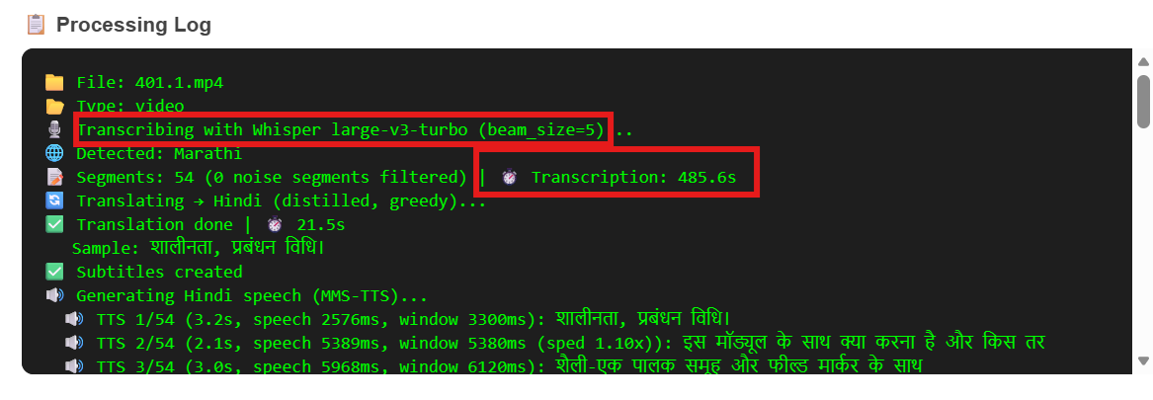

Automatic Detection of Input Language: Able to detect input language automatically
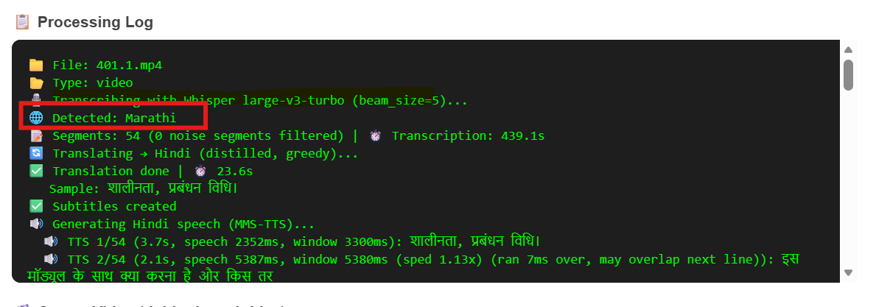

Translation: Able to translate the transcribed text into output language

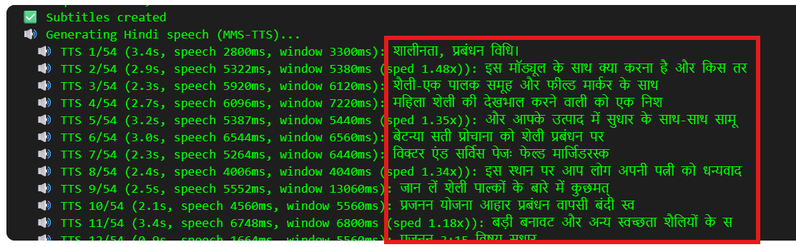

Text to Speech: Converts translated text input spoken audio per Segment
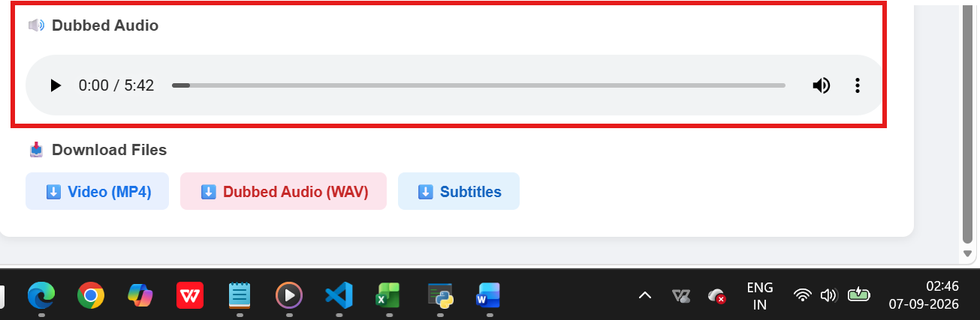

Subtitle Generation: Uses Whisper timestamps + translated text to generate Subtitle files with correct timing
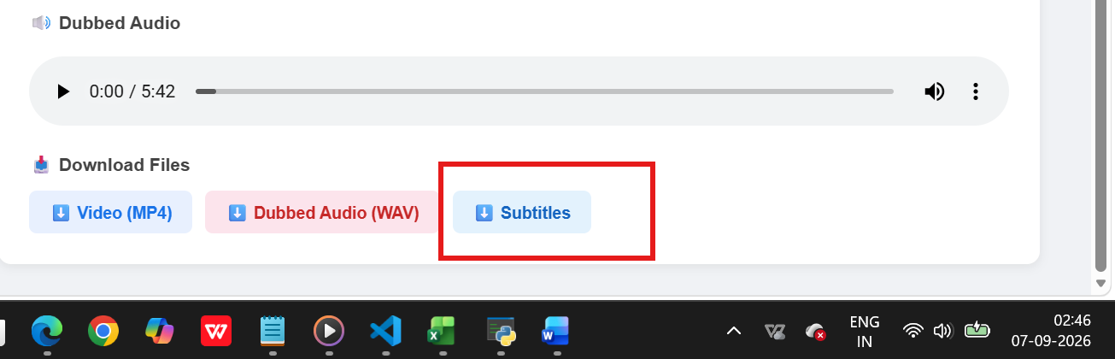

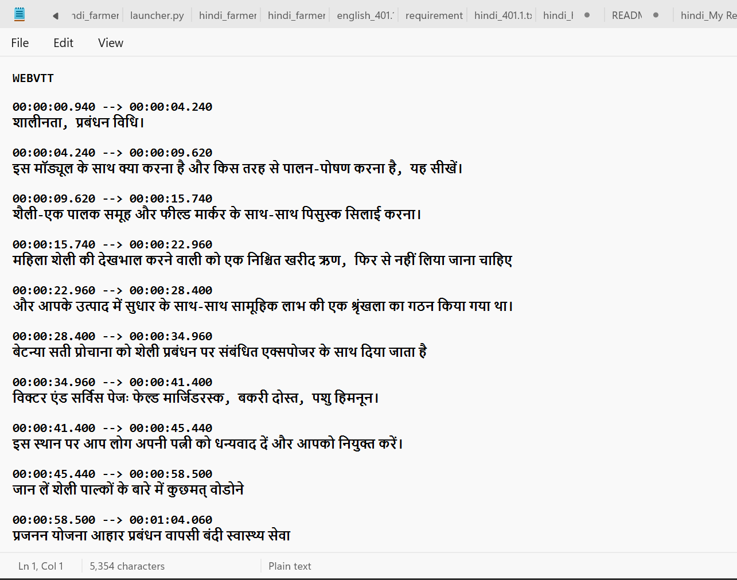

Audio/Video processing: Extract audio from video and burn subtitiles directly into video based on the duration, places the dubbed audio
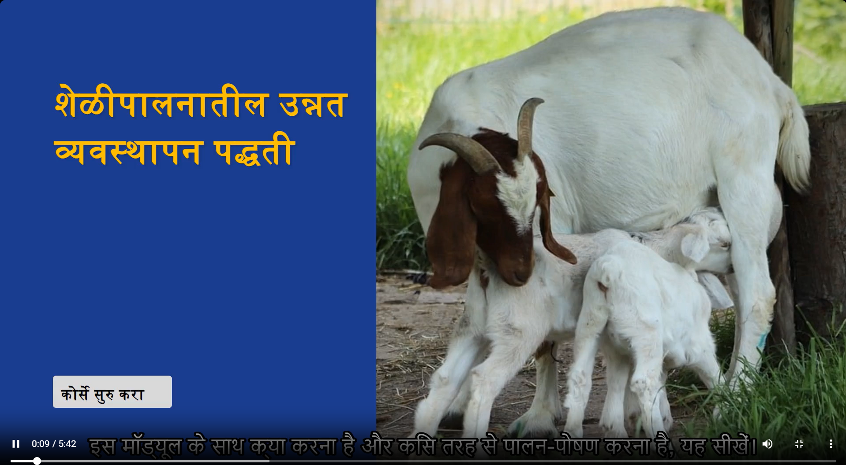

Audio mixing and Normalization: Build final audio track by overlaying TTS clips at correct timestamps. Normalize volume per segment so all speech sounds equally loud



Web User – Interface : Local Web UI - File upload, output languge selection, Live processing log, video player, download buttons
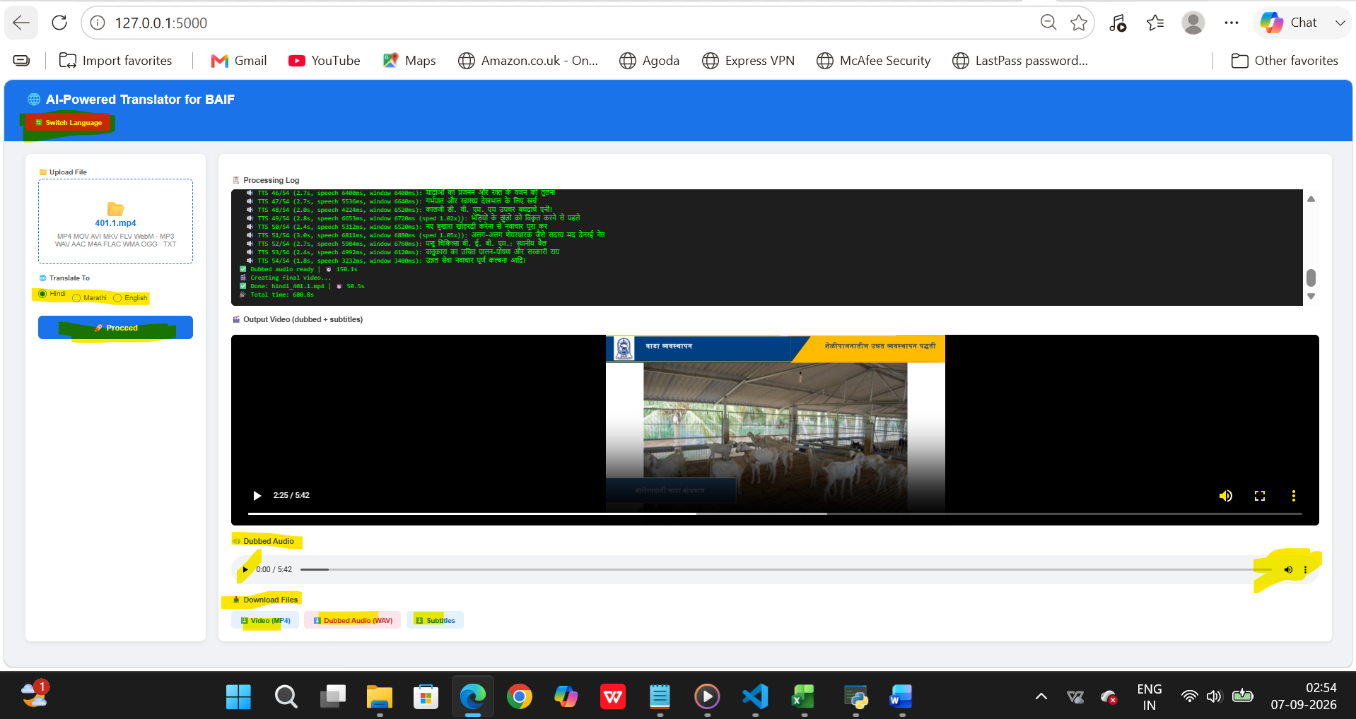

Switch language:
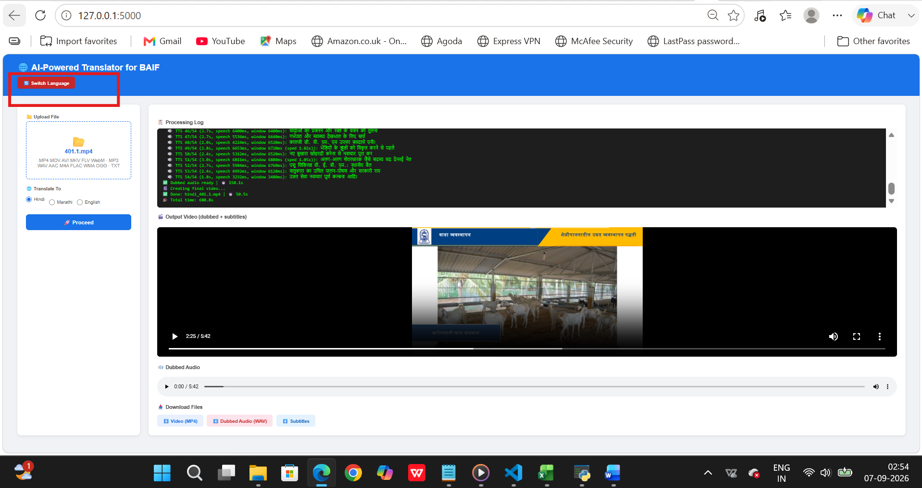

Easy start of Flask file: For another input language translation user will click on Switch Language button instead of starting from the first step
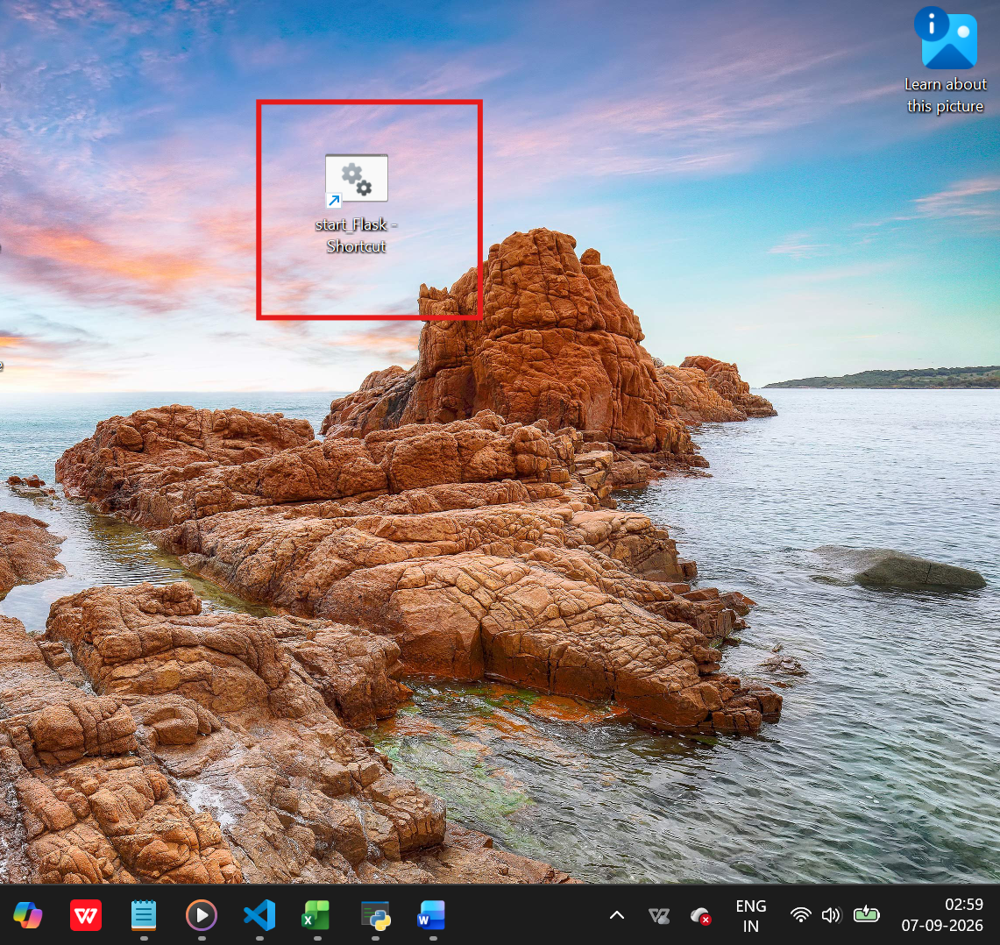

Only Text file translation:

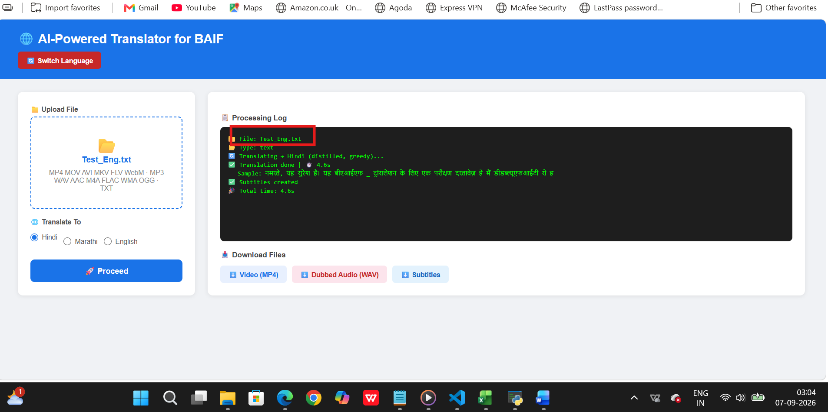

Only Audio file translation:
