Suresh Shrestha
2/5/2026
Module 4.2 Assignment

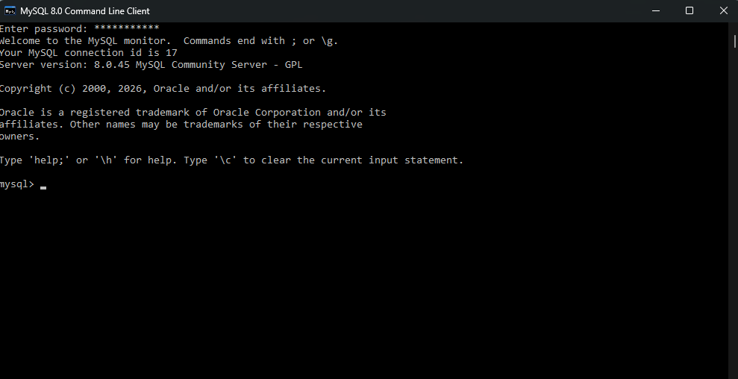

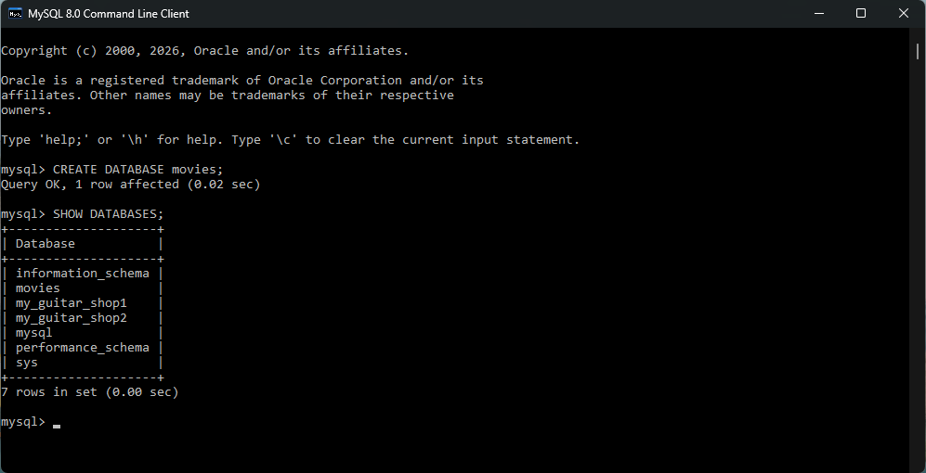

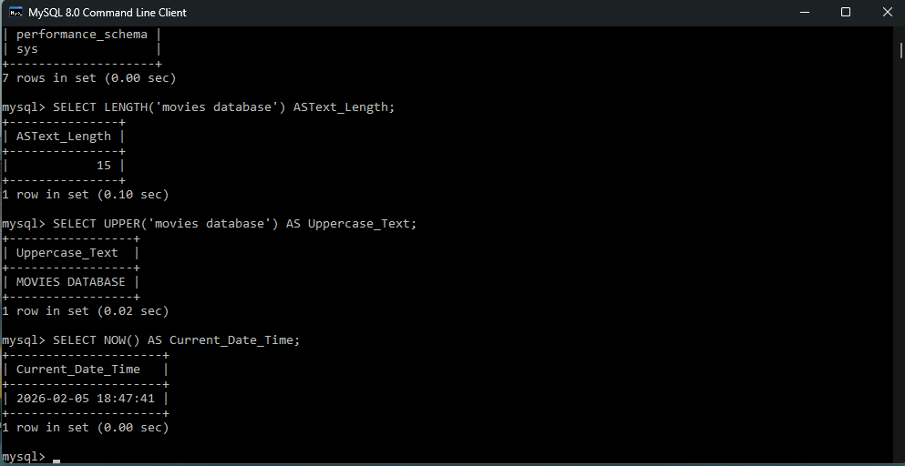

LENGTH (): used to determine how many characters are in a string, such as validating text length.
UPPER (): used to convert text to uppercase for consistent formatting or comparisons.
NOW (): returns the current date and time, often used for timestamps or logging.

