Suresh Shrestha
2/5/2026
Module 5.2 Assignment
- Screenshot
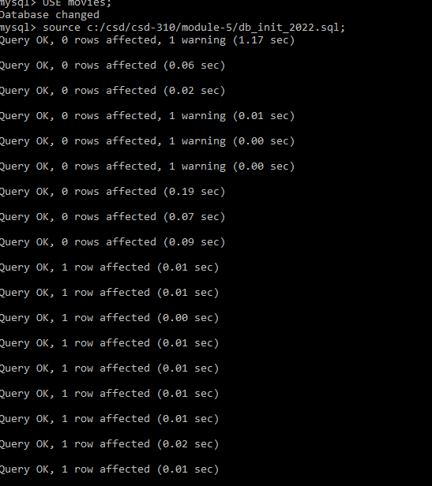

2. Screenshot
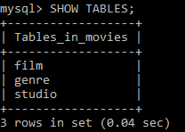
3. Output of mysql_test.py
