Suresh Shrestha
1/24/2026
Module 2.2 Assignment
Screenshot 1. Creating a breakpoint and starting the debugging process.
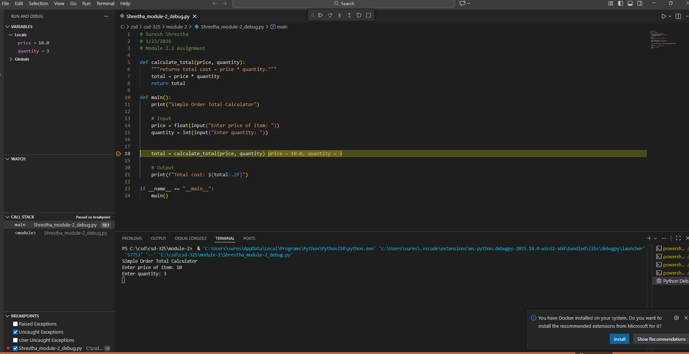

Screenshot 2. Step into the function
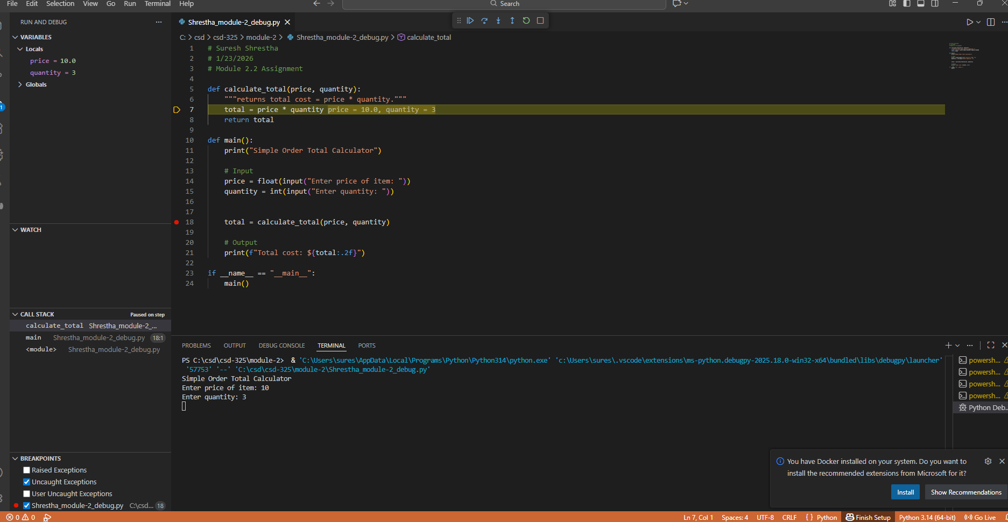
Screenshot 3. Moving through the program
