Suresh Shrestha
2/24/2026
Module 9.2 Assignment

Connection test
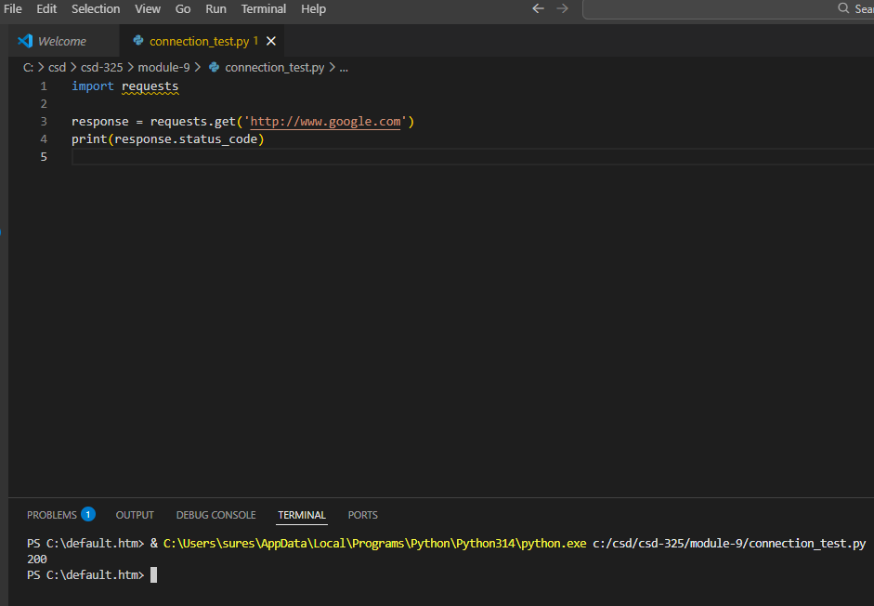

1) CONNECTION TEST
Status Code: 200

2) RAW RESPONSE
{"people": [{"craft": "ISS", "name": "Oleg Kononenko"}, {"craft": "ISS", "name": "Nikolai Chub"}, {"craft": "ISS", "name": "Tracy Caldwell Dyson"}, {"craft": "ISS", "name": "Matthew Dominick"}, {"craft": "ISS", "name": "Michael Barratt"}, {"craft": "ISS", "name": "Jeanette Epps"}, {"craft": "ISS", "name": "Alexander Grebenkin"}, {"craft": "ISS", "name": "Butch Wilmore"}, {"craft": "ISS", "name": "Sunita Williams"}, {"craft": "Tiangong", "name": "Li Guangsu"}, {"craft": "Tiangong", "name": "Li Cong"}, {"craft": "Tiangong", "name": "Ye Guangfu"}], "number": 12, "message": "success"}

3) FORMATTED JSON
{
"message": "success",
"number": 12,
"people": [
{
"craft": "ISS",
"name": "Oleg Kononenko"
},
{
"craft": "ISS",
"name": "Nikolai Chub"
},
{
"craft": "ISS",
"name": "Tracy Caldwell Dyson"
},
{
"craft": "ISS",
"name": "Matthew Dominick"
},
{
"craft": "ISS",
"name": "Michael Barratt"
},
{
"craft": "ISS",
"name": "Jeanette Epps"
},
{
"craft": "ISS",
"name": "Alexander Grebenkin"
},
{
"craft": "ISS",
"name": "Butch Wilmore"
},
{
"craft": "ISS",
"name": "Sunita Williams"
},
{
"craft": "Tiangong",
"name": "Li Guangsu"
},
{
"craft": "Tiangong",
"name": "Li Cong"
},
{
"craft": "Tiangong",
"name": "Ye Guangfu"
}
]
}

4) CURRENT ASTRONAUTS
People currently in space: 12
-----------------------------------
Oleg Kononenko - ISS
Nikolai Chub - ISS
Tracy Caldwell Dyson - ISS
Matthew Dominick - ISS
Michael Barratt - ISS
Jeanette Epps - ISS
Alexander Grebenkin - ISS
Butch Wilmore - ISS
Sunita Williams - ISS
Li Guangsu - Tiangong
Li Cong - Tiangong
Ye Guangfu - Tiangong
PS C:\default.htm>

