Suresh Shrestha
3/24/2026
Module 1.2 Assignment

1. GitHub repository Link
https://github.com/Suresh-Shrestha/csd-340.git

2. Screenshot of GitHub repository

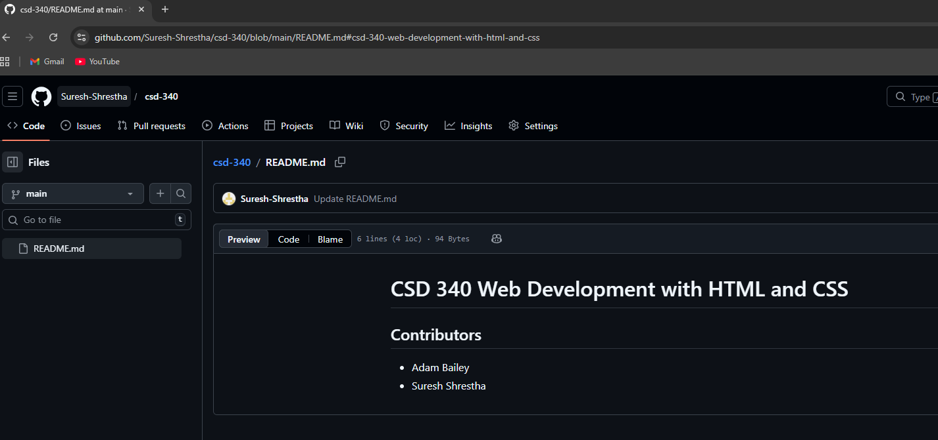

3. Screenshot of local directory

