Suresh Shrestha
3/24/2026
Module 1.3 Assignment

1. Validator with errors
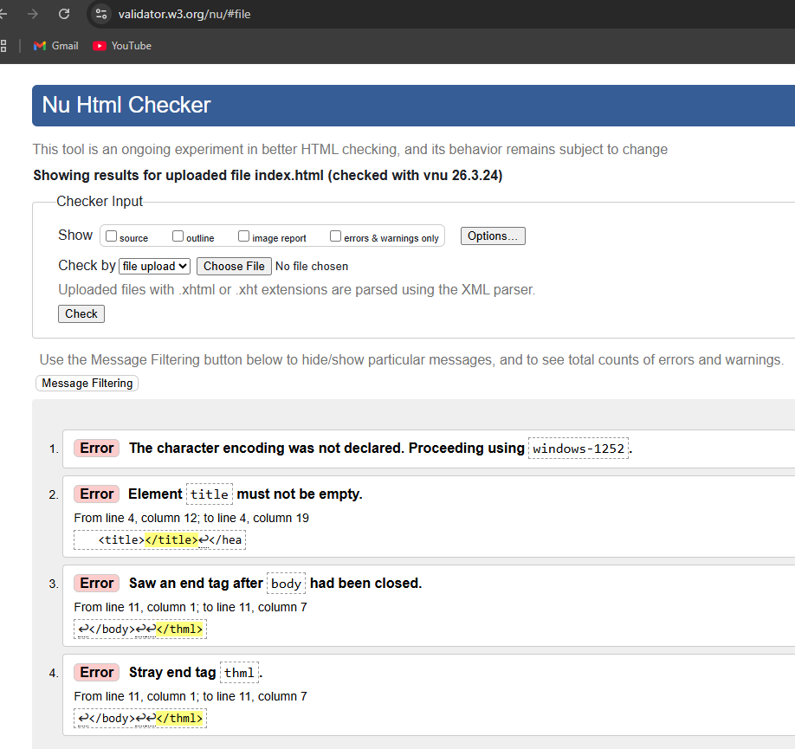

2. Validator after fixing
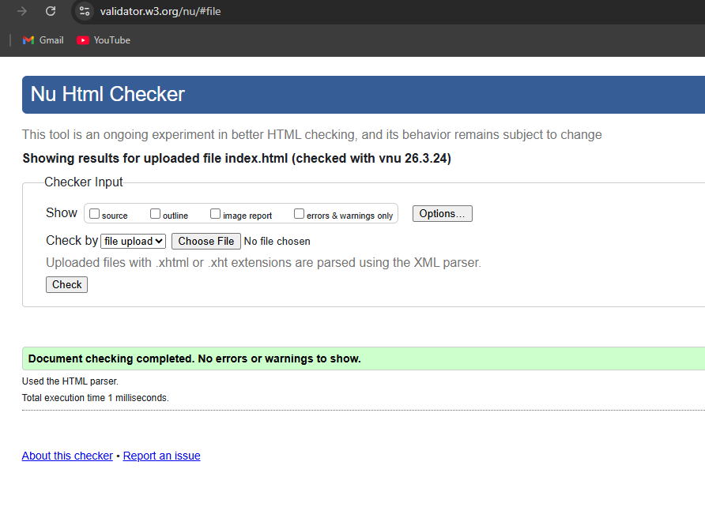
4. Webpage in browser
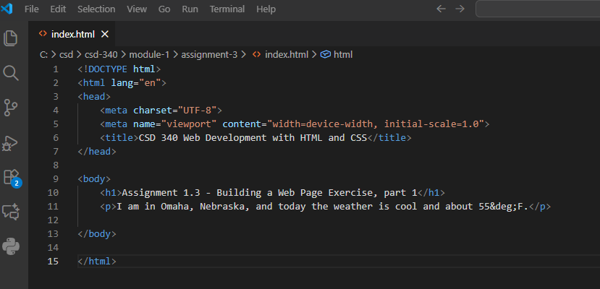

3. Final validator after adding content
