Project: Fryer_Assignment 4.2
Course: Dev Ops csd380
Description: Test Cases for TODO web app
Date: 9/3/2026
To complete the test case plan, fill out the information for Project, Course, Description and Date in the header below.
.
TABLE OF CONTENTS
Create a new TODO task item 2
< Prevent users from submitting a task form with without entering a todo item > 2
<Delete a TODO task item> 3
<Edit a TODO Task item> 3
<For invalid URLS provide a user with a custom 404 error page> 3

For each test, the developer should: provide a test description, a test objective, the developer name and date tested. For each step, fill out the actions to be taken and describe the expected results, and indicate yes or no for each step depending upon the result. The peer tester should provide their name, date tested, indicate yes or no for each step depending upon the result, and a screenshot (thumbnail) of the result.

Test 1 | < Create a new TODO task item >
 | Test Objective: User is able to create a new task item. | Developer:  Date tested: 2026/09/03 | Peer tester: Suresh Shrestha  Date tested: 9/4/2026
Step | Action | Expected results: | Developer pass/fail | Tester pass/fail  + Screenshot
1 | Click in the text box with the default Task text | Task shrinks below a blinking cursor. | Yes | Yes  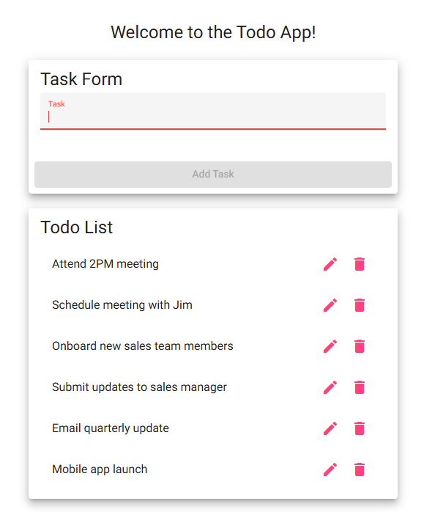
2 | Enter text “Test TODO item” into the text box. | Text is entered into the text box. | Yes | Yes  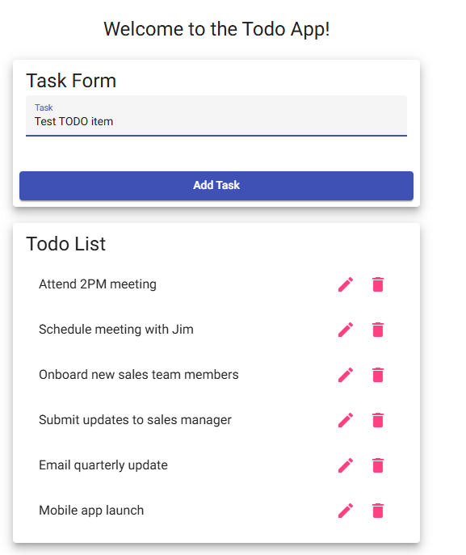
3 | Click Add Task button. | Task is added to the bottom of the TODO list. | Yes | Yes  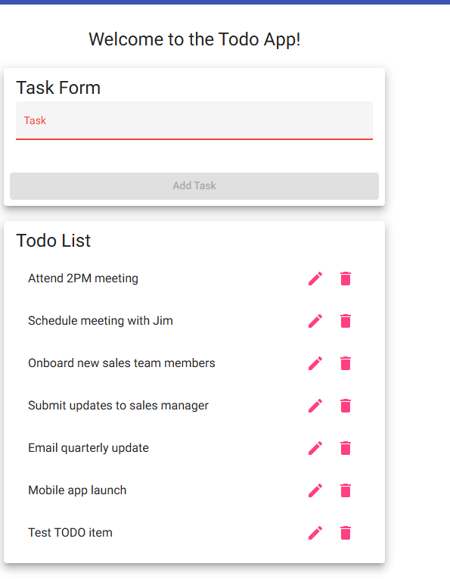
4 | Task text box has a red line on the bottom and default text are changed to red | Text box and default text have changed. | Yes | Yes
Comments | Comments should be substantive; this means there should be at least 2-3 well-structured sentences with constructive feedback. Peer tester Comment-Suresh Shrestha: The test worked as expected. I was able to enter “Test TODO item” and add it successfully to the Todo List. After the task was added, the Task field returned to its empty state with the red label and bottom line.

Test 2 | < Prevent users from submitting a task form with without entering a todo item >
 | Test Objective: Get to the web site | Developer:  Date tested: 2026/09/03 | Peer tester: Suresh Shrestha  Date tested: 9/4/2026
Step | Action | Expected results: | Developer pass/fail | Tester pass/fail
1 | Go to the website https://buwebdev.github.io/todo/ | Web page is shown with default TODO list. | Yes | Yes
2 | Click the Add Task button | Button can’t be pressed and is greyed out | Yes | Yes  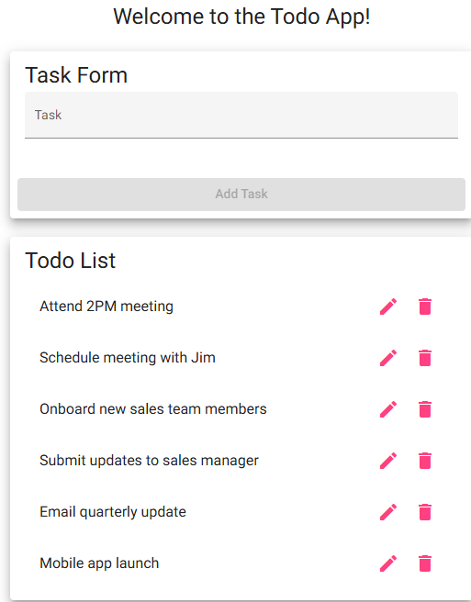
3 | Click into the task textbox and press the space bar to have a blank space in the text box | Blank space is in the text box | Yes | Yes  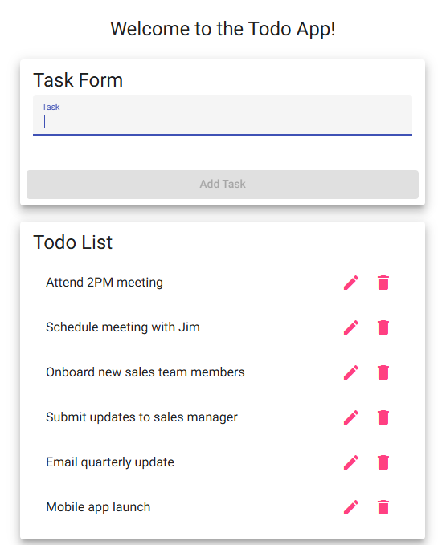
4 | Click the Add Task button | Button can’t be pressed and is greyed out | Yes | Yes  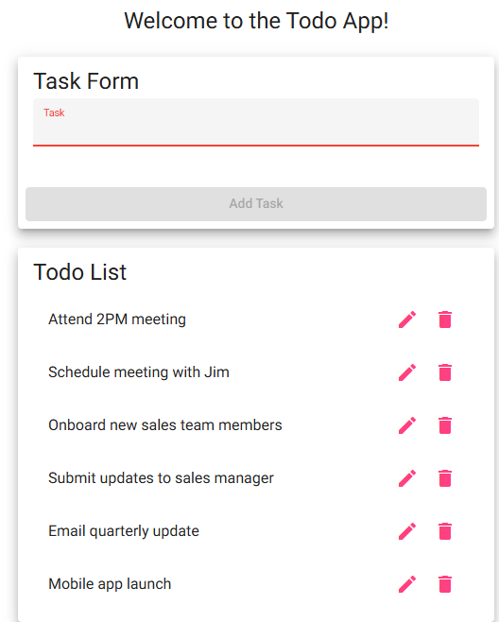
5 | Click into the taskbox and press the space bar 5 times and click the add Task button | Button can’t be pressed and nothing is added | NO | No  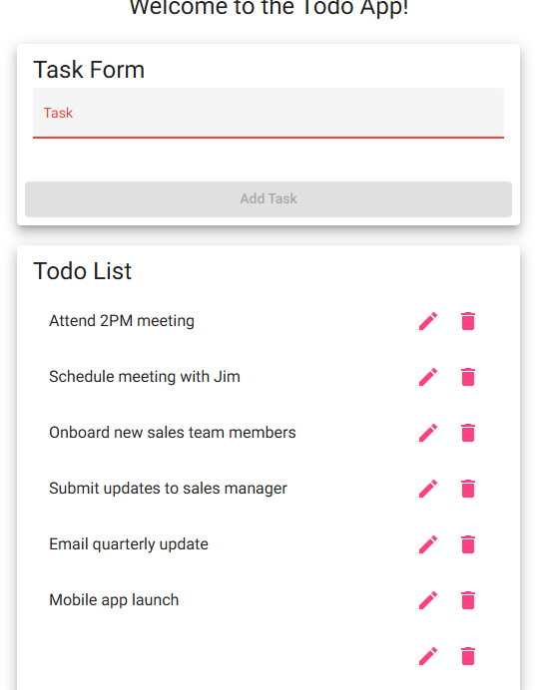
Comments | Comments should be substantive; this means there should be at least 2-3 well-structured sentences with constructive feedback. Peer Tester Comment – Suresh Shrestha: The application correctly prevented and empty task and a task containing one space from being submitted. However, when I entered five spaces, the Add Task button became active, and a blank task was added to the Todo List. Therefore, Step 5 did not work as expected.

Test 3 | < Delete a TODO task item >
 | Test Objective: | Developer:  Date tested: <yyyy/mm/dd> | Peer tester: Suresh Shrestha  Date tested: 9/4/2026
Step | Action | Expected results: | Developer pass/fail | Tester pass/fail
1 | Launch the TODO list application | TODO list is shown | Yes | Yes  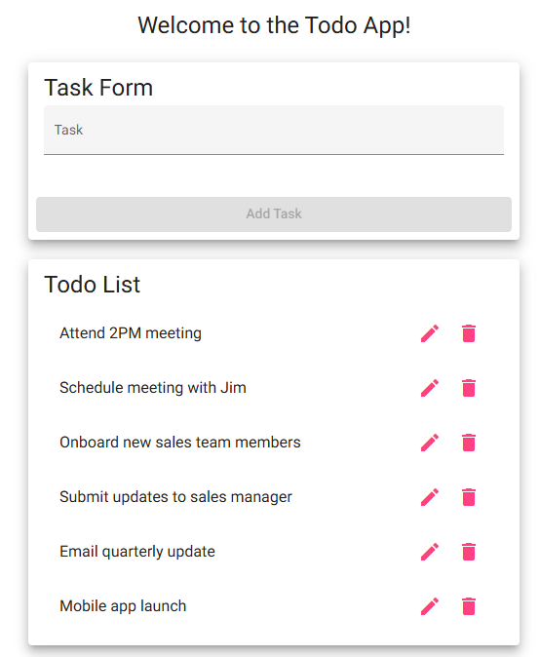
2 | Click on the trash can icon next to the First TODO list item: Attend 2PM meeting | TODO task is removed from the list. | Yes | Yes  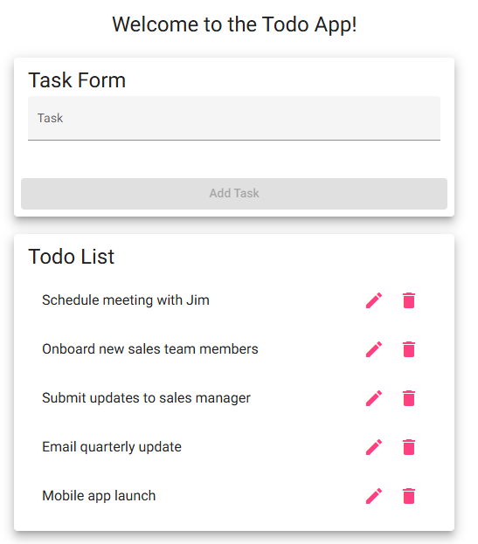
3 | Refresh the page | Task is still now shown | No | No  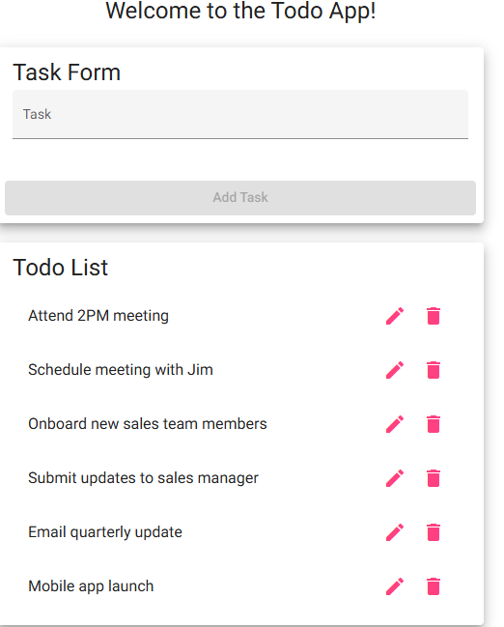
Comments | Comments should be substantive; this means there should be at least 2-3 well-structured sentences with constructive feedback. Peer Tester Comment – Suresh Shrestha: The task was successfully removed when I clicked the trash can Icon. However, after refreshing the page, “Attend 2PM meeting” appeared again in the Todo List. Therefore, the delete function does not persist after the page is refreshed.

Test 4 | < Edit a TODO Task item >
 | Test Objective: | Developer:  Date tested: <yyyy/mm/dd> | Peer tester: Suresh Shrestha  Date tested: 9/4/2026
Step | Action | Expected results: | Developer pass/fail | Tester pass/fail
1 | Launch the TODO list application | TODO list is shown | Yes | Yes
2 | Click on the pencil icon next to the last TODO task item: Mobile app launch | Window pops up with the task name shown | Yes | Yes  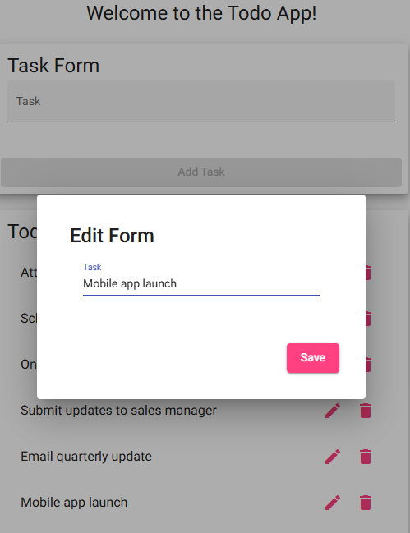
3 | Enter “Modify Task for Validation” | Text in the popup is changed | Yes | Yes  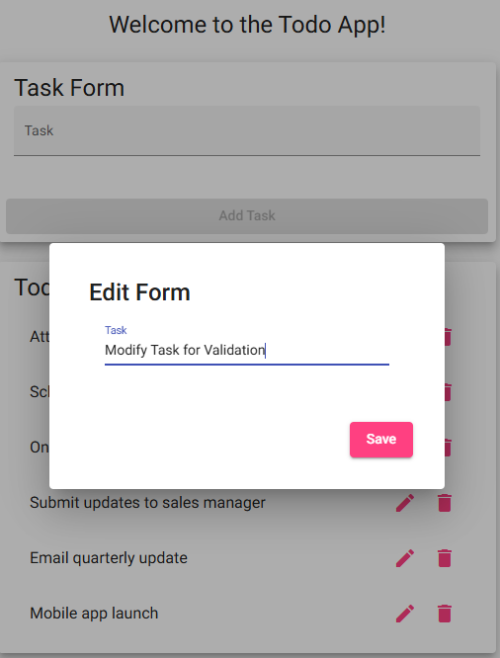
4 | Click the Save button | Popup closes and the task name is upaged | Yes | Yes  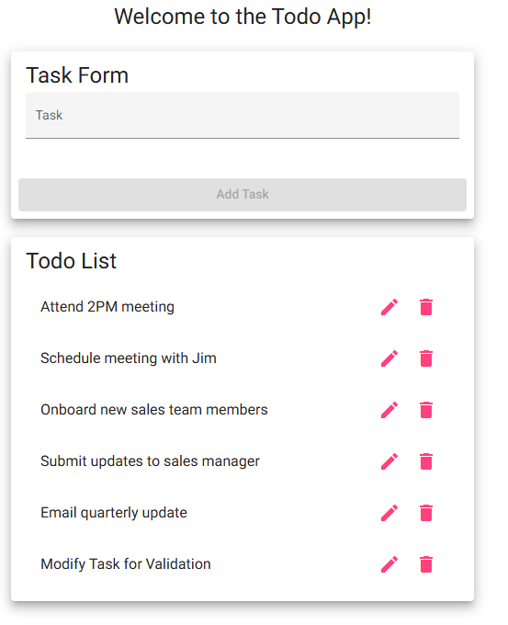
Comments | Comments should be substantive; this means there should be at least 2-3 well-structured sentences with constructive feedback. Peer Tester Comment – Suresh Shrestha: The edit function worked as expected. I changed “Mobile app launch” to “Modify Task for Validation,” saved the change, and the updated task appeared correctly in the Todo List.

Test 5 | < For invalid URLS provide a user with a custom 404 error page >
 | Test Objective: | Developer:  Date tested: <yyyy/mm/dd> | Peer tester: Suresh Shrestha  Date tested: 9/4/2026
Step | Action | Expected results: | Developer pass/fail | Tester pass/fail
1 | Go to the website: https://buwebdev.github.io/todo/fail | Page showing not-found works! Is shown | Yes | Yes  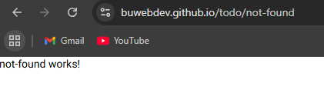
2 | Refresh the page | Same page is shown | Yes | Yes
3 | Take the not-found out of the URL and press enter | TODO list application is shown | Yes | Yes  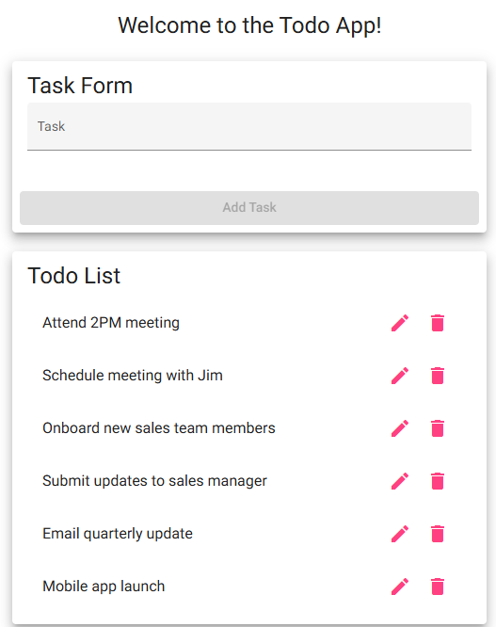
4 | Refresh the page | Screen refreshes and the TODO list application is shown | Yes | Yes
Comments | Comments should be substantive; this means there should be at least 2-3 well-structured sentences with constructive feedback. Peer Tester Comment – Suresh Shrestha: The invalid URL correctly displayed the custom not-found page, and it remained visible after refreshing. After returning to the normal Todo URL, the Todo application loaded successfully and continued to display correctly after another refresh.

