Suresh Shrestha
3/28/2026
Module 1.3 Assignment
1. Java version output
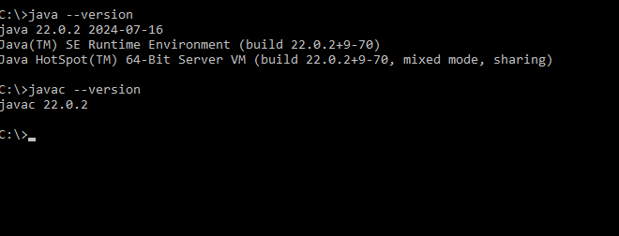
2. JavaFX SDK Lib Folder
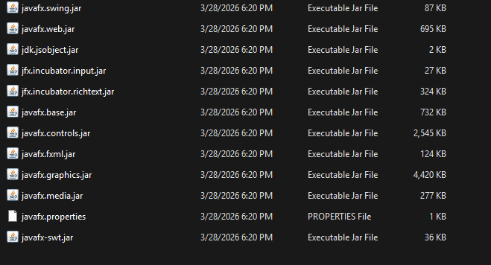

3. JavaFX Library Configuration in IntelliJ
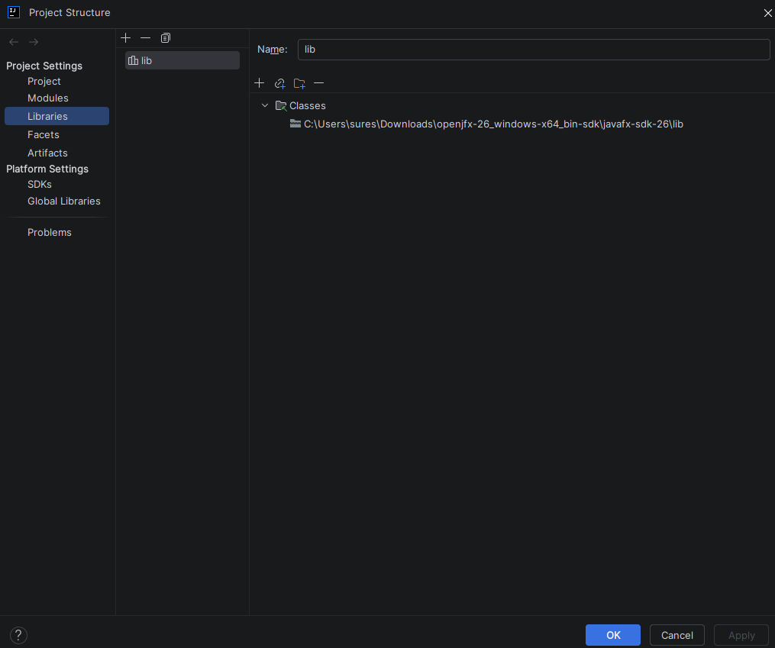

4. Java program code(Energy Calculator)
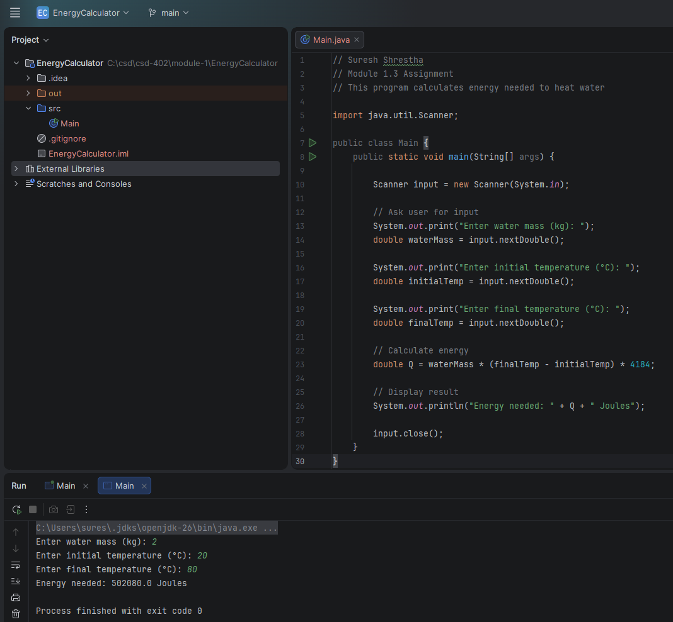

5. Run configuration with VM options
