Suresh Shrestha
7/10/2026
Module-7.2 Assignment Screenshots

1. mystyle.css
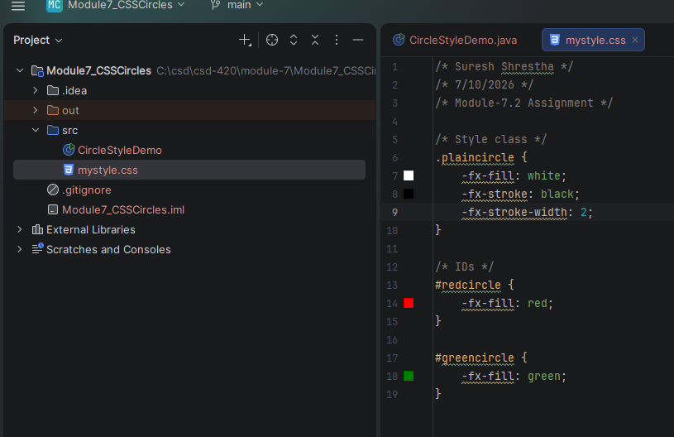

2. CircleStyleDemo.java
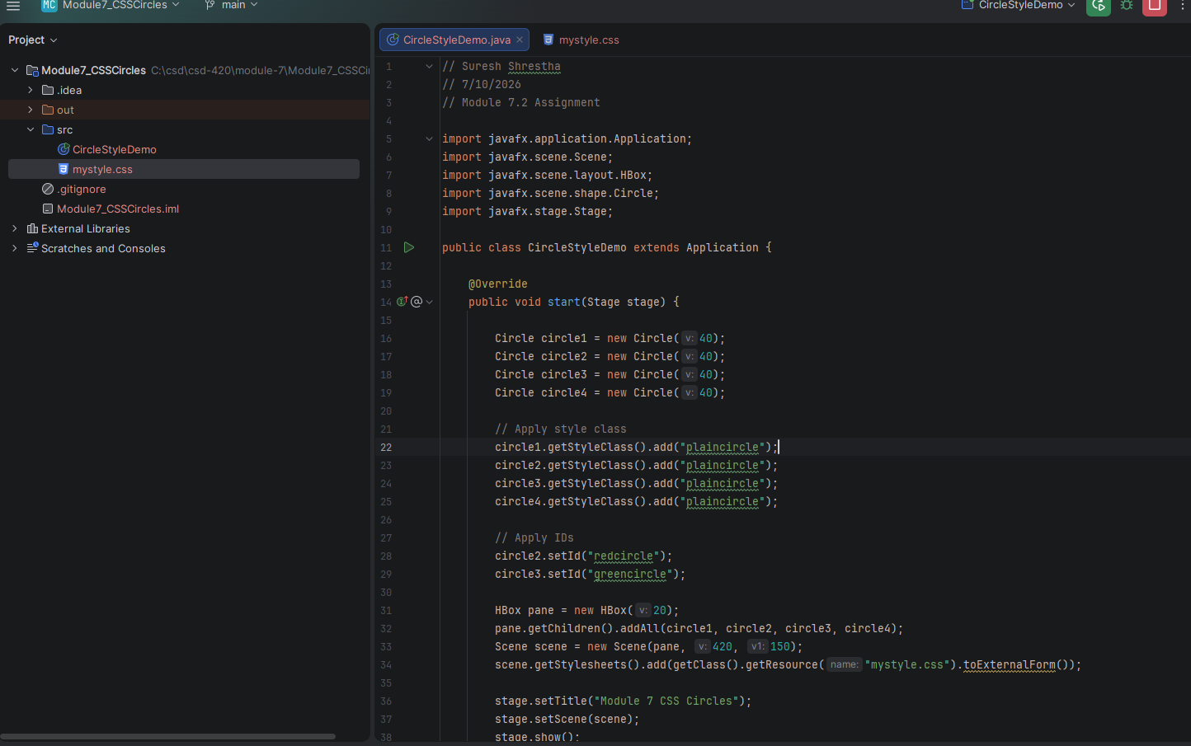

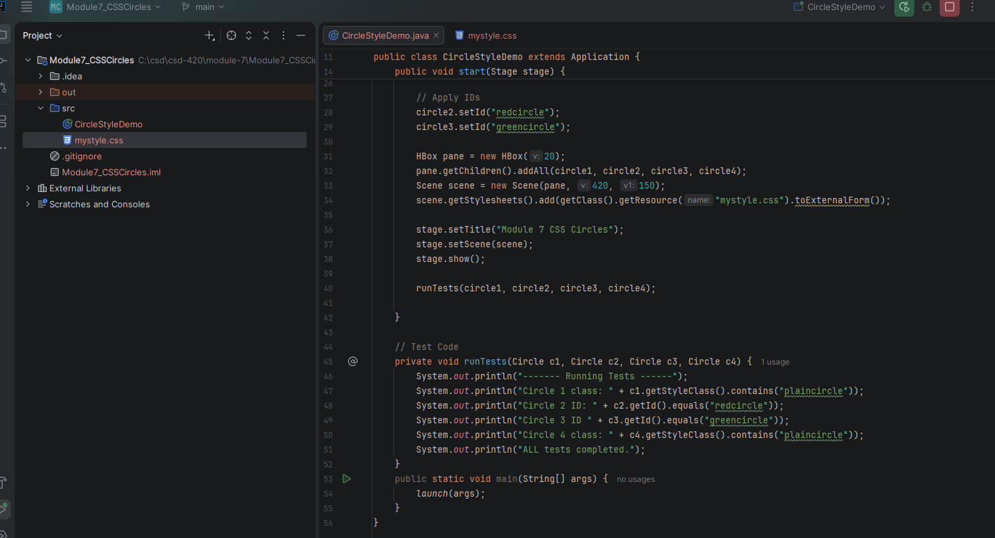
3. Program output

