Suresh Shrestha
6/5/2026
Module-1.3 Assignment

1. JavaFX Library Setup
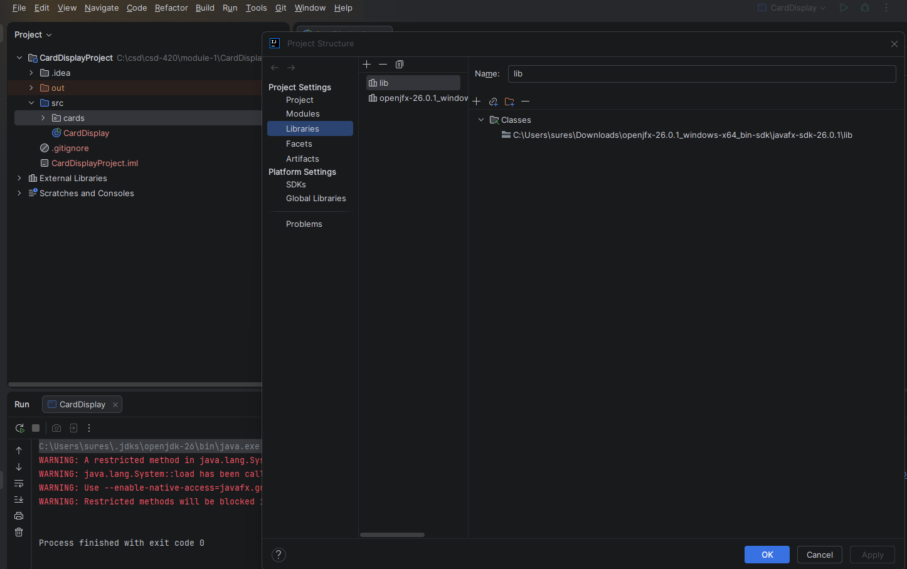

2. VM Options

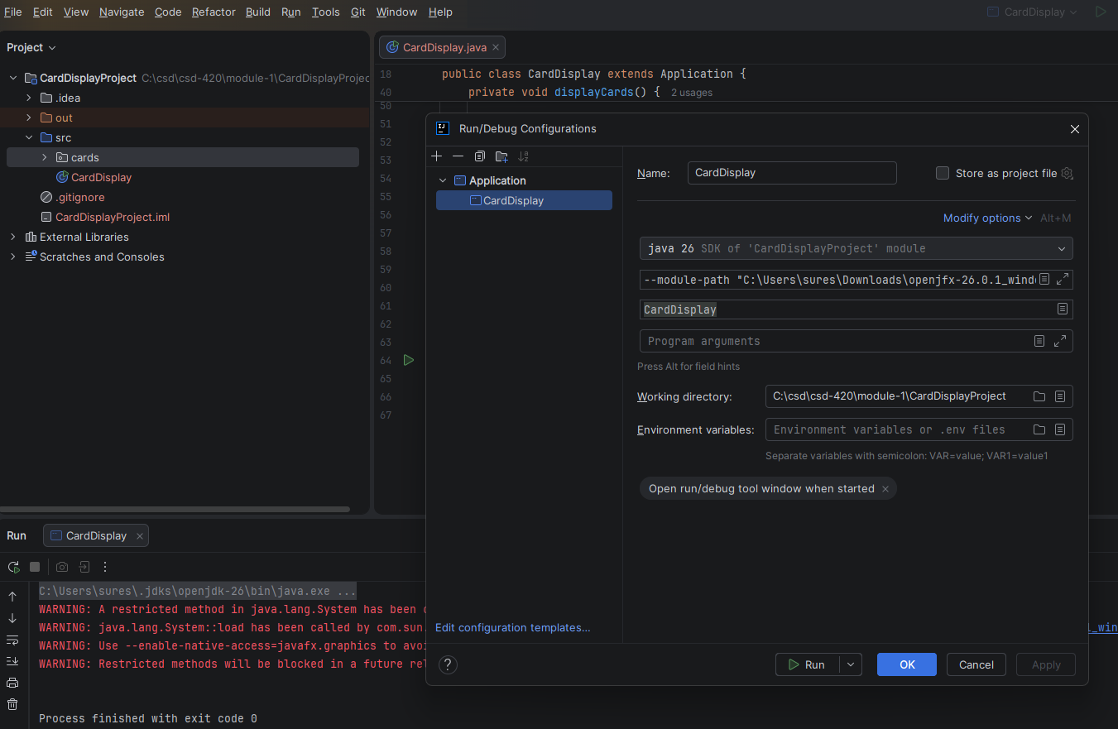

3. Program Running
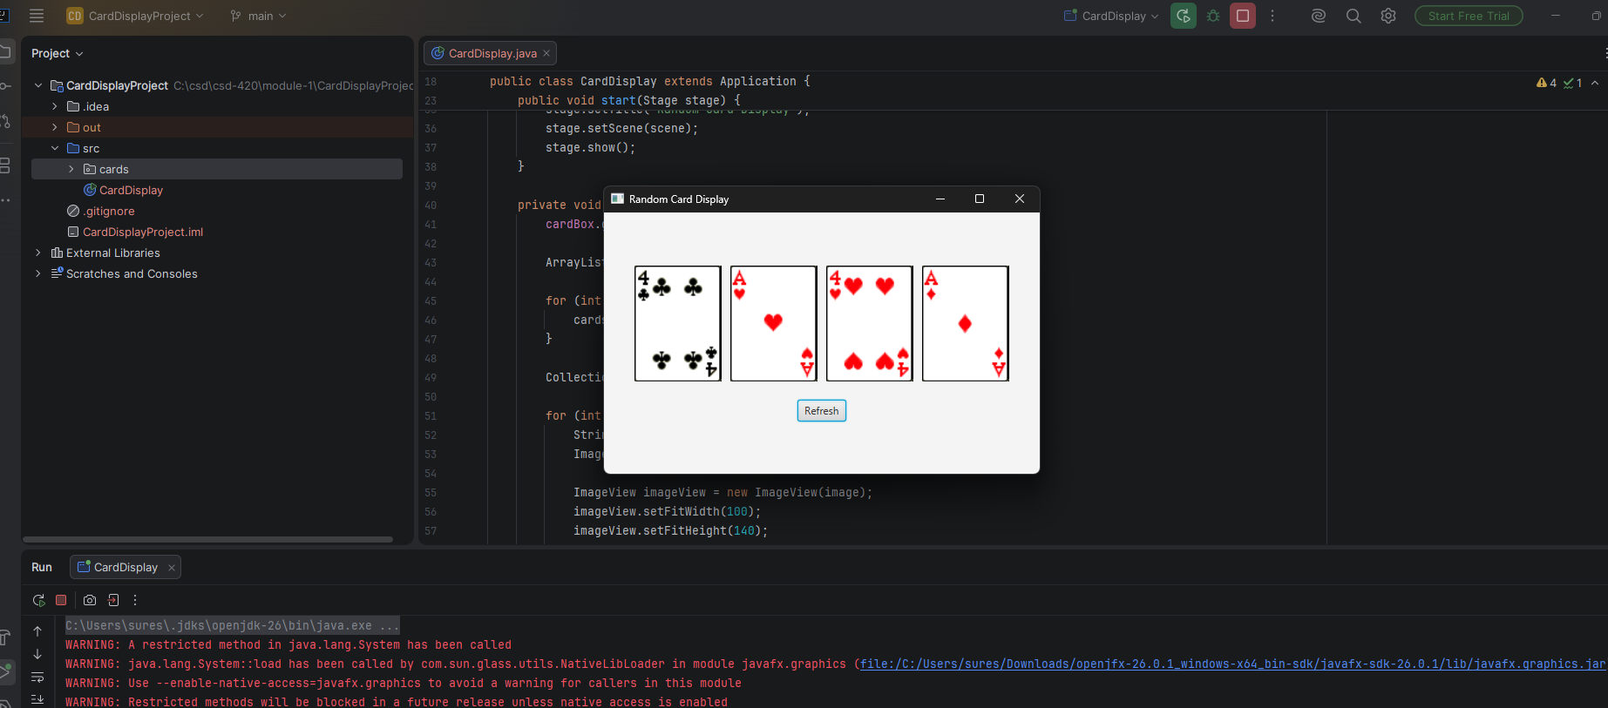

4. Program After Refresh
