Suresh Shrestha
6/13/2026
Module-2.2 Assignment
1. ShresthaReadData Output
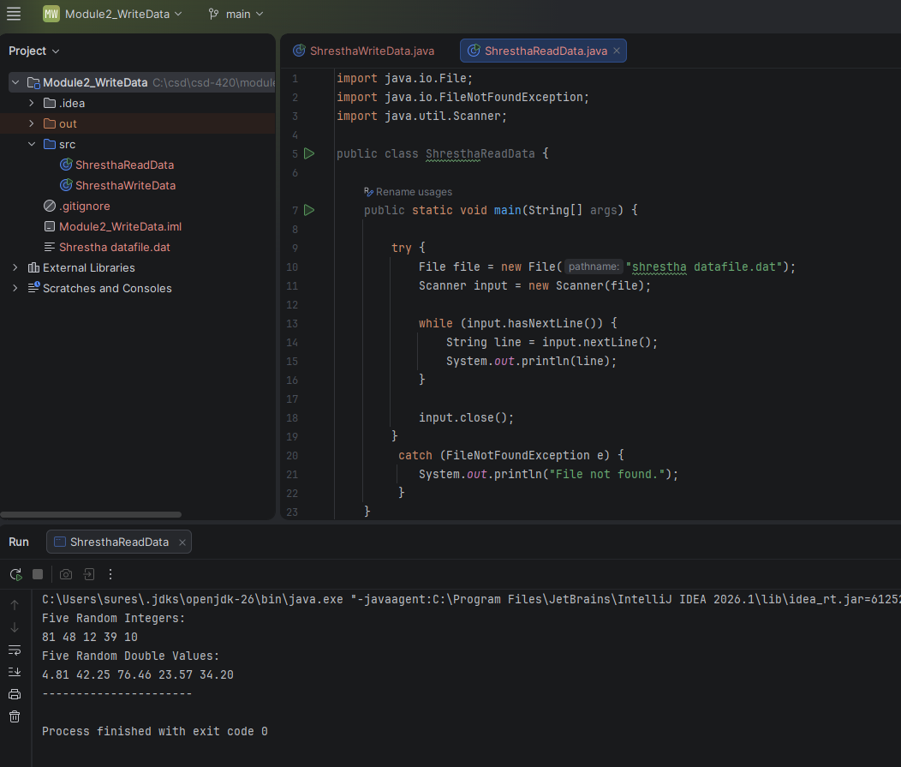

2. Shrestha datafile output

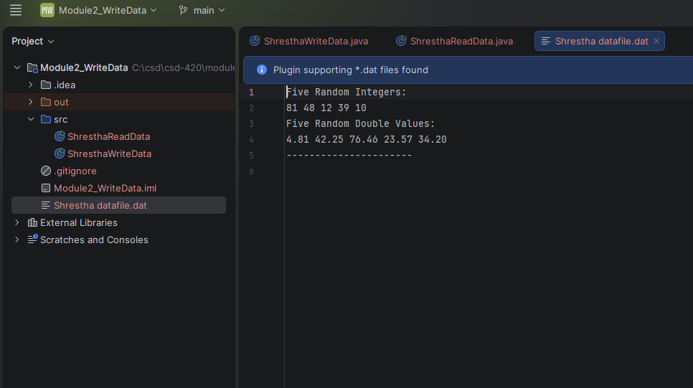

3. ShresthaWriteData code and output
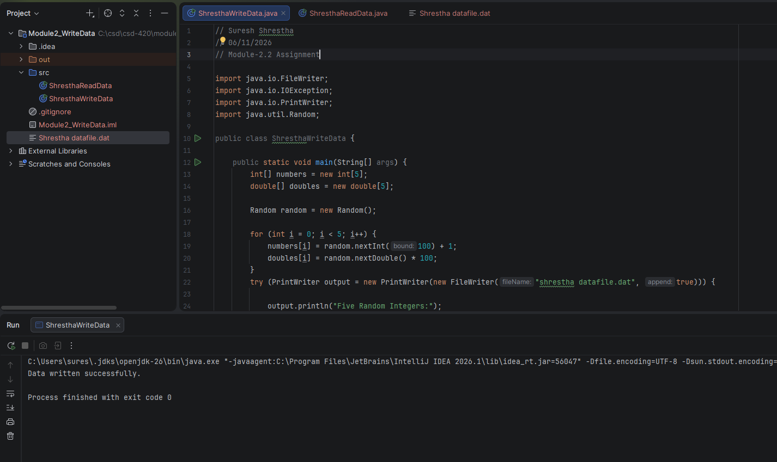
4. Java -version output

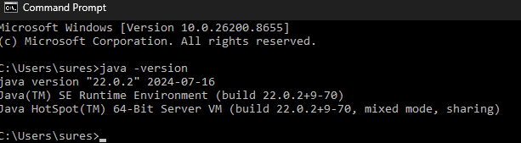

5. JavaFX configuration
